Tribun Pekanbaru, editorial 5 September 2020
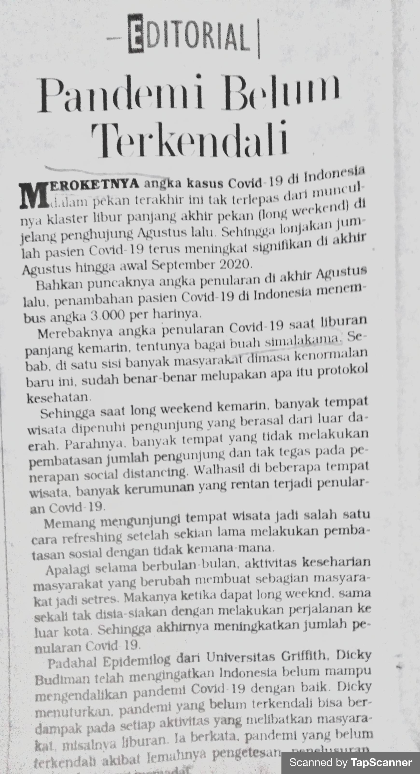

Tribun Pekanbaru, editorial 8 September 2020
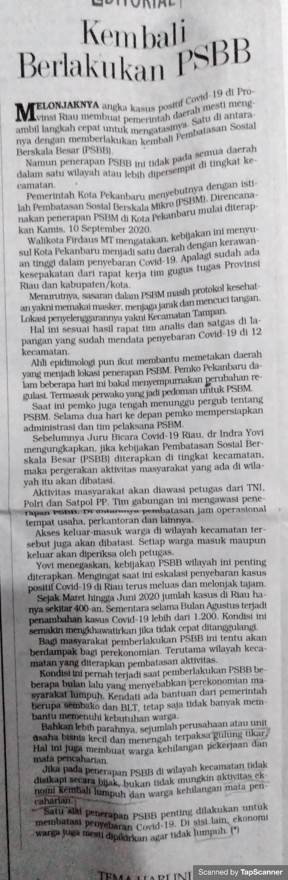

Tribun Pekanbaru, editorial 9 September 2020
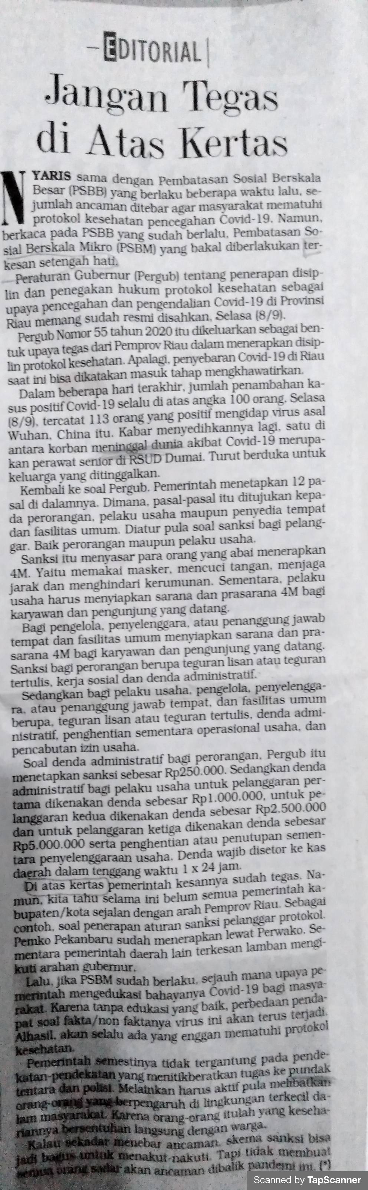

Tribun Pekanbaru, editorial 10 September 2020
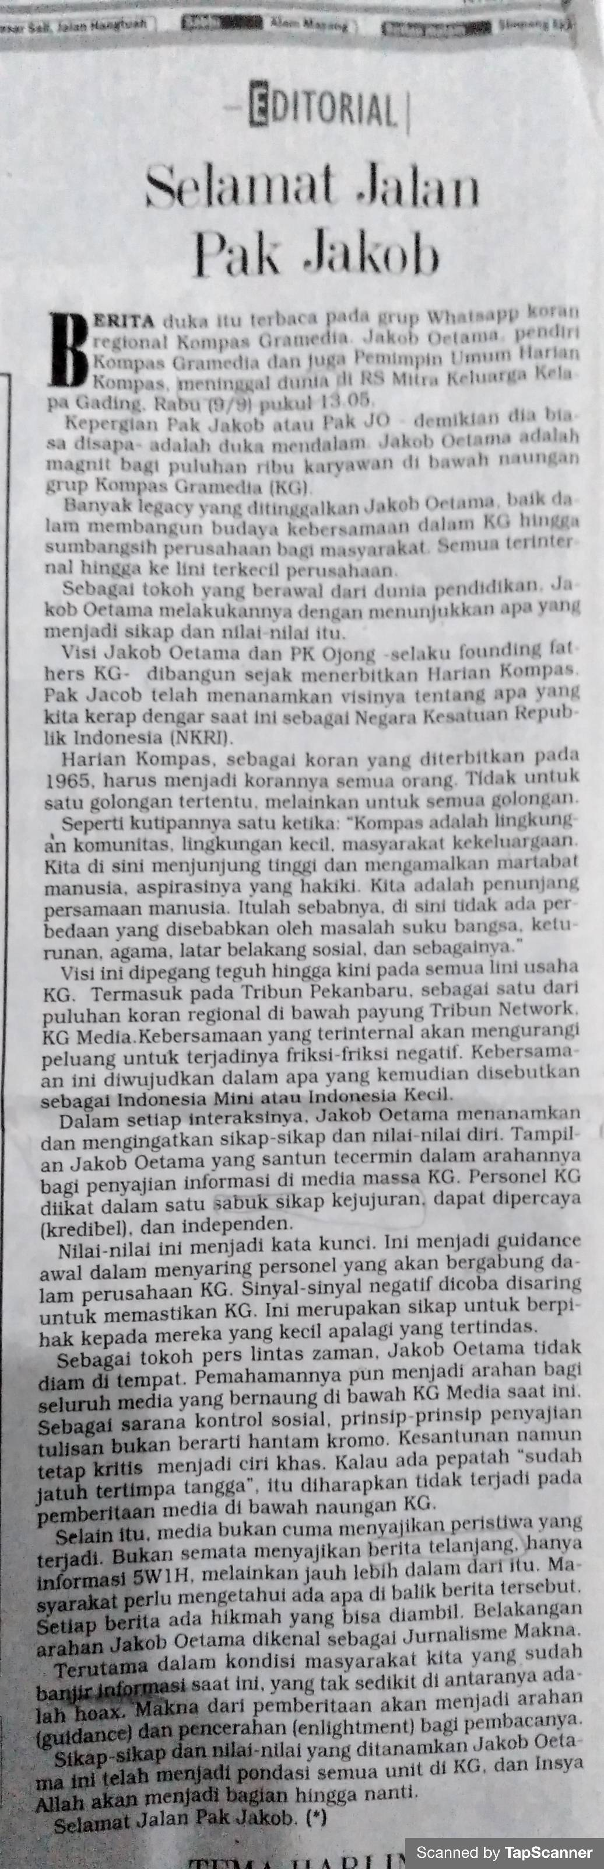

Tribun Pekanbaru, editorial 11 September 2020

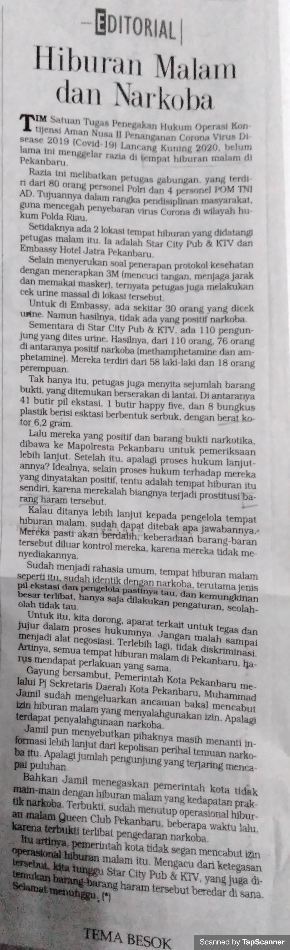
Tribun Pekanbaru, editorial 15 September 2020
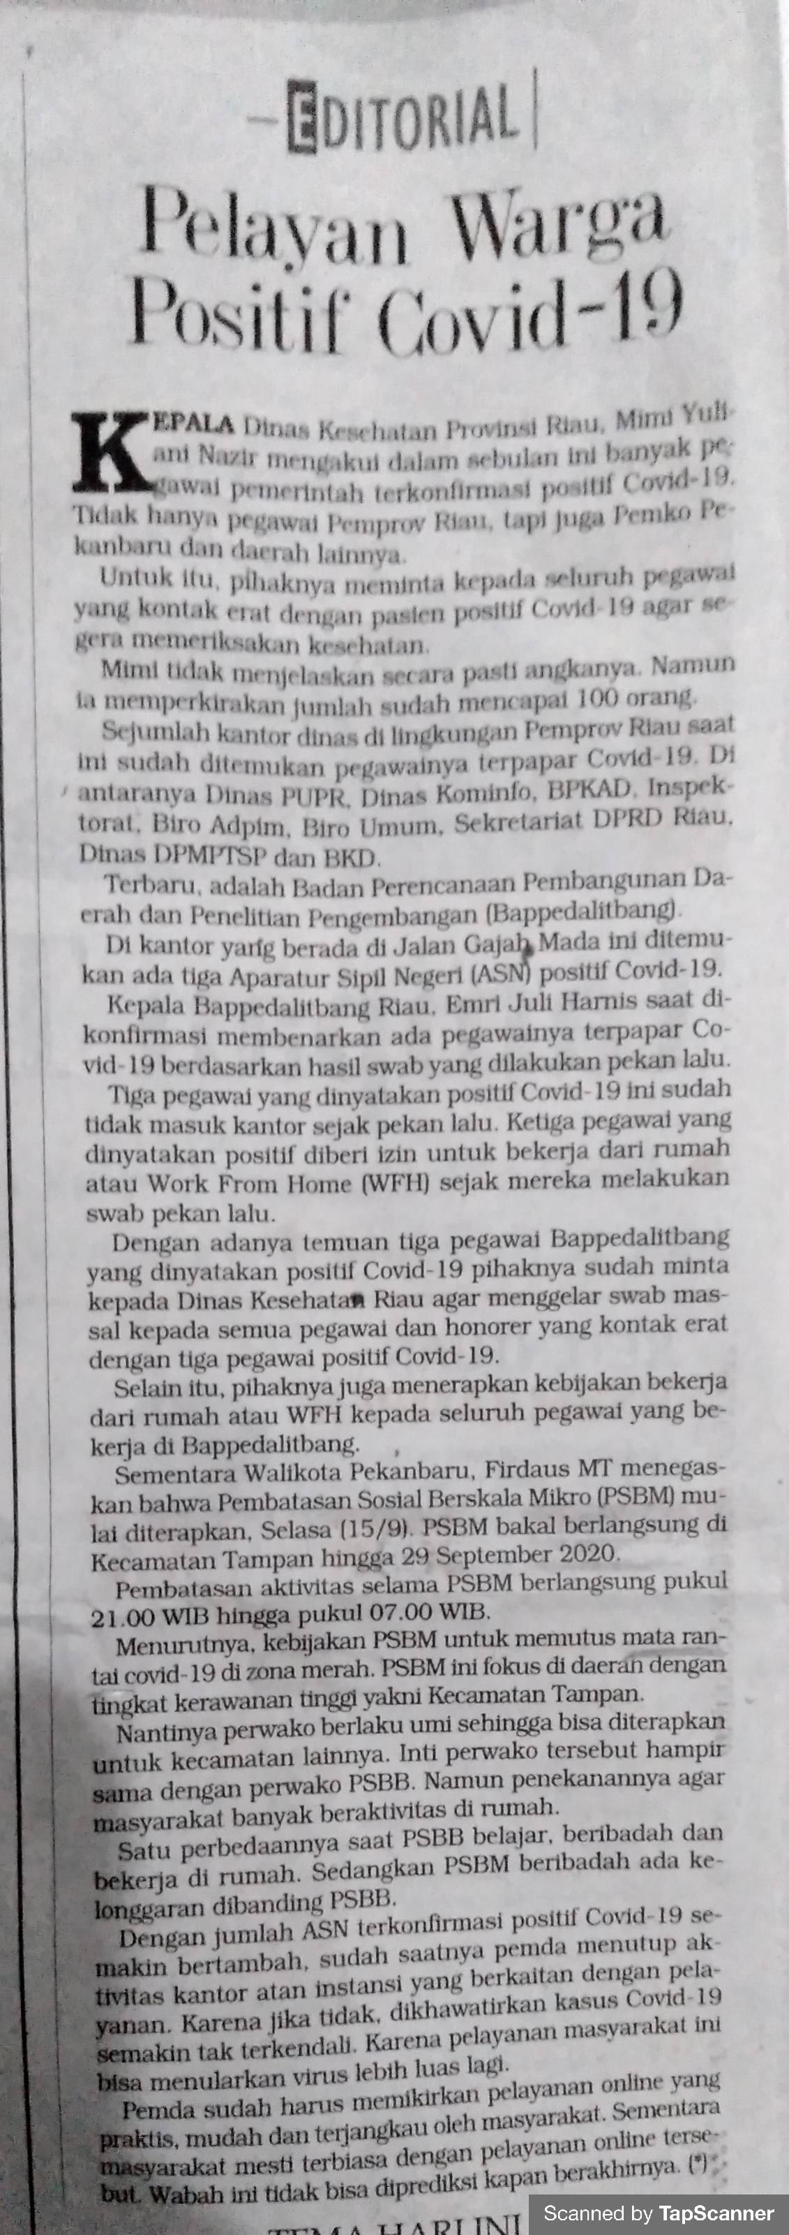

Tribun Pekanbaru, editorial 16 September 2020
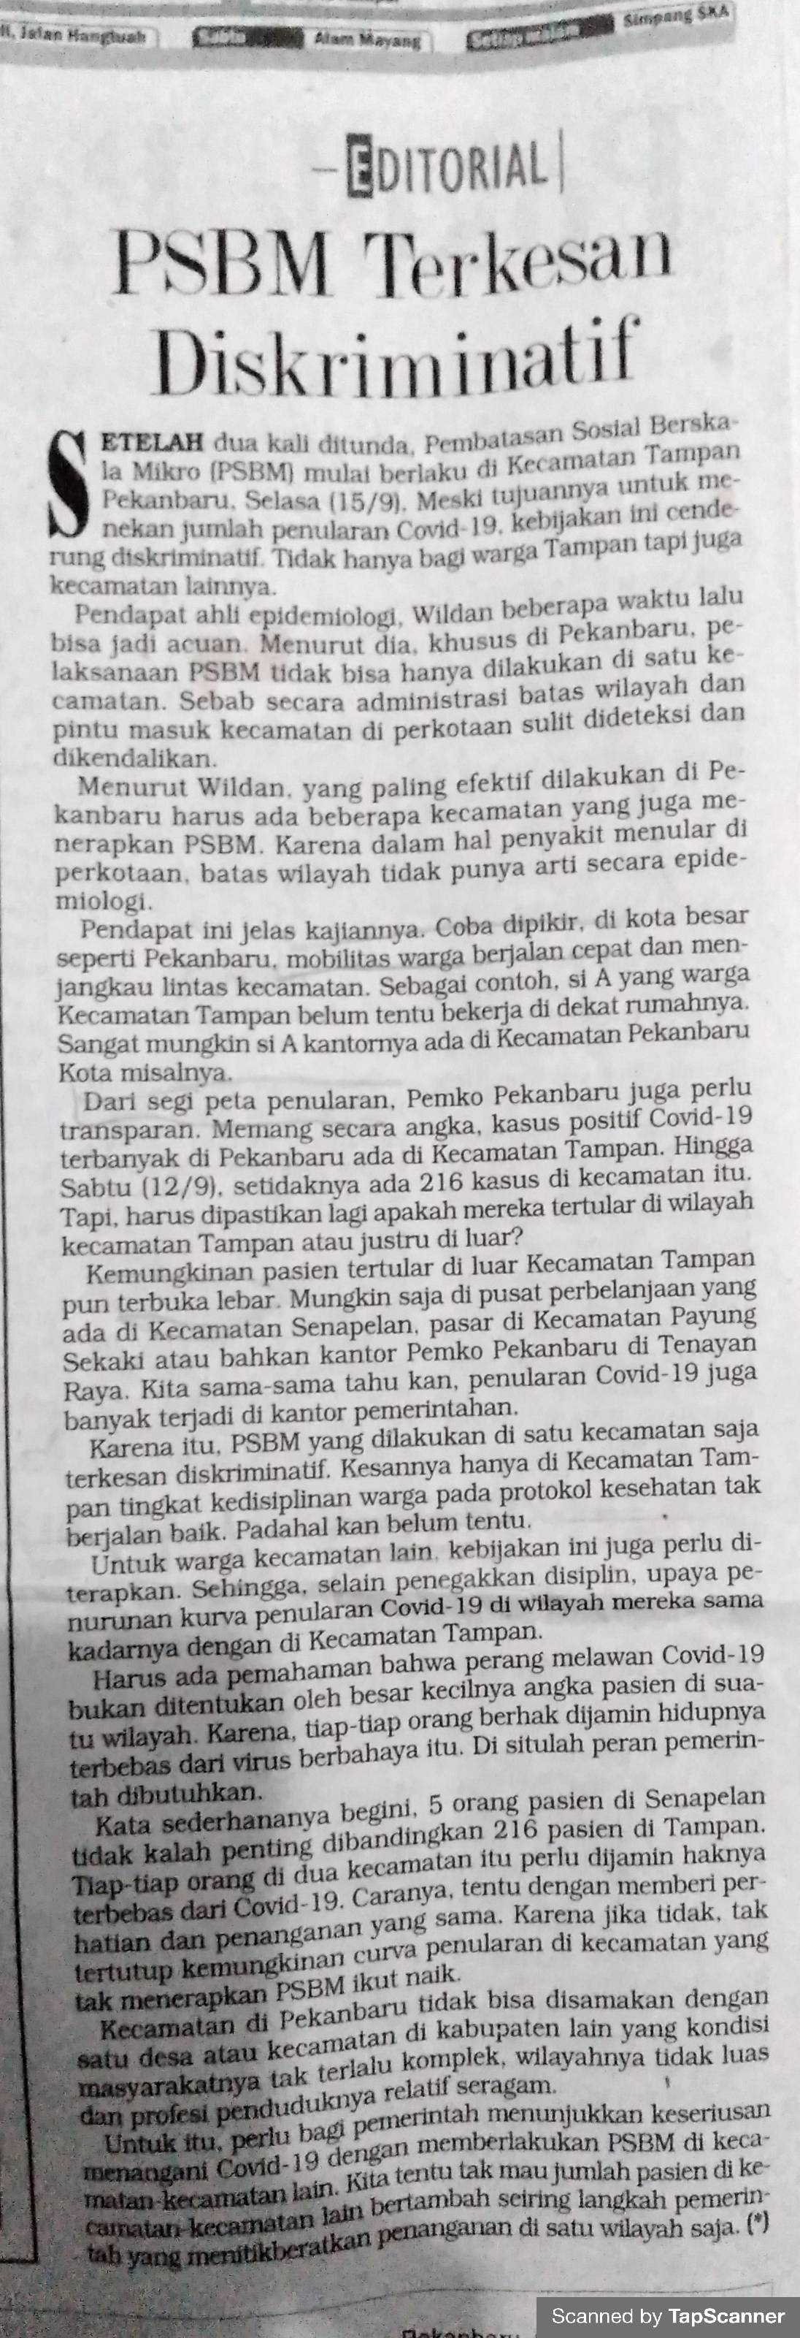

Tribun Pekanbaru, editorial 17 September 2020
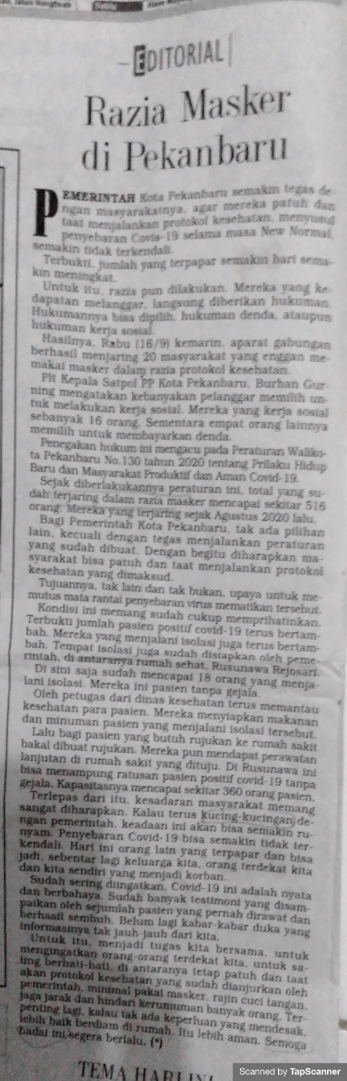

Tribun Pekanbaru, editorial 18 September 2020
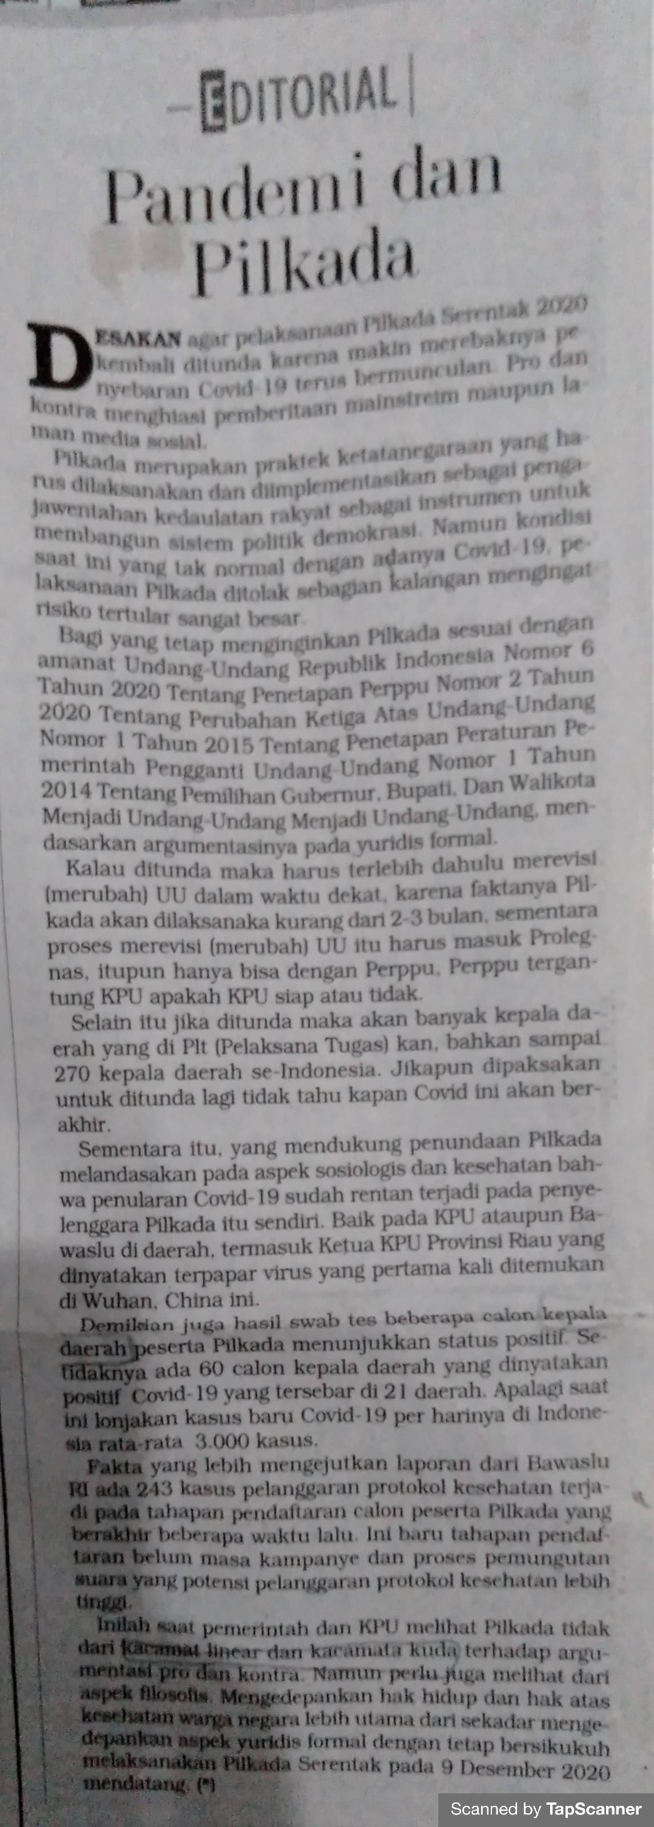

Tribun Pekanbaru, editorial 24 September 2020
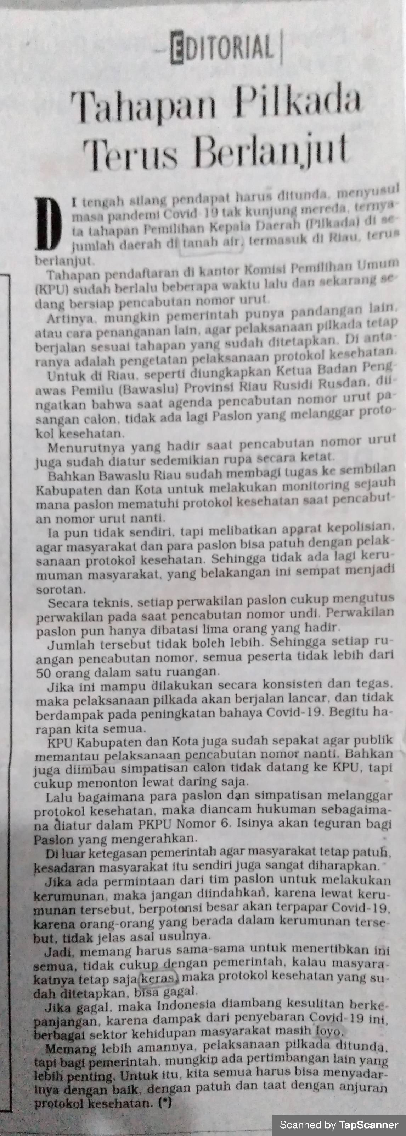

Tribun Pekanbaru, editorial 25September 2020

