Gold Investment at Hajj Financial Management Agency (BPKH)

Mutia Melina Damayanti¹, Ida Busnetty², Ellyana Amran³, Nirdukita Ratnawati⁴, and Soeharjoto⁵

¹1Islamic Economics & Finance of Trisakti University, email: mutiamelinadamayanti@gmail.com
²1Islamic Economics & Finance of Trisakti University, email: ida.busneti@ trisakti.ac.id
³Islamic Economics & Finance of Trisakti University, email: ellyana_amran@trisakti.ac.id
Abstract  Background: Despite the potential of gold as a strategic asset due to its diversification benefits and long-term value preservation, gold investment in BPKH remains significantly untapped.  Objectives: This research aims to analyze the influence of macroeconomic factors on price movements in Pegadaian gold accounts and analyze the factors that BPKH must pay attention to when investing in gold and which gold instrument is more recommended for BPKH.  Novelty: There has not been much research related to gold investment at BPKH, this research discusses matters related to the topic.  Research Methodology/ Design: The influence of macroeconomic factors analysis on the price of Pegadaian gold accounts was carried out using a multiple linear regression method with five independent variables and one dependent variable. Analysis of the factors that BPKH must pay attention to when investing in gold is carried out using Analytic Network Process qualitative method  Findings: Multiple linear regression analysis shows that the international gold price, exchange rate, inflation rate, and economic growth rate have significant effect on the price of Pegadaian gold accounts. The results of the ANP questionnaire state that BPKH needs to pay attention to several factors in gold investing: macroeconomic factors, risk factors and sharia compliance factors. As many as 90% of respondents recommended Pegadaian gold accounts as a better investment instrument for BPKH, meanwhile 10% of respondents preferred gold bullion instruments with clearer sharia contract considerations.  Implication: In order to diversify and maintain asset value when unstable economic conditions occur, BPKH should increase the gold investment portfolio with maximum limit is 5% of the total investment and/or bank placement of hajj fund. When investing in gold, BPKH should pay attention to macroeconomic factors: international gold prices, exchange rates, inflation rate and economic growth rates, as well as risk factors and sharia comply. | Keywords:  BPKH, hajj fund, gold invstment  JEL Classifications:  E22, E44, G31

Received: February 11, 2024; Revised: August 23, 2024; Accepted: August 23, 2024; Available online: August 30, 2024

- Introduction
Hajj Financial Management Agency (BPKH) is an institution that manages Hajj finances. Hajj financial management is based on sharia principles, cautiousness, advantage, non-profit, transparency and accountability. Hajj financial management aims to improve the quality of the Hajj pilgrimage, rationality and efficiency in the use of BPIH and benefits for the Muslim community. The legal basis for establishing BPKH lies in Law number 34 of 2014 concerning Hajj financial management and Presidential Regulation number 110 of 2017 concerning BPKH. The main objective of establishing BPKH is to manage Hajj funds in Indonesia and be able to provide benefits for Muslims in Indonesia.
Bank placement and/or investment in Hajj Financial can be done in the form of banking products, securities investment, gold investment, direct investment and other investments. bank placement of Hajj Financial can be made in the form of sharia banking products. During the three years since BPKH establishment, bank placement of Hajj Financial were a maximum of 50% of the total bank placements and/or investments of Hajj Financial. Henceforth, after three years of BPKH establishment, bank placement of Hajj Financial were a maximum of 30% of the total bank placements and/or investments of Hajj Financial. The remaining of the total Hajj Financial should be allocated in investment instruments. Investments of Hajj Financial can be made in the form of securities investments, gold investments, direct investments and other investments. Hajj Financial Investment in the form of securities includes Government Sharia Securities issued by the central government, sharia securities issued by Bank Indonesia; and sharia securities regulated and supervised by the Financial Services Authority.
According to Government Regulation number 5 of 2018, direct investment is a maximum of 20% (twenty percent) of total bank placement and/or investment of Hajj Financial. Other investments are a maximum of 10% (ten percent) of total bank placement and/or investment of Hajj Financial. The Hajj Financial Management Agency regulations stipulate that BPKH can invest in gold in the form of certified gold bullion produced and/or sold domestically and gold accounts managed by sharia financial institutions that are regulated and supervised by the Financial Services Authority. Gold investment at BPKH is limited to a maximum of 5% (five percent) of total bank placement and/or investment of Hajj Financial.
Hajj is part of the pillars of Islam for people who are able to carry it out. The Hajj law is fardhu 'ain, obligatory once in a lifetime for every capable Muslim. The obligation of Hajj has been mentioned in the Qur'an, Hadith and ijma' (agreement of the ulama). The argument of the Qur'an is found in Ali Imron's letter verse 97 which reads "Performing the Hajj is a human obligation towards Allah, namely (for) people who are able to travel to Baitullah. Whoever denies (the obligation of Hajj), then indeed Allah is Rich (does not need anything) from the universe”. The hadith reference regarding the obligation of the Hajj pilgrimage was obtained from the Hadith History of Bukhari no. 8 and Muslim no. 16 which reads "Islam is built on five things: testifying that there is no god worthy of worship except Allah and confessing that Muhammad is His messenger, establishing prayers, paying zakat, performing the Hajj and fasting in the month of Ramadan". There are so many hadiths that state that Hajj is obligatory, reaching the level of mutawatir (very many paths) so that it can be confirmed that the Hajj law is obligatory. Due to this obligation, the number of Indonesian Muslims registering to carry out the Hajj pilgrimage continues to increase, while the available Hajj quota is limited. Currently the number of waiting lists for the Indonesian Hajj has reached 5.2 million people (hajikemenag.go.id). The increase in the number of waiting Hajj pilgrims has resulted in a large accumulation of hajj fund. The large amount of hajj fund has the potential to increase the benefit value which can be used for improving the quality of hajj pilgrimage.
In 2018, the real cost of Hajj per person was ± IDR69 million, with a benefit value from BPKH of ± IDR34 million per person (49%). The benefit value is taken from the optimization of Hajj Fund managed by BPKH which originates from the initial deposit deposited by prospective pilgrims when they first register.
Tabel 1. Composition of Regular Hajj Costs Per Pilgrim (in IDR Million)
Year | 2017 | 2018 | 2019 | 2022 | 2023 | 2024 (P)
BPKH’s Benefit Value | 26,90 | 33,72 | 33,92 | 57,91 | 40,24 | 37,36
Cost Paid by Pilgrims | 34,89 | 35,24 | 35,24 | 39,89 | 49,81 | 56,05
Total Hajj Cost | 61,79 | 68,96 | 69,16 | 97,79 | 90,05 | 93,41
Source: Badan Pengelola Keuangan Haji
Tabel 2. Composition of Regular Hajj Costs (in percentage)
Year | 2017 | 2018 | 2019 | 2022 | 2023 | 2024 (P)
BPKH’s Benefit Value | 43,53% | 48,90% | 49,05% | 59,22% | 44,69% | 40,00%
Cost Paid by Pilgrims | 56,47% | 51,10% | 50,95% | 40,78% | 55,31% | 60,00%
Total Hajj Cost | 100% | 100% | 100% | 100% | 100% | 100%
Source: Badan Pengelola Keuangan Haji
The tables shown that each year BPKH must produce benefit value to pay almost half proportion of total hajj cost. In 2022, the percentage paid by BPKH is even greater than the percentage paid by the pilgrims because there was additional cost related to Covid19 that caused total hajj cost jump to IDR 98 million per person. This amount further increases the portion of BPKH’s benefit value. The Hajj Financial Investment as regulated in Law No. 34 of 2014 and PP No. 5 of 2018, is the backbone to achieve BPKH’s benefit value for covering total hajj cost which tend to increase in amount each year.

Tabel 3. Composition of Bank Placement & Investment by BPKH
as per 31 Dec 2022
Instruments | IDR | %
Bank Placements | 48.950.000.000.000 | 29,39%
Securities Investments | 112.959.600.000.000 | 67,83%
Direct Invesments & Other Invesments | 4.630.000.000.000 | 2,78%
Gold Investments | 400.000.000 | 0,00%
Total | 166.540.000.000.000 | 100%
Source: Laporan Keuangan BPKH. Retrieved August 14, 2024
The table shown that most of the hajj's financial asset is invested in Securities Investments followed by Bank Placements, while Gold Investment have not yet reached 1% of the total BPKH Investment and Placement. Apart from the limited sharia investment options, the composition of Hajj financial investments is also formed based on BPKH's conservative risk appetite and risk tolerance at low-to-moderate risk levels. Risk appetite is formed partly because there is a joint liability clause for members of the Executive Board and Members of the Supervisory Board if there is a loss on the investments and bank placements (Prasetyo, 2023). Currently the Law governing Hajj Finance does not yet have clauses relating to risk mitigation through reserves or capital as well as exemption from liability (acquit et de charge) as does Article 70 of the Law governing Limited Liability Company. If retained earnings are allowed to be used as reserves for investment risks, Hajj funds will have better protection and the management of Hajj finances will be safer (Gunawan, 2023). Long-term sustainability of Hajj finances can be met as long as total hajj cost each year can be paid by pilgrims and BPKH’s benefit value generated from the current year (Haryono and Busnetti, 2022).
One of the challenges of BPKH Investment is the limited number of Securities Investment instruments that comply with sharia principles in the market. In 2022 BPKH has started investment in Pegadaian gold account with a principal value of IDR400,000,000 this amount is considered very small, only 0.0002% of BPKH's total Investments and Bank Placements. Despite the potential of gold as a strategic asset for BPKH due to its diversification benefits and long-term value preservation, its utilization remains significantly untapped. If Gold Investment is optimized to reach a maximum limit of 5% of BPKH's total Investment and Placement, then BPKH is allowed to make Gold Investments of up to IDR9 trillion. BPKH requires a professional fund management strategy to ensure that all prospective pilgrims can perform hajj. Sustainability in managing hajj finances is urgently needed, including optimizing all potential investment instruments that have been regulated in BPKH regulations, including Gold Investment instruments. Based on the gap phenomenon, the author believes it is necessary to carry out research entitled "Gold Investment in the Hajj Financial Management Agency (BPKH)".
Gold investments have the characteristics of only consisting of principal that can be received back in the form of cash or physical gold; and has no cash flow from yield payments, only from capital gain. Gold is a commodity with volatile market prices and must be measured at fair value through profit or loss or Fair Value Through Profit and Loss (FVTPL). FVTPL measurement requires a mark to market against the market price at each reporting date, but does not require a provision for impairment of asset values (Witjaksono, 2022). Gains and losses arising from changes in the fair value of gold are recognized in the income statement as unrealized gains or losses.
This research aims to analyze the influence of macroeconomic factors on price movements in Pegadaian gold accounts, analyze the factors that BPKH must put into consideration when investing in gold, and analyze the better gold instrument that are more recommended for BPKH between gold bullion and gold accounts.

- Literature Review
Previous research related to gold investment includes the following:
Tabel 4. Previous Research Related to Gold
No | Journal Title | Author, Year | Research Result
1 | Interactive Relationship Between Precious Metal Prices and the Jakarta Islamic Stock Index | Padliansyah, Juliana, & Hasiara, 2020 | This research concludes that precious metals such as gold, silver, platinum and palladium are effective portfolio diversification tools for the Islamic stock market. Investors in the Islamic stock market in Indonesia may receive expected returns with minimum risk by using precious metal diversification tools (gold, silver, platinum and palladium).
2 | Dynamic Correlation of Gold and Sharia Stocks as a Hedge and Safe Haven for Investment in Indonesia | Billah & Hartomo, 2018 | - This research explains the dynamic correlation between gold and sharia shares as a hedge and safe haven in the Indonesian financial market. The results obtained show that Gold can significantly fulfill its role as a hedge and safe haven for other assets. Meanwhile, sharia shares do not act as hedging assets and safe havens.  - However, shares can be combined with Gold so that together they can become a strong hedge and reduce the level of risk for investment in Indonesia. The advice to investors is that investors can invest in capital market assets and futures markets, in this case sharia shares and gold, because the two markets are interrelated and influence each other.  - However, for better results and to provide a sense of security, investors should invest in a portfolio between gold and shares, because the combination of the two will reduce the level of risk when the economy is turbulent without reducing the returns desired by investors.
3 | Gold Investment: Alternative Investment in the Midst of the Global Crisis | Johari, 2018 | - This research concludes that gold investment is a simple form of investment because it can be done by anyone. Gold investments, whether in the form of gold coins, gold bars or gold jewelry, have higher returns compared to deposits, and are much more stable compared to shares.  - During its development, gold investment has experienced a significant decline. This event occurred in the period 1980-2000 (approximately 20 years). This period is known as a bearish period. This incident is often used as an argument by opponents of gold investment regarding the weaknesses of this investment. On the other hand, supporters of gold investment, use the 2001-2008 bullish period as an argument that in less than half the time (8 years), all the decline that occurred during the bearish period has exceeded the recovery.
4 | Gold as a Safe Investment Instrument at a Time when Other Financial Investment Instruments Experience Increased Risk | Sholeh, 2014 | - This research concludes that the results of the analysis of gold investment and other financial instruments show that gold investment has more attractive profits, both in terms of the prospective price level and the results obtained from the investment. In terms of investment risk, gold investment also has a lower risk percentage compared to investment in other instruments. This can prevent losses that investors will experience.  - From these two analyses, it can be concluded that gold investment provides more profitable and safer results.
5 | Comparative Analysis of the Performance of Gold Investment and Stock Investment During the Inflation Period 1994 – 2013 | Wahyuni & Wahyudi, 2014 | - This research aims to analyze the causal relationship between gold returns and stock market returns as well as the influence between the two and the influence of the inflation variable as one of the macroeconomic variables on gold returns and stock market returns.  - This research was conducted to find out the best investment choice between gold investment and stock investment during the 1994–2013 inflation period in Indonesia. The research was conducted using monthly data on gold prices, IHSG and inflation during the period January 1994 to December 2013. The analytical method used in this research is the VAR estimation model using the optimal lag test, data stationarity test, Johansen cointegration test, Granger causality test, analysis IRF and VD analysis.  - The results of this research show that there is no causal relationship between gold returns and stock market returns. Based on the VAR estimation model, it is known that in the short term gold returns have no influence on stock market returns and vice versa and the inflation variable has no effect on gold returns and stock market returns. In the end, it is known that investing in gold is the best choice compared to investing in shares during times of inflation.
6 | Optimizing Hajj Fund Investment in the Covid-19 Pandemic Era | Junaedi, Arsyad, & Aurijah, 2020 | - This research aims to explore optimal Hajj financial investment options through analyzing the relationship between investment prospects in gold, sharia shares and rice agribusiness investment with exchange rate dynamics, inflation, BI-rate, pandemic cases and policy differences in handling the Covid-19 pandemic. The method used is a mixed method of qualitative description and quantitative analysis. The data used is primary data and secondary data for the period January-August 2020. The analysis technique used is multiple regression with the summy variable of pandemic policy.  - The results obtained show that gold investment, sharia stock investment and rice agribusiness investment can be priority choices for Hajj financial investment. The prospect of gold investment is quite bright and statistically it is not significantly affected by exchange rate fluctuations, inflation, the BI rate and pandemic cases.
7 | Forecasting the price of gold: An error correction approach | Gangopadhyay et al., 2016 | - Long-term opposite movements in gold prices and stock markets. Gold acts as a hedge for a portfolio. Furthermore, gold acts as a safe haven asset when volatility is high.  - Oil prices have a negative relationship with gold, which indicates that gold can act as a good hedge against commodity prices.  - US bond rates have a negative relationship with gold which suggests that when returns from investments abroad are high, demand for gold in India may fall.  - Gold acts as a good inflation hedge.
8 | Determinants of gold price movements: An empirical investigation in the presence of multiple structural breaks | Chirwa & Odhiambo, 2020 | - Using Multivariate ARDL-based error-correction analysis/method.  - There is a significant and positive relationship indicating a long-term association between gold price movements, the London Stock Exchange (LSE), Nikkei (JP225) stocks, T. Rowe global multi-sector bond funds, and the CBOE volatility index in  the short and long term long.  - There is a significant and negative relationship between gold price movements and bond market indicators (GMO emerging country debt and Pimco emerging markets local currency bond funds) both in the short and long term.  - NASDAQ, DJI, and S&P500 have a negative relationship to gold price movements in the short term. NYSE has a positive relationship with gold price movements in the short term.  - Goldman Sachs bonds have a significant and positive relationship to gold prices in the long term.
9 | Economic policy uncertainty and gold return dynamics: Evidence from highfrequency data | Zhang et al., 2021 | - Using Time varying parameter VAR analysis/method (TVP-VAR).  - The effects of shocks on uncertainty are more consistent and significant in the case of realized gold volatility than gold returns and are stronger in the medium to long term, indicating that uncertainty shocks have additional effects on gold market volatility that can persist in the long term.  - The response of gold returns and volatility to policy uncertainty is found to be greater during major political events or crises, with many of the effects driven by the contribution of these rare events to positive volatility spikes in the gold market.
10 | The analysis of factors affecting global gold price | Qian et al., 2019 | - Using Response Surface Methodology (RSM) analysis/method.  - Dollar index, federal funds rate, exchange rate, oil prices and S&P 500 have a negative impact on gold prices. The Consumer Price Index has a positive impact on gold prices.  - The interaction between the US dollar index and oil prices, the federal funds rate and the exchange rate, the CPI and the exchange rate, the CPI and the oil price have a significant impact on the price of gold.  - The square value of the dollar index, CPI and S&P 500 has a significant impact on the price of gold.

  - Theoretical framework
This research uses two frameworks, as follows:
      - This research aims to analyze the influence of macroeconomic factors on price movements of Pegadaian gold accounts using the multiple linear regression analysis method, because it has more than one independent variable. The variable that influences is called the independent (free) variable, and the variable that is influenced is called the dependent (bound) variable. This research consists of five independent variables, namely the international gold price, inflation rate, rupiah exchange rate against the USD, reference interest rate, and economic growth rate, while the dependent variable is the price of the Pegadaian Gold Account.

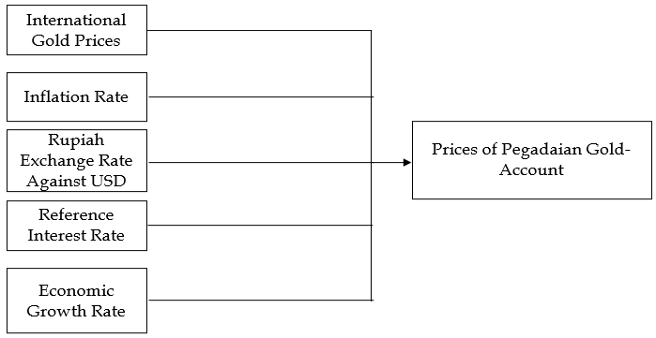

Figure 1. Theoretical Framework

With the following regression equation
Y = α + βX1 + βX2 + βX3 + β X4 + βX5
Y = Prices of Pegadaian Gold Account
X1 = Inflation Rates
X2 = Rupiah Exchange Rates against USD
X3 = Reference Interest Rates
X4 = Economic Growth Rates
X5 = International Prices of Gold
      - This research also aims to analyze the factors that BPKH must pay attention to when investing in gold and the gold instrument that is more recommended for BPKH between gold bullion and gold account, through a descriptive qualitative method using the ANP (Analytic Network Process) method.

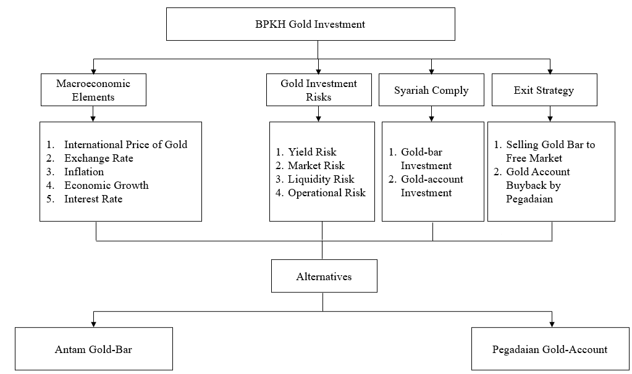
Source: Author’s Framework
Figure 2. Theoretical Framework of ANP

The hierarchical structure of the Analytical Network Process (ANP) in this research has Goal, Criteria, Sub-Criteria and Alternative Levels. At the Goal level, the aim of this research is to find out the recommended Gold Instruments for BPKH between Gold Bars or Gold Accounts. At the criteria level, the approach used is macroeconomic factors, gold investment risk, sharia compliance, and exit strategy. Meanwhile, the sub-criteria in the ANP hierarchical structure are criteria for each aspect as follows:
a. The Macroeconomic Aspect has criteria for international gold prices, exchange rates, inflation rates, economic growth rates, and reference interest rates.
b. The Risk Aspect consists of yield, market, liquidity and operational risks.
c. The Sharia Comply aspect includes sharia compliance in gold bullion instruments and gold account instruments.
d. The Exit Strategy aspect includes selling gold bullion to the free market and buying back gold accounts by PT Pegadaian.
The alternative level has two model options: gold bullion and gold account.
  - Hypothetical Development
According to Financial Services Authority (OJK), domestic gold price refers to the international gold price converted from United States (US) dollars into rupiah, so we developed the following hypothesis:
Hypothesis 1: International gold prices have a significant effect on the price of Pegadaian gold accounts.
The price of gold is also greatly influenced by the movement of the rupiah against the US dollar. If the rupiah exchange rate against the US dollar weakens, the local gold price will strengthen or rise. Conversely, if the rupiah exchange rate strengthens, local gold prices tend to fall (Financial Services Authority, 2019). Research by Cristy et al in 2014 found that the exchange rate variable had a significant positive influence on the price of gold. Meanwhile Erdoğdu (2017), Ibrahim et al (2014), and Sukri et al (2015) found that the exchange rate variable had a significant negative influence on the price of gold (Sunaryo, 2022). Based on the explanation above, we develop the following hypothesis:
Hypothesis 2: The Rupiah exchange rate against the USD has a significant effect on the price of gold accounts.

Inflation is one of the main factors that makes the prices of goods increase, this also has an impact on the price of gold. The higher the inflation rate, the more expensive the price of gold. This is because people are reluctant to save assets in the form of money which easily loses value and prefer to invest in gold whose prices tend to be more stable when inflation occurs. Because it is increasingly in demand, the price of gold will increase (Financial Services Authority, 2019). the inflation variable had a positive and significant effect on the price of gold (Wicaksono, 2016). The variables inflation, dollar exchange rate and BI rate simultaneously influence the price of gold. Based on this explanation, we developed the following hypothesis:
Hypothesis 3: The inflation rate has a significant effect on the price of gold accounts.
The price of gold really depends on the monetary policy taken by the United States central bank (Federal System or informally called The Fed). The monetary policy in question is the policy of increasing or decreasing interest rates. If the Fed lowers interest rates, gold has the potential to rise in price. Because the dollar has become unattractive as an investment option and people tend to put their money in gold (Financial Services Authority, 2019). Wicaksono's research results in 2016 also showed that the BI rate variable had a negative and significant effect on the price of gold. The variables inflation, dollar exchange rate and BI rate simultaneously influence the price of gold. Based on the explanation above, we develop the following hypothesis:
Hypothesis 4: The reference interest rate has a significant effect on the price of gold accounts.
According to OJK (2019), macroeconomic factors that influence gold price movements include global conditions. Various political, economic situations, crises, recessions or wars are one of the triggers for the rise and fall of gold prices. In unstable economic and political conditions, gold is often seen as a savior. That's why when a crisis or war occurs, usually the price of gold will soar. Before the Covid pandemic occurred, news of the increase in gold prices was caused by the trade war situation between the United States and China. This situation has encouraged global investors to flock to invest in safe assets, one of which is gold. When the situation begins to stabilize, safe haven assets will lack interest because investors' risk appetite will return to hunting for riskier assets. There are three reasons gold is chosen when the economy is uncertain or there is geopolitical turmoil. First, the value of gold is maintained even if inflation or deflation occurs. Second, the value of gold is maintained even if an economic crisis or war occurs. Third, demand for gold does not decrease along with limited gold availability. Based on the explanation above, we develop the following hypothesis:
Hypothesis 5: The level of economic growth has a significant effect on the price of gold accounts.

- Research Methodology
This research is a combination of quantitative methods via multiple linear regression analysis and qualitative methods via the ANP method.
- This research aims to analyze the influence of macroeconomic factors on price movements of Pegadaian gold accounts using the multiple linear regression analysis method. The variable that influences is called the independent (free) variable, and the variable that is influenced is called the dependent (bound) variable. This research consists of five independent variables, namely the international gold price, inflation rate, rupiah exchange rate against the USD, reference interest rate, and economic growth rate, while the dependent variable is the price of the Pegadaian Gold Account. The data used in quantitative analysis uses secondary data from various sources as follows:
Tabel 5. Data Sources
No | Data | Source
1 | Prices of Pegadaian Gold-Account Year 2017-2022 | - Direct from PT Pegadaian,  - Some of the data are downloaded from https://www.pegadaian.co.id/harga.
2 | Prices of Antam Gold-Bar Year 2017-2022 | pusatdata.kontan.co.id
3 | Harga Emas Internasional Year 2017-2022 | Historical prices of London Bullion Market Association (LBMA).
4 | - Rupiah Exchange Rate Against USD  - Inflation Rate  - Reference Interest Rate  - Economic Growth Rate  Year 2017-2022 | - www.bi.go.id  - www.bps.go.id

- This research also aims to analyze the factors that BPKH must pay attention to when investing in gold and the gold instruments that are more recommended for BPKH, including gold bullion instruments and gold accounts, through a descriptive qualitative method using the ANP (Analytic Network Process) method. Data collection for qualitative analysis using the ANP method is carried out in the following three steps:
- Conduct in-depth interviews with experts, practitioners and regulators to understand existing problems related to gold investment at BPKH.
- The results of the interviews are used to create questionnaires needed to collect data from respondents.
- Finally, ANP analysis is used to analyze problems, solutions and strategies for implementing gold investment policies at BPKH.

In ANP analysis the number of respondents is not used as a benchmark for validity. The condition for valid respondents in ANP is that they are people who are masters or experts in their field (Rifka, 2016:5). The population and sample in this study were ten (10) people who were considered to have the most comprehensive understanding of gold investment at BPKH, namely as follows:
Table 6. List of Respondents in Research
No | Respondents
1 | Member of the Executive Board BPKH with more than 20 years of experience
2 | Deputy of Securities & Gold Investment BPKH with more than 20 years of experience
3 | Investment & Bank Placement Committee Member BPKH with more than 20 years of experience
4 | Head of IBES Division DSN MUI with more than 15 years of experience
5 | Secretary of DSN MUI Institute with more than 15 years of experience
6 | Head of Division PT Pegadaian with more than 20 years of experience
7 | Head of Division PT Pegadaian Galeri 24 with more than 15 years of experience
8 | Lecturer of Universitas Esa Unggul with more than 25 years of experience
9 | Risk and Compliance Manager of PT Gemilang Hartadinata Abadi with more than 10 years of experience
10 | Co-Founder PasaRDana with more than 15 years of experience

- Result & Discussion
D.1 Classic Test
A classic test has been carried out on the regression model: Influence of international gold price, exchange rate, inflation rate, interest rate, and economic growth rate on the price of Pegadaian gold-account.
Tabel 7. The Result of Classic Test
Test
Normality | Multicollinearity | Heteroscedasticity | Autocorrelation
$$√$$ | $$√$$ | $$√$$ | $$√$$

From the classic test results, it can be concluded that the model of the influence of macroeconomic factors on the price of Pegadaian gold accounts has passed four classical tests, hence it can be used for multiple linear regression tests.

D.2 Multiple Linear Regression Analysis
To answer objective number 1, namely how macroeconomic factors influence gold account price movements, multiple linear regression analysis has been carried out with the following results:

Tabel 8. Descriptive Statistics
 | Mean | Std. Deviation | N
Gold account | 752522.24 | 144991.964 | 72
Inflation | 2.9729 | 1.12957 | 72
Exchange rate | 14280.5 | 627.291 | 72
Interest rate | 4.5104 | 0.85109 | 72
Economy growth | 2.76 | 3.83865 | 72
International gold price | 49.7715 | 8.37948 | 72

  - Descriptive Statistics explains that the sample size is 72, the average Pegadaian gold account is 752522.24 with a standard deviation of 144991.964.
  - The independent variable average and standard deviation are in accordance with the information in the table above.

Tabel 9. Correlations between Macroeconomic Factors and the Price of Gold Account

 |  | Gold Account | Inflation | Exchange rate | Interest rate | Economy growth | International gold price
Pearson Correlation | Gold account | 1.000 | -.350 | -.617 | -.641 | -.593 | .981
 | Inflation | -.350 | 1.000 | .066 | .366 | .703 | -.411
 | Exchange rate | .617 | .066 | 1.000 | -.160 | -.198 | .479
 | Interest rate | -.641 | .366 | -.016 | 1.000 | .484 | -.717
 | Economy growth | -.593 | .703 | -.198 | .484 | 1.000 | -.602
 | International gold price | .981 | -.411 | .479 | -.717 | -.602 | 1.000
Sig. (1- tailed) | Gold account | .000 | .001 | < .001 | < .001 | < .001 | < .001
 | Inflation | .001 | .000 | .292 | .001 | .000 | .000
 | Exchange rate | .000 | .292 | .000 | .449 | .048 | .000
 | Interest rate | .000 | .001 | .449 | .000 | .000 | .000
 | Economy growth | .000 | .000 | .048 |  | .000 | .000
 | International gold price | .000 | .000 | .000 | .000 | .000 | .000
N | Gold account | 72 | 72 | 72 | 72 | 72 | 72
 | Inflation | 72 | 72 | 72 | 72 | 72 | 72
 | Exchange rate | 72 | 72 | 72 | 72 | 72 | 72
 | Interest rate | 72 | 72 | 72 | 72 | 72 | 72
 | Economy growth | 72 | 72 | 72 | 72 | 72 | 72
 | International gold price | 72 | 72 | 72 | 72 | 72 | 72
  - Sig value (1-tailed) for all independent variables < alpha 0.05
  - The magnitude of the respective correlation coefficients is:
X1 = -.350 means that the inflation rate has a negative correlation with the Pegadaian gold account. This result is not in line with the findings of Wicaksono's research in 2016, where it was stated that inflation had a positive influence on the price of gold in Indonesia. This research advises investors to sell their gold holdings when inflation increases, this is because increasing inflation in Indonesia will push the price of gold up. The negative correlation between the inflation variable and the price of Pegadaian gold accounts can be explained because in the research period from 2017 to 2022 there was a Covid pandemic in 2020 to 2022. In the research period there was a decline in the inflation rate until the beginning of 2022, which was caused by the pandemic which caused a decrease in purchasing power. public. Meanwhile, in the same period, the price of gold as a safe-haven asset experienced a significant spike, so the results show that inflation has a negative correlation with Pegadaian gold accounts.
X2 = 0.617, meaning that the Rupiah exchange rate against USD has a positive correlation with the Pegadaian gold account. These results are in line with research by Kesarditama, Haryadi, and Vyn Amzar in 2020 which stated that the Rupiah exchange rate against the USD showed a positive and significant influence on the price of gold in Indonesia.
X3 = -.641, meaning that the reference interest rate has a negative correlation with the Pegadaian gold account. One of the functions of reference interest for banks and financial institutions is to determine loan interest and deposit interest. This is in accordance with the theory which states that the reference interest rate will usually reduce demand for gold and will cause gold prices to tend to fall, both buying and selling prices. The trend of weakening gold prices as a result of rising interest rates is because people tend to switch to other forms of investment (logammulia.com).
X4 = -0.593, meaning that the level of economic growth has a negative correlation with Pegadaian gold accounts. In theory, gold can be used as a hedge to prevent economic events such as inflation or currency depreciation (Witjaksono et al, 2022). A number of studies have examined the effectiveness of gold as a safe-haven and hedging instrument in financial markets, where gold has been proven to act as a hedging shield. This means that in theory the level of economic growth is negatively correlated with the price of gold. In the event that an event occurs that causes uncertainty and negative economic growth, the performance of gold prices will be better. In the research period from 2017 to 2022, the Covid pandemic occurred in 2020 to 2022. During the pandemic, negative economic growth occurred, while the price of gold as a safe-haven asset experienced a significant spike, in accordance with the results of the analysis which showed that economic growth had a negative correlation with gold accounts. Pawnshop.
X5 = 0.981 means that the International Gold Price (LBMA) has a positive correlation with a Pegadaian gold account, this is a necessity because the price of domestic gold refers to the price of foreign gold expressed in rupiah (Bareksa.co).

Tabel 10. Variables Entered/Removed
Variables Entered/Removedª
Model | Variables Entered | Variables Removed | Method
1 | International gold price, Inflation, Exchange rate, Economy growth, Interest rate^{b} |  | Enter
a. Dependent Variable: Gold account
b. All requested variables entered.

  - The Dependent Variable is the price of Pegadaian gold-account.
  - The Independent Variables are the international price of gold, exchange rate, inflation rate, economic growth rate and interest rate.

Tabel 11. Model Summary
Model Summary^{b}
Model | R | R Square | Adjusted R Square | Std. Error of the Estimate
1 | .996ª | .992 | .991 | 13725.014
a. Predictors: (Constant), International gold price, Inflation, Exchange rate, Economy growth, Interest rate
b. Dependent Variable: Gold account

  - R-Square is the Determination Coefficient which is used to measure the ability of the independent variable to explain variations in the dependent variable. For multiple regression, it is best to use Adjusted R Square.
  - All independent variables can explain 99.1% of the variation in gold accounts, while the remaining 0.9% is explained by other variables that were not studied.

Tabel 12. Anova
Model |  | Sum of Squares | df | Mean Square | F | Sig.
1 | Regression | 1.48E+12 | 5 | 2.96E+11 | 1571.513 | <,001^{b}
 | Residual | 12432815863 | 66 | 188375997.92
 | Total | 1.49E+12 | 71
a. Dependent Variable: Gold account
b. Predictors: (Constant), International gold price, Inflation, Exchange rate, Economy growth, Interest rate

Significance value <0.05, all constants (independent variables) together influence the price of gold accounts. This result is used for the Simultaneous Influence Test (F Value Test) in multiple regression tests or tests with more than one independent variable.

Tabel 13. Coefficients
Coefficientsª
Model |  | Unstandardized Coefficients |  | Standardized Coefficients Beta | t | Sig.
 |  | B | Std. Error
1 | Constant | -623091.532 | 39191.887 |  | -15.898 | <.001
 | Inflation | 4359.969 | 2155.256 | .034 | 2.023 | .047
 | Exchange rate | 42.650 | 3.729 | .185 | 11.438 | <.001
 | Interest rate | 779.421 | 3275.145 | .005 | .238 | .813
 | Economy growth | -2031.065 | 688.450 | -.054 | -2.950 | .004
 | International gold price | 15183.092 | 412.390 | .877 | 36.817 | <.001
a. Dependent Variable: Gold account

Tabel 14. Summary of Multiple Regression Analysis Results of the Influence of Macroeconomic Factors on the Price of Gold Accounts
No | Variables | Correlation | Impact
1 | International Price of Gold | Positive | Significant
2 | Rupiah Exchange Rate against USD | Positive | Significant
3 | Inflation Rate | Negative | Significant
4 | Reference Interest Rate | Negative | Unsignificant
5 | Economic Growth Rate | Negative | Significant

The variables of international gold prices and the Rupiah exchange rate against the USD are positively correlated, while the variables of inflation rate, reference interest rate and economic growth rate are negatively correlated with the price of Pegadaian gold accounts.
The results of the regression analysis of the international gold price variable which has a significant and positive effect on gold accounts are in line with theory because the domestic gold price is actually used to describe the foreign gold price expressed in rupiah. Spot price and fixed price are two global gold price parameters that are generally used in the market. London is the main center of world gold trading where the gold price is set every day at 10.30 GMT (London Gold AM Fix) and again at 15.00 GMT (London Gold PM Fix). LBMA sets the Gold Fix price (https://www.bareksa.com/).
The results of the regression analysis show that the variable Rupiah exchange rate against USD has a significant influence and positive correlation on Pegadaian's gold account. This result is in line with research by Kesarditama, Haryadi, and Vyn Amzar in 2020 which states that the Rupiah exchange rate against USD shows a positive and significant influence on gold prices in Indonesia. According to the official Precious Metals website, basically the prices of gold and the United States dollar do have a negative or opposite correlation. When the American Central Bank issues a policy regarding interest rates that strengthens the dollar currency, the world gold price, including local gold, will automatically decrease. Conversely, if the price of the United States dollar weakens and the rupiah strengthens, the price of gold will soar (https://www.logammulia.com/).
The results of the regression analysis of the inflation variable are also in line with the findings of Wicaksono's research in 2016, where it was stated that inflation had a significant impact on the price of gold in Indonesia. This research advises investors to sell their gold holdings when inflation increases, this is because increasing inflation in Indonesia will push the price of gold up. Gold can be used as a hedge to prevent economic events such as inflation or currency depreciation (Witjaksono et al., 2022).
The results of the regression analysis of the economic growth rate variable are also in line with a number of studies which state the effectiveness of gold as a safe-haven and hedging instrument in the financial market. In theory, the level of economic growth is negatively correlated with the price of gold, where if an event occurs that causes uncertainty and negative economic growth, the performance of the gold price will be better. The research period was carried out from 2017 to 2022, during which the Covid pandemic occurred from 2020 to 2022. During the pandemic there was negative economic growth while the price of gold as a safe haven asset experienced a significant spike, so the analysis results show that the level of economic growth had a significant impact. significant with a negative correlation to the price of Pegadaian gold accounts.

Meanwhile, regression analysis shows that Pegadaian gold accounts are not affected by interest rate variables. One theory that supports the results of this research is Lawrence's empirical study in 2003 which stated that interest rates were not related to the price of gold (Sabilawa, 2019).
D.3 ANP Result Analysis
The results of the ANP analysis process show that the combined assessment of criteria, sub-criteria and alternatives made by respondents regarding the structure has a good level of consistency. Furthermore, this assessment produces an assessment of each element, as well as creating an overview of the priorities for each element.
Tabel 15. Result of Analytic Network Process Data Processing
Criterias | Weight | Rank | W
1. Makro Economics | 0.35 | 1 | 0.000
2. Risk | 0.24 | 3
3. Sharia-Comply | 0.25 | 2
4. Exit Strategy | 0.16 | 4
Macro economic
1. Exchange Rates | 0.25 | 1 | 0.000
2. Inflation | 0.19 | 2
3. Interest Rates | 0.17 | 3
4. Economic Growth | 0.18 | 3
5. International Gold Price | 0.19 | 3
Risk
1. Yield | 0.26 | 2 | 0.373
2. Market | 0.29 | 1
3. Liquidity | 0.26 | 3
4. Operational | 0.18 | 4
Sharia-Comply
1. Gold-bar investment | 0.53 | 1 | 0.000
2. Gold-account investment | 0.47 | 2
Exit Strategy
1. Gold Bullion selling to free market | 0.45 | 2 | 0.000
2. Gold-account buyback | 0.55 | 1
Alternatives
1. Gold-bar investment | 0.48 | 2 | 0.000
2. Gold-account investment | 0.54 | 1
Source : Processed data (2023)

Analysis has been carried out on the ANP questionnaire to answer questions number 2 and 3, namely what factors must be considered by BPKH when investing in gold, and which gold instrument is more recommended for BPKH between gold-bar and gold-account. The questions in the ANP questionnaire are in the form of a tabular questionnaire. In the process of inputting data into the software, the table questionnaire is converted into a pairwise comparison (pairwise comparison) by comparing at the element level to find out which influence has more importance, and how big the influence is (on a scale of 1-9). The numerical scale 1-9 is used as a translation of the verbal assessment as in the following table.
Table 16. Comparison of Verbal Scale and Numerical Scale
Verbal Rating Scale | Numeric Scale
Highly important/ relevant/influential | 9
 | 8
Very important/ relevant/influential | 7
 | 6
Important/ relevant/influential | 5
 | 4
Less important/ relevant/influential | 3
 | 2
Not important/ relevant/influential | 1

Table 17. The Priority Factors in Gold Investment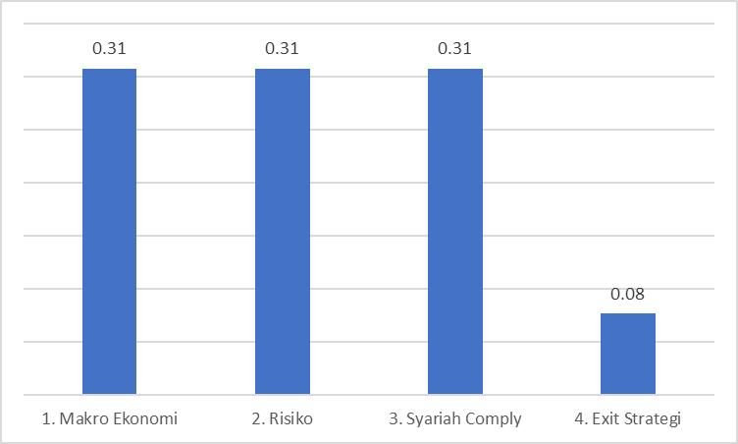

The results of the ANP questionnaire data processing show that BPKH needs to pay attention to several factors in investing in gold, namely macroeconomic factors, risk factors, and sharia compliance factors. All three have the same weight of 31%, while the exit strategy is the last priority with a weight of 7%.

Table 18. Macroeconomic Factors that Influence Gold Investment
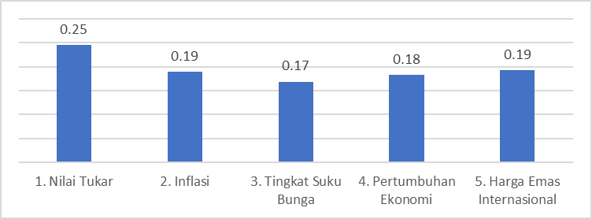

The results of the ANP questionnaire show the respondents' opinions on the macroeconomic factors that influence gold price movements, as follows:
  - The exchange rate is seen as the macroeconomic factor that most influencing in gold price movements with a weight of 25%.
  - International gold prices and inflation rate are considered as the next factors that most influencing in gold price movements with a weight of 19% each.
  - Economic growth rate and interest rate are seen as the least influencing macroeconomic factors in gold price movements with a weight of 19% and 17%.
This finding supports the results of the regression analysis that was carried out previously, where it is known that the exchange rate, international gold price, inflation rate and economic growth rate have significant effect on the movement of Pegadaian gold account price, while the interest rate variable does not have a significant effect on the movement of Pegadaian gold account price.
Table 19. Risk in Gold Investment
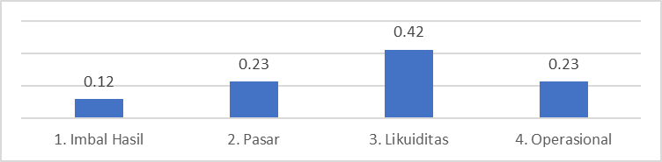

Regarding the risk aspect of gold investment, respondents believe that liquidity risk is the main risk that must be paid the most attention with a weight of 42%. With the volatile nature of gold prices, a gold portfolio composition that is too large poses a risk to the liquidity of hajj fund. Liquidity risk as stated in POJK number 18/POJK.03/2016 concerning the Implementation of Risk Management for Shareholders occurs when a bank fails to fulfill its maturing obligations with assets that can be used as collateral or sources of cash flow funding. This can disrupt the bank's activities and financial conditions for trading. Government Regulation Number 5 of 2018 concerning Implementation of Law Number 34 concerning Hajj Financial Management has actually reduced the liquidity risk related to gold investment for BPKH by limiting gold investment to 5% of the total investment and placement of Hajj Financing.
Furthermore, operational risk and market risk both have a weight of 23%. The last sequence is the risk of return which has a weight of 12%. BPKH’s investment in Pegadaian gold account is a mitigation of operational risk since the physical gold bar is stored by PT Pegadaian. PT Pegadaian is a State-Owned Enterprise which have 122 years old experience in managing transactions and storing gold. Pegadaian uses the principles of Good Corporate Governance (GCG) which support the values of justice, independence, responsibility, accountability and transparency in managing its company (pegadaian.co.id). Investing in physical gold bullion is considered to have a bigger operational risk. Market risk and return risk can be mitigated by paying attention to price movements to determine the best timing for investing in gold. In 2023, BPKH has divested Pegadaian gold accounts with a return of 12% within a period of ± 1 year (BPKH, 2023).
Table 20. Syariah Compliance in Gold Investment
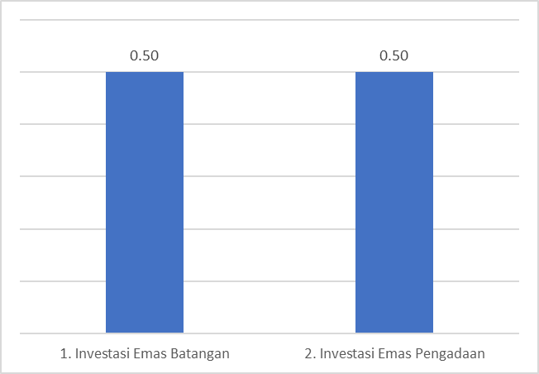

The dimension of sharia compliance is considered equally important in both gold bullion instruments and Pegadaian gold accounts where both sub-criteria have the same weight, namely 50%. Sharia compliance in gold bullion investment is met with the following conditions:
  - Only done in cash, scholars agree that a trade is considered usury if it is not carried out in cash.
  - If a non-cash transaction occurs, it must comply with or comply with the National Sharia Council Fatwa Number 77/DSN-MUI/V/2010 concerning Non-Cash Gold Buying and Selling.
Meanwhile, BPKH's investment in the Pegadaian Gold Account has fulfilled sharia compliance because the Pegadaian Gold Savings product has received endorsement from the PT Pegadaian Sharia Supervisory Board (Pegadaian.co.id).
Table 21. Exit Strategy in Gold Investment
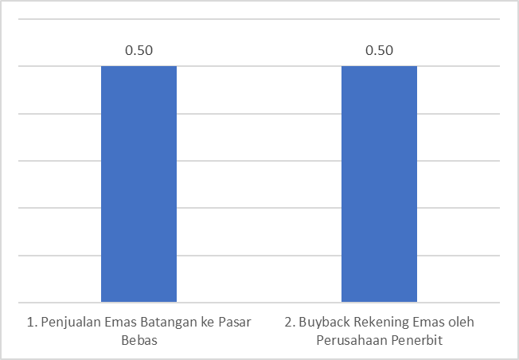

Similar to the sharia compliance factor, the exit strategy in the form of selling gold bullion to the free market and gold accounts buyback policy by the issuing company has the same weight, namely 50%. This shows that respondents believe that sharia compliance and exit strategies must still be fulfilled when investing in gold, either through gold bullion or gold accounts instruments. Exit strategy in gold-bullion investment is done by selling the goldbar, while exit strategy in gold-account investment is carried out in the following way:
      - Printing the goldbar with a choices of size from 1 up to 100 grams (pegadaian.co.id).
      - Gold-account buyback by Pegadaian. Both Pegadaian physical stores and the Pegadaian Digital Application are available for use in making buyback transactions (https://www.pegadaian.co.id/produk/tabungan-emas#).

As many as 90% of respondents recommend gold accounts with the following considerations:
        - Mitigating operational risks in the form of counterfeiting and loss of physical gold. Physical storage of gold is carried out by BPKH Investment Partners, in this case Pegadaian.
        - It is more liquid because it has an exit strategy in the form of a buyback policy or Pegadaian acts as a standby buyer who is ready to buy BPKH gold if it wants to be sold.
Meanwhile, 10% of respondents preferred gold bullion instruments with clearer sharia contract considerations. The investment made by BPKH in Pegadaian Gold-Accounts are in accordance with the recommendations of the majority of ANP respondents consisting of BPKH officials, DSN-MUI, Pegadaian officials, academics and practitioners.

Conclusions & Policy Recommendation
The conclusions of this research are as follows:
- The results of multiple linear regression analysis answer the first problem, namely how macroeconomic factors influence the price movement of Pegadaian gold accounts. The results of the analysis show that the international gold price variables, the Rupiah exchange rate against USD, the inflation rate, and the economic growth rate have a significant effect on the price of Pegadaian gold accounts. Meanwhile, the reference interest rate does not have a significant effect on the price of Pegadaian gold accounts. The variables of international gold prices and the Rupiah exchange rate against the USD have a positive correlation, while the variables of the inflation rate, reference interest rate and economic growth rate have a negative correlation with the price of Pegadaian gold accounts. The results of the ANP questionnaire analysis confirmed the results of the multiple linear regression analysis, stating that the international gold price, the Rupiah exchange rate against the USD, and the inflation rate were the three main macroeconomic factors that influenced gold price movements. With a weight of 25%, the exchange rate variable is considered to have the most influence on changes in gold prices. The international gold price variable and the inflation rate are seen as the next variables that influence changes in gold prices with a weight of 19% each. The level of economic growth and interest rates are in last place with a weight of 18% and 17% respectively.
- The second objective in the research to analyze the factors BPKH must pay attention to when investing in gold, was answered through the results of the ANP questionnaire data processing, which shows that BPKH needs to pay attention to several factors in investing in gold, namely: macroeconomic factors, risk factors, and sharia compliance. All three have the same weight of 31%, while exit strategy is the last priority with a weight of 7%.

- The third objective in the research to analyze which gold investment instrument is more recommended for BPKH, was answered through the ANP analysis which showed that 90% respondents of the ANP questionnaire recommended Pegadaian gold account as a better investment instrument for BPKH with consideration of operational risk mitigation as well as considered more liquid because of the buyback policy. Meanwhile, 10% respondents of the ANP questionnaire preferred gold bullion instrument with clearer sharia contract considerations.
The policy recommendation of this research include the following:
- In order to diversify as well as to maintain asset value when unstable economic conditions occur, BPKH should increase the gold investment portfolio with maximum limit is 5% of the total investment and/or bank placement of hajj fund.
- When investing in gold, BPKH should pay attention to the movements in macroeconomic factors, namely international gold prices, exchange rates, inflation rate and economic growth rates. BPKH must also pay attention to risk factors and sharia comply of the gold instrument.
- Apart from the efforts to increase the financial benefits of hajj fund through optimizing gold investment, the percentage of cost paid by pilgrims also plays an important role in supporting the sustainability of hajj fund. In this case, the percentage of hajj cost paid by pilgrims should be adjusted rationally.
- Total hajj cost is also a crucial aspect, especially in the main components such as flight costs, hotels and catering. The efficiency of these components can be strived by collaborating with airlines or aviation fuel providers, purchasing hotels/ apartments in Mecca and/or Medina, and establishing catering factories for Indonesian hajj pilgrims. The initiation of these investment can be explored conjointly with the Ministry of Religion as the organizer of Indonesian Hajj pilgrimage.

REFERENCES
Abilawa, MS (2019). Kajian Kelayakan Investasi Emas Batangan. Laporan Hasil Kajian dari PT Prediksi Dinamika Indonesia kepada BPKH, Jakarta.
Billah, N.A., dan Hartomo, D.D. (2018), Korelasi Dinamis Emas dan Saham Syariah sebagai Lindung Nilai dan Safe Haven pada Investasi di Indonesia. Jurnal Bisnis & Manajemen, Vol. 18, No. 2, 2018 : 67-86. Fakultas Ekonomi dan Bisnis Universitas Sebelas Maret Surakarta.
Bpkh.go.id/laporan-keuangan-bpkh/.
Budiman, M. A, & Kusuma, D. B. W. (2016). Analisis Faktor yang Mempengaruhi Biaya Penyelenggaraan Ibadah Haji di Indonesia. Jurnal Hukum Islam, Vol.14, Number 1.
Chirwa, T. G., & Odhiambo, N. M. (2020). Determinants of gold price movements: An empirical investigation in the presence of multiple structural breaks. Resources Policy, 69. https://doi.org/10.1016/j.resourpol.2020.101818
DSN MUI Nomor 77/DSN-MUI/VI/2010.
⁠Gangopadhyay, K., Jangir, A., & Sensarma, R. (2016). Forecasting the price of gold: An error correction approach. IIMB Management Review, 28(1). https://doi.org/10.1016/j.iimb.2015.11.001
Gold Investor: Risk Management and Capital Preservation (3rd edition, 2013). World Gold Council, London, UK.
Gunawan, Indra. (2023), Tantangan Kinerja, Tatakelola dan Sinergi serta Inovasi Investasi Dana Haji Menuju Kemaslahatan yang Berkesinambungan, diambil 20 Oktober 2023 dari https://bpkh.go.id/tantangan-kinerja-tatakelola-dan-peluang-sinergi-bpkh-sinergi-dan-inovasi-investasi-dana-haji-menuju-kemaslahatan-yang-berkesinambungan/.
Halim, Abdul. (2005). Analisis Investasi. Edisi Kedua. Jakarta: Salemba Empat. Hal. 12.
Hartono, Jogiyanto. (2013). Teori Portofolio dan Analisis Investasi. Edisi Ketujuh. Yogyakarta: BPFE-Yogyakarta. Hal. 22.
Haryono, Sidiq dan Busneti, Ida (2022). Analisis Portofolio Investasi BPKH untuk Menjaga Sustainability Keuangan Haji. Syntax Literate: Jurnal Ilmiah Indonesia Vol. 7 No. 11.
Herlianto, Didit. (2013). Manajemen Investasi Plus Jurus Mendeteksi Investasi Bodong. Gosyen Publishing, Yogyakarta. Hal. 45.
Hidayati, Arina (2018). Fluktuasi Biaya Haji dalam Perspektif Investasi Syariah. Thesis Master Fakultas Ekonomi dan Bisnis Islam, Institut Agama Islam Negeri Ponorogo.
Johari, Muhamad (2017). Investasi Emas; Alternatif Berinvestasi di Tengah Krisis Global, Tafaqquh. Jurnal Hukum Ekonomi Syariah dan Ahwal Syahsiyah, Vol. 2 No. 2 (2017): Desember.
Junaedi, D., Arsyad, M. R., dan Aurijah, S. C. (2021), Optimalisasi Investasi Dana Haji Era Pandemi Covid-19. Al-Kharaj : Jurnal Ekonomi, Keuangan & Bisnis Syariah: Volume 3 No 1 (2021) 1-16.
Padliansyah, R., Juliana, A., dan Hasiara, La Ode (2020). Hubungan Interaktif antara Harga Logam Mulia dan Jakarta Islamic Stock Index. Moneter: Jurnal Akuntansi dan Keuangan, Volume 7 No. 1 April 2020.
PEBS FEB UI (2021). Laporan Penelitian: Metode Penentuan Harga dan Aspek Akunting dalam Investasi Emas.
Pegadaian.co.id
Peraturan Badan Pengelola Keuangan Haji Nomor 10 Tahun 2020 tentang Tata Cara dan Bentuk Investasi Surat Berharga dan Emas.
Peraturan Pemerintah Nomor 5 Tahun 2018 tentang Pelaksanaan Undang-Undang Nomor 34 Tahun 2014 tentang Pengelolaan Keuangan Haji.
Prasetyo, Wibowo (2023), Ada BPIH, Bipih, dan Nilai Manfaat, Berapa yang Dibayar Jemaah Haji? diakses pada 1 Desember 2023 dari https://kemenag.go.id/nasional/ada-bpih-bipih-dan-nilai-manfaat-berapa-yang-dibayar-jemaah-haji-pemDS.
Qian, Yao & Ralescu, Dan & Zhang, Bo. (2019). The analysis of factors affecting global gold price. Resources Policy. 64. 101478. 10.1016/j.resourpol.2019.101478.
Sholeh, Mohammad (2014). Emas sebagai Instrumen Investasi yang Aman pada saat Instrumen Investasi Keuangan Lain Mengalami Peningkatan Resiko. Jurnal Mahasiswa Universitas Negeri Surabaya.
⁠Sunaryo, 2022, Determinan Harga Emas (Studi Kasus Pada PT Aneka Tambang, Tbk. Periode Tahun 2010 - 2019), Jurnal Ekonomi dan Bisnis Kinerja Vol. 5 No. 1. DOI: 10.34005/kinerja.v5i01.2126
Undang-Undang Nomor 34 Tahun 2014 tentang Pengelolaan Keuangan Haji.
Wahyuni, Asri Nur (2014), Analisis Perbandingan Kinerja Investasi Emas dan Investasi Saham selama Masa Inflasi 1994 – 2013. Jurnal Bisnis Strategi, Vol. 23 No. 2 Des. 2014.
Wicaksono, Mochammad Yusuf (2016). Pengaruh Inflasi, Kurs Dollar dan Suku Bunga terhadap Harga Emas di Indonesia. Jurnal Pendidikan dan Ekonomi. Volume 5 Nomor 2 Tahun 2016.
Witjaksono, Beny dkk. (2022). Investasi Emas BPKH. Badan Pengelola Keuangan Haji, Jakarta. Hal. 34-35.
Zhang, H., Demirer, R., Huang, J., Huang, W., & Tahir Suleman, M. (2021). Economic policy uncertainty and gold return dynamics: Evidence from high-frequency data. Resources Policy, 72. https://doi.org/10.1016/j.resourpol.2021.102078

