OUTPUT SPSS UJI LINIERITAS, UJI REGRESI BERGANDA (KONTRIBUSI SIGNIFIKAN HANYA CC & PC) & UJI REGRESI SATU-SATU (SIGNIFIKAN HANYA IC DENGAN MODEL REGRESI NON LINIER KUADRATIK)

GET
FILE='/Volumes/EAD/The Researces I Did/2020 - Social Network Analysis personalitas adaptasi psikologis dan penerimaan perbedaan budaya/2020 - Social Network Analysis penerimaan kebhinekaan kultural/Uji SPSS v2/SPSS v2.sav'.
DATASET NAME DataSet2 WINDOW=FRONT.
MEANS TABLES=Adaptasi_Psikologis BY CC BC EVC IC PC
/CELLS=MEAN COUNT STDDEV
/STATISTICS LINEARITY.

Means

Notes
Output Created |  | 15-APR-2020 13:37:26
Comments
Input | Data | /Volumes/EAD/The Researces I Did/2020 - Social Network Analysis personalitas adaptasi psikologis dan penerimaan perbedaan budaya/2020 - Social Network Analysis penerimaan kebhinekaan kultural/Uji SPSS v2/SPSS v2.sav
Input | Active Dataset | DataSet2
Input | Filter | <none>
Input | Weight | <none>
Input | Split File | <none>
Input | N of Rows in Working Data File | 47
Missing Value Handling | Definition of Missing | For each dependent variable in a table, user-defined missing values for the dependent and all grouping variables are treated as missing.
Missing Value Handling | Cases Used | Cases used for each table have no missing values in any independent variable, and not all dependent variables have missing values.
Syntax |  | MEANS TABLES=Adaptasi_Psikologis BY CC BC EVC IC PC  /CELLS=MEAN COUNT STDDEV  /STATISTICS LINEARITY.
Resources | Processor Time | 00:00:00.03
Resources | Elapsed Time | 00:00:00.00

[DataSet2] /Volumes/EAD/The Researces I Did/2020 - Social Network Analysis personalitas adaptasi psikologis dan penerimaan perbedaan budaya/2020 - Social Network Analysis penerimaan kebhinekaan kultural/Uji SPSS v2/SPSS v2.sav

Case Processing Summary
 | Cases
 | Included |  | Excluded |  | Total
 | N | Percent | N | Percent | N | Percent
Adaptasi Psikologis * Closeness Centrality | 47 | 100.0% | 0 | 0.0% | 47 | 100.0%
Adaptasi Psikologis * Betweenness Centrality | 47 | 100.0% | 0 | 0.0% | 47 | 100.0%
Adaptasi Psikologis * Eigenvector Centrality | 47 | 100.0% | 0 | 0.0% | 47 | 100.0%
Adaptasi Psikologis * Information Centrality | 47 | 100.0% | 0 | 0.0% | 47 | 100.0%
Adaptasi Psikologis * Power Centrality | 47 | 100.0% | 0 | 0.0% | 47 | 100.0%

Adaptasi Psikologis * Closeness Centrality

Report
Adaptasi Psikologis
Closeness Centrality | Mean | N | Std. Deviation
.0054640 | 34.00 | 2 | .000
.0056820 | 38.00 | 1 | .
.0057470 | 46.50 | 2 | .707
.0058140 | 36.00 | 1 | .
.0060610 | 38.00 | 2 | 9.899
.0061350 | 42.00 | 1 | .
.0062500 | 26.00 | 1 | .
.0064520 | 46.50 | 2 | 12.021
.0064940 | 38.00 | 1 | .
.0066230 | 38.00 | 1 | .
.0067570 | 49.00 | 1 | .
.0071430 | 36.00 | 1 | .
.0073530 | 48.00 | 1 | .
.0074070 | 42.00 | 1 | .
.0075190 | 39.00 | 2 | 9.899
.0079370 | 35.00 | 1 | .
.0081300 | 43.00 | 1 | .
.0084030 | 43.00 | 3 | 5.568
.0085470 | 34.50 | 2 | 4.950
.0086960 | 26.00 | 2 | 2.828
.0088500 | 28.00 | 1 | .
.0090910 | 33.00 | 1 | .
.0263160 | 42.00 | 5 | 6.083
.0344830 | 45.00 | 1 | .
.0625000 | 41.50 | 2 | 17.678
.0666670 | 44.00 | 1 | .
.0714290 | 42.25 | 4 | 9.912
.0769230 | 34.33 | 3 | 5.132
Total | 39.23 | 47 | 7.730

ANOVA Table
 |  |  | Sum of Squares | df | Mean Square | F | Sig.
Adaptasi Psikologis * Closeness Centrality | Between Groups | (Combined) | 1505.009 | 27 | 55.741 | .852 | .656
Adaptasi Psikologis * Closeness Centrality | Between Groups | Linearity | 13.195 | 1 | 13.195 | .202 | .658
Adaptasi Psikologis * Closeness Centrality | Between Groups | Deviation from Linearity | 1491.814 | 26 | 57.377 | .877 | .629
Adaptasi Psikologis * Closeness Centrality | Within Groups |  | 1243.417 | 19 | 65.443
Adaptasi Psikologis * Closeness Centrality | Total |  | 2748.426 | 46

Measures of Association
 | R | R Squared | Eta | Eta Squared
Adaptasi Psikologis * Closeness Centrality | .069 | .005 | .740 | .548

Adaptasi Psikologis * Betweenness Centrality

Report
Adaptasi Psikologis
Betweenness Centrality | Mean | N | Std. Deviation
.0000000 | 32.00 | 1 | .
2.1666670 | 26.00 | 1 | .
3.0568180 | 45.00 | 3 | 5.292
4.0166670 | 36.00 | 1 | .
7.7285710 | 47.00 | 1 | .
9.2578880 | 29.00 | 1 | .
13.4095240 | 30.00 | 1 | .
13.6773810 | 33.00 | 1 | .
14.2000000 | 28.00 | 1 | .
15.4583330 | 34.00 | 1 | .
16.4219700 | 41.00 | 1 | .
17.7412210 | 54.00 | 1 | .
19.4838820 | 46.00 | 1 | .
20.2239560 | 29.00 | 1 | .
21.1416670 | 34.00 | 1 | .
25.1761900 | 38.00 | 1 | .
31.0805560 | 41.00 | 1 | .
31.2755920 | 44.00 | 1 | .
32.0484130 | 33.00 | 1 | .
34.0005490 | 42.00 | 1 | .
40.5330090 | 36.00 | 1 | .
44.2480230 | 31.00 | 1 | .
44.5095240 | 38.00 | 1 | .
46.5057150 | 45.00 | 1 | .
49.7096680 | 34.00 | 1 | .
50.4000000 | 28.00 | 1 | .
51.3136080 | 42.00 | 1 | .
52.6102690 | 44.00 | 1 | .
61.0488100 | 55.00 | 1 | .
62.7564210 | 37.00 | 1 | .
64.5916670 | 40.00 | 1 | .
82.2277560 | 38.00 | 1 | .
87.5991210 | 38.00 | 1 | .
102.4791640 | 43.00 | 1 | .
135.5815660 | 47.00 | 1 | .
136.3556660 | 49.00 | 1 | .
139.2992060 | 24.00 | 1 | .
141.2190480 | 31.00 | 1 | .
152.3426240 | 46.00 | 1 | .
163.2873000 | 38.00 | 1 | .
179.8217170 | 45.00 | 1 | .
191.9263920 | 52.00 | 1 | .
202.9828730 | 48.00 | 1 | .
217.9560440 | 35.00 | 1 | .
394.0153300 | 48.00 | 1 | .
Total | 39.23 | 47 | 7.730

ANOVA Table
 |  |  | Sum of Squares | df | Mean Square | F | Sig.
Adaptasi Psikologis * Betweenness Centrality | Between Groups | (Combined) | 2692.426 | 44 | 61.191 | 2.185 | .364
Adaptasi Psikologis * Betweenness Centrality | Between Groups | Linearity | 215.367 | 1 | 215.367 | 7.692 | .109
Adaptasi Psikologis * Betweenness Centrality | Between Groups | Deviation from Linearity | 2477.059 | 43 | 57.606 | 2.057 | .382
Adaptasi Psikologis * Betweenness Centrality | Within Groups |  | 56.000 | 2 | 28.000
Adaptasi Psikologis * Betweenness Centrality | Total |  | 2748.426 | 46

Measures of Association
 | R | R Squared | Eta | Eta Squared
Adaptasi Psikologis * Betweenness Centrality | .280 | .078 | .990 | .980

Adaptasi Psikologis * Eigenvector Centrality

Report
Adaptasi Psikologis
Eigenvector Centrality | Mean | N | Std. Deviation
.0529230 | 44.00 | 1 | .
.0549830 | 38.00 | 1 | .
.0561350 | 42.00 | 1 | .
.0607540 | 46.00 | 1 | .
.0615720 | 26.00 | 1 | .
.0639070 | 30.00 | 1 | .
.0643090 | 47.00 | 1 | .
.0643870 | 41.50 | 2 | 17.678
.0644120 | 36.50 | 2 | 4.950
.0648070 | 52.00 | 1 | .
.0666900 | 38.00 | 1 | .
.0667480 | 29.00 | 1 | .
.0667660 | 41.00 | 1 | .
.0694300 | 55.00 | 1 | .
.0715750 | 38.00 | 1 | .
.0763140 | 38.00 | 1 | .
.0776400 | 42.00 | 1 | .
.0855640 | 28.00 | 1 | .
.0857630 | 48.00 | 1 | .
.0988430 | 24.00 | 1 | .
.1016310 | 34.00 | 1 | .
.1076570 | 46.00 | 1 | .
.1084730 | 36.00 | 1 | .
.1099320 | 33.00 | 1 | .
.1128530 | 34.00 | 1 | .
.1184460 | 47.00 | 1 | .
.1241960 | 28.00 | 1 | .
.1284470 | 44.00 | 1 | .
.1286700 | 38.00 | 2 | 9.899
.1306390 | 43.00 | 1 | .
.1344330 | 38.00 | 1 | .
.1359130 | 49.00 | 1 | .
.1374400 | 31.00 | 1 | .
.1422730 | 35.00 | 1 | .
.1466450 | 32.00 | 1 | .
.1609220 | 48.00 | 1 | .
.1627190 | 36.00 | 1 | .
.1710620 | 37.00 | 1 | .
.2702430 | 45.00 | 1 | .
.3125530 | 42.00 | 5 | 6.083
Total | 39.23 | 47 | 7.730

ANOVA Table
 |  |  | Sum of Squares | df | Mean Square | F | Sig.
Adaptasi Psikologis * Eigenvector Centrality | Between Groups | (Combined) | 2165.426 | 39 | 55.524 | .667 | .804
Adaptasi Psikologis * Eigenvector Centrality | Between Groups | Linearity | 32.548 | 1 | 32.548 | .391 | .552
Adaptasi Psikologis * Eigenvector Centrality | Between Groups | Deviation from Linearity | 2132.878 | 38 | 56.128 | .674 | .798
Adaptasi Psikologis * Eigenvector Centrality | Within Groups |  | 583.000 | 7 | 83.286
Adaptasi Psikologis * Eigenvector Centrality | Total |  | 2748.426 | 46

Measures of Association
 | R | R Squared | Eta | Eta Squared
Adaptasi Psikologis * Eigenvector Centrality | .109 | .012 | .888 | .788

Adaptasi Psikologis * Information Centrality

Report
Adaptasi Psikologis
Information Centrality | Mean | N | Std. Deviation
1.4867320 | 45.00 | 3 | 5.292
1.6489510 | 46.00 | 1 | .
1.6860590 | 42.00 | 1 | .
1.7160320 | 34.00 | 1 | .
1.7178090 | 41.00 | 1 | .
1.7280380 | 26.00 | 1 | .
1.7833720 | 38.00 | 1 | .
1.7975530 | 42.00 | 1 | .
1.9400800 | 38.00 | 1 | .
1.9467590 | 45.00 | 1 | .
2.0166780 | 36.00 | 1 | .
2.0374740 | 29.00 | 1 | .
2.0496980 | 47.00 | 1 | .
2.0542970 | 34.00 | 1 | .
2.0611680 | 29.00 | 1 | .
2.0681490 | 41.00 | 1 | .
2.0756570 | 32.00 | 1 | .
2.0765080 | 30.00 | 1 | .
2.0983480 | 40.00 | 1 | .
2.1212350 | 34.00 | 1 | .
2.1415250 | 55.00 | 1 | .
2.1466250 | 54.00 | 1 | .
2.1494850 | 33.00 | 1 | .
2.2107470 | 38.00 | 1 | .
2.2466750 | 44.00 | 1 | .
2.2478430 | 24.00 | 1 | .
2.2601880 | 28.00 | 1 | .
2.2737780 | 31.00 | 1 | .
2.2753830 | 28.00 | 1 | .
2.3099130 | 36.00 | 1 | .
2.3309050 | 33.00 | 1 | .
2.3927290 | 35.00 | 1 | .
2.4065460 | 45.00 | 1 | .
2.4167220 | 38.00 | 1 | .
2.4361610 | 31.00 | 1 | .
2.4548260 | 37.00 | 1 | .
2.4778530 | 47.00 | 1 | .
2.4977520 | 44.00 | 1 | .
2.5081080 | 49.00 | 1 | .
2.5237690 | 52.00 | 1 | .
2.5666360 | 46.00 | 1 | .
2.5767170 | 38.00 | 1 | .
2.6693730 | 48.00 | 1 | .
2.7291210 | 43.00 | 1 | .
3.0878860 | 48.00 | 1 | .
Total | 39.23 | 47 | 7.730

ANOVA Table
 |  |  | Sum of Squares | df | Mean Square | F | Sig.
Adaptasi Psikologis * Information Centrality | Between Groups | (Combined) | 2692.426 | 44 | 61.191 | 2.185 | .364
Adaptasi Psikologis * Information Centrality | Between Groups | Linearity | 30.775 | 1 | 30.775 | 1.099 | .404
Adaptasi Psikologis * Information Centrality | Between Groups | Deviation from Linearity | 2661.650 | 43 | 61.899 | 2.211 | .361
Adaptasi Psikologis * Information Centrality | Within Groups |  | 56.000 | 2 | 28.000
Adaptasi Psikologis * Information Centrality | Total |  | 2748.426 | 46

Measures of Association
 | R | R Squared | Eta | Eta Squared
Adaptasi Psikologis * Information Centrality | .106 | .011 | .990 | .980

Adaptasi Psikologis * Power Centrality

Report
Adaptasi Psikologis
Power Centrality | Mean | N | Std. Deviation
6.3333330 | 44.00 | 1 | .
6.5833330 | 41.50 | 2 | 17.678
6.8333330 | 42.25 | 4 | 9.912
7.0000000 | 34.33 | 3 | 5.132
8.1666670 | 42.00 | 5 | 6.083
9.3333330 | 45.00 | 1 | .
14.5333330 | 34.00 | 1 | .
14.7833330 | 36.00 | 1 | .
15.1428570 | 34.00 | 1 | .
15.1595240 | 38.00 | 1 | .
15.5035710 | 46.00 | 1 | .
15.7000000 | 47.00 | 1 | .
15.7761900 | 26.00 | 1 | .
15.9166670 | 38.00 | 2 | 9.899
16.0869050 | 42.00 | 1 | .
16.3595240 | 46.50 | 2 | 12.021
16.9000000 | 38.00 | 1 | .
17.1166670 | 49.00 | 1 | .
17.2202380 | 38.00 | 1 | .
17.9333330 | 42.00 | 1 | .
18.4666670 | 46.00 | 1 | .
18.6595240 | 36.00 | 1 | .
18.9261900 | 48.00 | 1 | .
19.0833330 | 35.00 | 1 | .
19.2333330 | 32.00 | 1 | .
19.6166670 | 43.00 | 1 | .
20.0833330 | 29.50 | 2 | 2.121
20.1166670 | 37.00 | 1 | .
20.2833330 | 48.00 | 1 | .
20.4166670 | 38.00 | 1 | .
20.4333330 | 44.00 | 1 | .
20.5000000 | 24.00 | 1 | .
20.5833330 | 28.00 | 1 | .
21.2500000 | 33.00 | 1 | .
Total | 39.23 | 47 | 7.730

ANOVA Table
 |  |  | Sum of Squares | df | Mean Square | F | Sig.
Adaptasi Psikologis * Power Centrality | Between Groups | (Combined) | 1693.509 | 33 | 51.318 | .632 | .859
Adaptasi Psikologis * Power Centrality | Between Groups | Linearity | 97.512 | 1 | 97.512 | 1.202 | .293
Adaptasi Psikologis * Power Centrality | Between Groups | Deviation from Linearity | 1595.997 | 32 | 49.875 | .615 | .871
Adaptasi Psikologis * Power Centrality | Within Groups |  | 1054.917 | 13 | 81.147
Adaptasi Psikologis * Power Centrality | Total |  | 2748.426 | 46

Measures of Association
 | R | R Squared | Eta | Eta Squared
Adaptasi Psikologis * Power Centrality | -.188 | .035 | .785 | .616

REGRESSION
/MISSING LISTWISE
/STATISTICS COEFF OUTS R ANOVA COLLIN TOL
/CRITERIA=PIN(.05) POUT(.10)
/NOORIGIN
/DEPENDENT Adaptasi_Psikologis
/METHOD=ENTER CC BC EVC IC PC
/SCATTERPLOT=(*ZRESID ,*ZPRED)
/RESIDUALS NORMPROB(ZRESID).

Regression

Notes
Output Created |  | 15-APR-2020 13:38:09
Comments
Input | Data | /Volumes/EAD/The Researces I Did/2020 - Social Network Analysis personalitas adaptasi psikologis dan penerimaan perbedaan budaya/2020 - Social Network Analysis penerimaan kebhinekaan kultural/Uji SPSS v2/SPSS v2.sav
Input | Active Dataset | DataSet2
Input | Filter | <none>
Input | Weight | <none>
Input | Split File | <none>
Input | N of Rows in Working Data File | 47
Missing Value Handling | Definition of Missing | User-defined missing values are treated as missing.
Missing Value Handling | Cases Used | Statistics are based on cases with no missing values for any variable used.
Syntax |  | REGRESSION  /MISSING LISTWISE  /STATISTICS COEFF OUTS R ANOVA COLLIN TOL  /CRITERIA=PIN(.05) POUT(.10)  /NOORIGIN  /DEPENDENT Adaptasi_Psikologis  /METHOD=ENTER CC BC EVC IC PC  /SCATTERPLOT=(*ZRESID ,*ZPRED)  /RESIDUALS NORMPROB(ZRESID).
Resources | Processor Time | 00:00:01.06
Resources | Elapsed Time | 00:00:01.00
Resources | Memory Required | 5488 bytes
Resources | Additional Memory Required for Residual Plots | 488 bytes

Variables Entered/Removedª
Model | Variables Entered | Variables Removed | Method
1 | Power Centrality, Eigenvector Centrality, Betweenness Centrality, Information Centrality, Closeness Centrality^{b} | . | Enter

a. Dependent Variable: Adaptasi Psikologis
b. All requested variables entered.

Model Summary^{b}
Model | R | R Square | Adjusted R Square | Std. Error of the Estimate
1 | .503ª | .253 | .162 | 7.078

a. Predictors: (Constant), Power Centrality, Eigenvector Centrality, Betweenness Centrality, Information Centrality, Closeness Centrality
b. Dependent Variable: Adaptasi Psikologis

ANOVAª
Model |  | Sum of Squares | df | Mean Square | F | Sig.
1 | Regression | 694.426 | 5 | 138.885 | 2.772 | .030^{b}
1 | Residual | 2054.000 | 41 | 50.098
1 | Total | 2748.426 | 46

a. Dependent Variable: Adaptasi Psikologis
b. Predictors: (Constant), Power Centrality, Eigenvector Centrality, Betweenness Centrality, Information Centrality, Closeness Centrality

Coefficientsª
Model |  | Unstandardized Coefficients |  | Standardized Coefficients | t | Sig. | Collinearity Statistics
 |  | B | Std. Error | Beta | t | Sig. | Tolerance | VIF
1 | (Constant) | 52.693 | 11.207 |  | 4.702 | .000
1 | Closeness Centrality | -231.049 | 107.938 | -.778 | -2.141 | .038 | .138 | 7.241
1 | Betweenness Centrality | .029 | .018 | .294 | 1.578 | .122 | .525 | 1.906
1 | Eigenvector Centrality | -9.049 | 16.833 | -.091 | -.538 | .594 | .637 | 1.571
1 | Information Centrality | 6.258 | 5.171 | .282 | 1.210 | .233 | .335 | 2.983
1 | Power Centrality | -1.571 | .570 | -1.084 | -2.756 | .009 | .118 | 8.488

a. Dependent Variable: Adaptasi Psikologis

Collinearity Diagnosticsª
Model | Dimension | Eigenvalue | Condition Index | Variance Proportions
 |  |  |  | (Constant) | Closeness Centrality | Betweenness Centrality | Eigenvector Centrality
1 | 1 | 4.596 | 1.000 | .00 | .00 | .01 | .01
1 | 2 | .722 | 2.524 | .00 | .07 | .09 | .00
1 | 3 | .429 | 3.275 | .00 | .02 | .38 | .11
1 | 4 | .241 | 4.364 | .00 | .00 | .12 | .41
1 | 5 | .007 | 26.154 | .33 | .90 | .01 | .30
1 | 6 | .006 | 28.258 | .66 | .00 | .40 | .18

Collinearity Diagnosticsª
Model | Dimension | Variance Proportions
Model | Dimension | Information Centrality | Power Centrality
1 | 1 | .00 | .00
1 | 2 | .00 | .00
1 | 3 | .00 | .00
1 | 4 | .00 | .01
1 | 5 | .22 | .98
1 | 6 | .77 | .01

a. Dependent Variable: Adaptasi Psikologis

Residuals Statisticsª
 | Minimum | Maximum | Mean | Std. Deviation | N
Predicted Value | 30.07 | 48.26 | 39.23 | 3.885 | 47
Residual | -11.725 | 14.936 | .000 | 6.682 | 47
Std. Predicted Value | -2.357 | 2.323 | .000 | 1.000 | 47
Std. Residual | -1.657 | 2.110 | .000 | .944 | 47

a. Dependent Variable: Adaptasi Psikologis

Charts

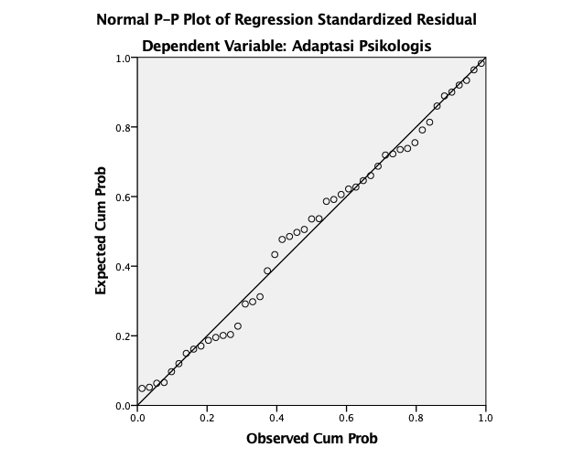

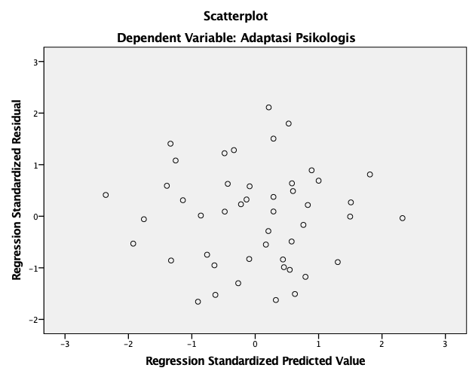

* Curve Estimation.
TSET NEWVAR=NONE.
CURVEFIT
/VARIABLES=Adaptasi_Psikologis WITH CC
/CONSTANT
/MODEL=LINEAR QUADRATIC
/PRINT ANOVA
/PLOT FIT.

Curve Fit

Notes
Output Created |  | 15-APR-2020 13:40:22
Comments
Input | Data | /Volumes/EAD/The Researces I Did/2020 - Social Network Analysis personalitas adaptasi psikologis dan penerimaan perbedaan budaya/2020 - Social Network Analysis penerimaan kebhinekaan kultural/Uji SPSS v2/SPSS v2.sav
Input | Active Dataset | DataSet2
Input | Filter | <none>
Input | Weight | <none>
Input | Split File | <none>
Input | N of Rows in Working Data File | 47
Missing Value Handling | Definition of Missing | User-defined missing values are treated as missing.
Missing Value Handling | Cases Used | Cases with a missing value in any variable are not used in the analysis.
Syntax |  | CURVEFIT  /VARIABLES=Adaptasi_Psikologis WITH CC  /CONSTANT  /MODEL=LINEAR QUADRATIC  /PRINT ANOVA  /PLOT FIT.
Resources | Processor Time | 00:00:00.16
Resources | Elapsed Time | 00:00:01.00
Use | From | First observation
Use | To | Last observation
Predict | From | First Observation following the use period
Predict | To | Last observation
Time Series Settings (TSET) | Amount of Output | PRINT = DEFAULT
Time Series Settings (TSET) | Saving New Variables | NEWVAR = NONE
Time Series Settings (TSET) | Maximum Number of Lags in Autocorrelation or Partial Autocorrelation Plots | MXAUTO = 16
Time Series Settings (TSET) | Maximum Number of Lags Per Cross-Correlation Plots | MXCROSS = 7
Time Series Settings (TSET) | Maximum Number of New Variables Generated Per Procedure | MXNEWVAR = 60
Time Series Settings (TSET) | Maximum Number of New Cases Per Procedure | MXPREDICT = 1000
Time Series Settings (TSET) | Treatment of User-Missing Values | MISSING = EXCLUDE
Time Series Settings (TSET) | Confidence Interval Percentage Value | CIN = 95
Time Series Settings (TSET) | Tolerance for Entering Variables in Regression Equations | TOLER = .0001
Time Series Settings (TSET) | Maximum Iterative Parameter Change | CNVERGE = .001
Time Series Settings (TSET) | Method of Calculating Std. Errors for Autocorrelations | ACFSE = IND
Time Series Settings (TSET) | Length of Seasonal Period | Unspecified
Time Series Settings (TSET) | Variable Whose Values Label Observations in Plots | Unspecified
Time Series Settings (TSET) | Equations Include | CONSTANT

Model Description
Model Name |  | MOD_1
Dependent Variable | 1 | Adaptasi Psikologis
Equation | 1 | Linear
Equation | 2 | Quadratic
Independent Variable |  | Closeness Centrality
Constant |  | Included
Variable Whose Values Label Observations in Plots |  | Unspecified
Tolerance for Entering Terms in Equations |  | .0001

Case Processing Summary
 | N
Total Cases | 47
Excluded Casesª | 0
Forecasted Cases | 0
Newly Created Cases | 0

a. Cases with a missing value in any variable are excluded from the analysis.

Variable Processing Summary
 |  | Variables
 |  | Dependent | Independent
 |  | Adaptasi Psikologis | Closeness Centrality
Number of Positive Values |  | 47 | 47
Number of Zeros |  | 0 | 0
Number of Negative Values |  | 0 | 0
Number of Missing Values | User-Missing | 0 | 0
Number of Missing Values | System-Missing | 0 | 0

Adaptasi Psikologis

Linear

Model Summary
R | R Square | Adjusted R Square | Std. Error of the Estimate
.069 | .005 | -.017 | 7.796

The independent variable is Closeness Centrality.

ANOVA
 | Sum of Squares | df | Mean Square | F | Sig.
Regression | 13.195 | 1 | 13.195 | .217 | .644
Residual | 2735.231 | 45 | 60.783
Total | 2748.426 | 46

The independent variable is Closeness Centrality.

Coefficients
 | Unstandardized Coefficients |  | Standardized Coefficients | t | Sig.
 | B | Std. Error | Beta | t | Sig.
Closeness Centrality | 20.585 | 44.183 | .069 | .466 | .644
(Constant) | 38.754 | 1.535 |  | 25.254 | .000

Quadratic

Model Summary
R | R Square | Adjusted R Square | Std. Error of the Estimate
.199 | .040 | -.004 | 7.745

The independent variable is Closeness Centrality.

ANOVA
 | Sum of Squares | df | Mean Square | F | Sig.
Regression | 109.183 | 2 | 54.592 | .910 | .410
Residual | 2639.242 | 44 | 59.983
Total | 2748.426 | 46

The independent variable is Closeness Centrality.

Coefficients
 | Unstandardized Coefficients |  | Standardized Coefficients | t | Sig.
 | B | Std. Error | Beta | t | Sig.
Closeness Centrality | 352.606 | 266.107 | 1.187 | 1.325 | .192
Closeness Centrality ** 2 | -4254.394 | 3363.108 | -1.133 | -1.265 | .213
(Constant) | 36.143 | 2.566 |  | 14.087 | .000

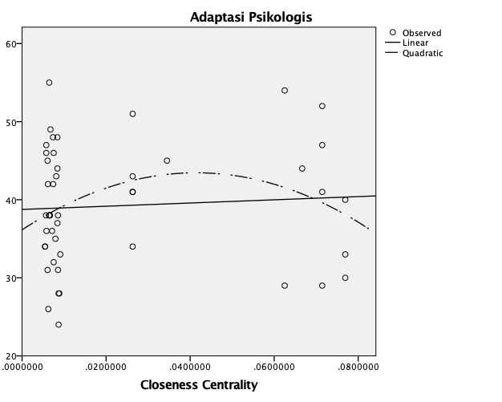

* Curve Estimation.
TSET NEWVAR=NONE.
CURVEFIT
/VARIABLES=Adaptasi_Psikologis WITH PC
/CONSTANT
/MODEL=LINEAR QUADRATIC
/PRINT ANOVA
/PLOT FIT.

Curve Fit

Notes
Output Created |  | 15-APR-2020 13:40:41
Comments
Input | Data | /Volumes/EAD/The Researces I Did/2020 - Social Network Analysis personalitas adaptasi psikologis dan penerimaan perbedaan budaya/2020 - Social Network Analysis penerimaan kebhinekaan kultural/Uji SPSS v2/SPSS v2.sav
Input | Active Dataset | DataSet2
Input | Filter | <none>
Input | Weight | <none>
Input | Split File | <none>
Input | N of Rows in Working Data File | 47
Missing Value Handling | Definition of Missing | User-defined missing values are treated as missing.
Missing Value Handling | Cases Used | Cases with a missing value in any variable are not used in the analysis.
Syntax |  | CURVEFIT  /VARIABLES=Adaptasi_Psikologis WITH PC  /CONSTANT  /MODEL=LINEAR QUADRATIC  /PRINT ANOVA  /PLOT FIT.
Resources | Processor Time | 00:00:00.23
Resources | Elapsed Time | 00:00:00.00
Use | From | First observation
Use | To | Last observation
Predict | From | First Observation following the use period
Predict | To | Last observation
Time Series Settings (TSET) | Amount of Output | PRINT = DEFAULT
Time Series Settings (TSET) | Saving New Variables | NEWVAR = NONE
Time Series Settings (TSET) | Maximum Number of Lags in Autocorrelation or Partial Autocorrelation Plots | MXAUTO = 16
Time Series Settings (TSET) | Maximum Number of Lags Per Cross-Correlation Plots | MXCROSS = 7
Time Series Settings (TSET) | Maximum Number of New Variables Generated Per Procedure | MXNEWVAR = 60
Time Series Settings (TSET) | Maximum Number of New Cases Per Procedure | MXPREDICT = 1000
Time Series Settings (TSET) | Treatment of User-Missing Values | MISSING = EXCLUDE
Time Series Settings (TSET) | Confidence Interval Percentage Value | CIN = 95
Time Series Settings (TSET) | Tolerance for Entering Variables in Regression Equations | TOLER = .0001
Time Series Settings (TSET) | Maximum Iterative Parameter Change | CNVERGE = .001
Time Series Settings (TSET) | Method of Calculating Std. Errors for Autocorrelations | ACFSE = IND
Time Series Settings (TSET) | Length of Seasonal Period | Unspecified
Time Series Settings (TSET) | Variable Whose Values Label Observations in Plots | Unspecified
Time Series Settings (TSET) | Equations Include | CONSTANT

Model Description
Model Name |  | MOD_2
Dependent Variable | 1 | Adaptasi Psikologis
Equation | 1 | Linear
Equation | 2 | Quadratic
Independent Variable |  | Power Centrality
Constant |  | Included
Variable Whose Values Label Observations in Plots |  | Unspecified
Tolerance for Entering Terms in Equations |  | .0001

Case Processing Summary
 | N
Total Cases | 47
Excluded Casesª | 0
Forecasted Cases | 0
Newly Created Cases | 0

a. Cases with a missing value in any variable are excluded from the analysis.

Variable Processing Summary
 |  | Variables
 |  | Dependent | Independent
 |  | Adaptasi Psikologis | Power Centrality
Number of Positive Values |  | 47 | 47
Number of Zeros |  | 0 | 0
Number of Negative Values |  | 0 | 0
Number of Missing Values | User-Missing | 0 | 0
Number of Missing Values | System-Missing | 0 | 0

Adaptasi Psikologis

Linear

Model Summary
R | R Square | Adjusted R Square | Std. Error of the Estimate
.188 | .035 | .014 | 7.675

The independent variable is Power Centrality.

ANOVA
 | Sum of Squares | df | Mean Square | F | Sig.
Regression | 97.512 | 1 | 97.512 | 1.655 | .205
Residual | 2650.913 | 45 | 58.909
Total | 2748.426 | 46

The independent variable is Power Centrality.

Coefficients
 | Unstandardized Coefficients |  | Standardized Coefficients | t | Sig.
 | B | Std. Error | Beta | t | Sig.
Power Centrality | -.273 | .212 | -.188 | -1.287 | .205
(Constant) | 43.136 | 3.233 |  | 13.343 | .000

Quadratic

Model Summary
R | R Square | Adjusted R Square | Std. Error of the Estimate
.246 | .061 | .018 | 7.660

The independent variable is Power Centrality.

ANOVA
 | Sum of Squares | df | Mean Square | F | Sig.
Regression | 166.460 | 2 | 83.230 | 1.418 | .253
Residual | 2581.965 | 44 | 58.681
Total | 2748.426 | 46

The independent variable is Power Centrality.

Coefficients
 | Unstandardized Coefficients |  | Standardized Coefficients | t | Sig.
 | B | Std. Error | Beta | t | Sig.
Power Centrality | 1.583 | 1.725 | 1.093 | .918 | .364
Power Centrality ** 2 | -.070 | .064 | -1.291 | -1.084 | .284
(Constant) | 32.833 | 10.038 |  | 3.271 | .002

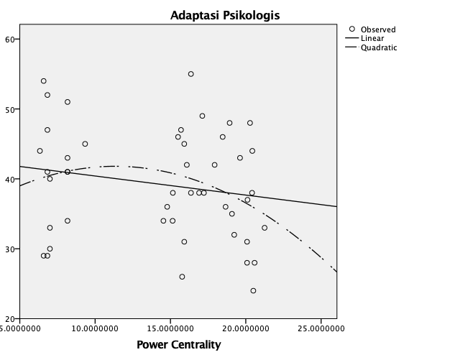

* Curve Estimation.
TSET NEWVAR=NONE.
CURVEFIT
/VARIABLES=Adaptasi_Psikologis WITH BC
/CONSTANT
/MODEL=LINEAR QUADRATIC
/PRINT ANOVA
/PLOT FIT.

Curve Fit

Notes
Output Created |  | 15-APR-2020 13:40:59
Comments
Input | Data | /Volumes/EAD/The Researces I Did/2020 - Social Network Analysis personalitas adaptasi psikologis dan penerimaan perbedaan budaya/2020 - Social Network Analysis penerimaan kebhinekaan kultural/Uji SPSS v2/SPSS v2.sav
Input | Active Dataset | DataSet2
Input | Filter | <none>
Input | Weight | <none>
Input | Split File | <none>
Input | N of Rows in Working Data File | 47
Missing Value Handling | Definition of Missing | User-defined missing values are treated as missing.
Missing Value Handling | Cases Used | Cases with a missing value in any variable are not used in the analysis.
Syntax |  | CURVEFIT  /VARIABLES=Adaptasi_Psikologis WITH BC  /CONSTANT  /MODEL=LINEAR QUADRATIC  /PRINT ANOVA  /PLOT FIT.
Resources | Processor Time | 00:00:00.21
Resources | Elapsed Time | 00:00:01.00
Use | From | First observation
Use | To | Last observation
Predict | From | First Observation following the use period
Predict | To | Last observation
Time Series Settings (TSET) | Amount of Output | PRINT = DEFAULT
Time Series Settings (TSET) | Saving New Variables | NEWVAR = NONE
Time Series Settings (TSET) | Maximum Number of Lags in Autocorrelation or Partial Autocorrelation Plots | MXAUTO = 16
Time Series Settings (TSET) | Maximum Number of Lags Per Cross-Correlation Plots | MXCROSS = 7
Time Series Settings (TSET) | Maximum Number of New Variables Generated Per Procedure | MXNEWVAR = 60
Time Series Settings (TSET) | Maximum Number of New Cases Per Procedure | MXPREDICT = 1000
Time Series Settings (TSET) | Treatment of User-Missing Values | MISSING = EXCLUDE
Time Series Settings (TSET) | Confidence Interval Percentage Value | CIN = 95
Time Series Settings (TSET) | Tolerance for Entering Variables in Regression Equations | TOLER = .0001
Time Series Settings (TSET) | Maximum Iterative Parameter Change | CNVERGE = .001
Time Series Settings (TSET) | Method of Calculating Std. Errors for Autocorrelations | ACFSE = IND
Time Series Settings (TSET) | Length of Seasonal Period | Unspecified
Time Series Settings (TSET) | Variable Whose Values Label Observations in Plots | Unspecified
Time Series Settings (TSET) | Equations Include | CONSTANT

Model Description
Model Name |  | MOD_3
Dependent Variable | 1 | Adaptasi Psikologis
Equation | 1 | Linear
Equation | 2 | Quadratic
Independent Variable |  | Betweenness Centrality
Constant |  | Included
Variable Whose Values Label Observations in Plots |  | Unspecified
Tolerance for Entering Terms in Equations |  | .0001

Case Processing Summary
 | N
Total Cases | 47
Excluded Casesª | 0
Forecasted Cases | 0
Newly Created Cases | 0

a. Cases with a missing value in any variable are excluded from the analysis.

Variable Processing Summary
 |  | Variables
 |  | Dependent | Independent
 |  | Adaptasi Psikologis | Betweenness Centrality
Number of Positive Values |  | 47 | 46
Number of Zeros |  | 0 | 1
Number of Negative Values |  | 0 | 0
Number of Missing Values | User-Missing | 0 | 0
Number of Missing Values | System-Missing | 0 | 0

Adaptasi Psikologis

Linear

Model Summary
R | R Square | Adjusted R Square | Std. Error of the Estimate
.280 | .078 | .058 | 7.503

The independent variable is Betweenness Centrality.

ANOVA
 | Sum of Squares | df | Mean Square | F | Sig.
Regression | 215.367 | 1 | 215.367 | 3.826 | .057
Residual | 2533.059 | 45 | 56.290
Total | 2748.426 | 46

The independent variable is Betweenness Centrality.

Coefficients
 | Unstandardized Coefficients |  | Standardized Coefficients | t | Sig.
 | B | Std. Error | Beta | t | Sig.
Betweenness Centrality | .028 | .014 | .280 | 1.956 | .057
(Constant) | 37.324 | 1.467 |  | 25.450 | .000

Quadratic

Model Summary
R | R Square | Adjusted R Square | Std. Error of the Estimate
.280 | .078 | .037 | 7.587

The independent variable is Betweenness Centrality.

ANOVA
 | Sum of Squares | df | Mean Square | F | Sig.
Regression | 215.666 | 2 | 107.833 | 1.873 | .166
Residual | 2532.759 | 44 | 57.563
Total | 2748.426 | 46

The independent variable is Betweenness Centrality.

Coefficients
 | Unstandardized Coefficients |  | Standardized Coefficients | t | Sig.
 | B | Std. Error | Beta | t | Sig.
Betweenness Centrality | .030 | .035 | .303 | .861 | .394
Betweenness Centrality ** 2 | -7.942E-6 | .000 | -.025 | -.072 | .943
(Constant) | 37.251 | 1.797 |  | 20.733 | .000

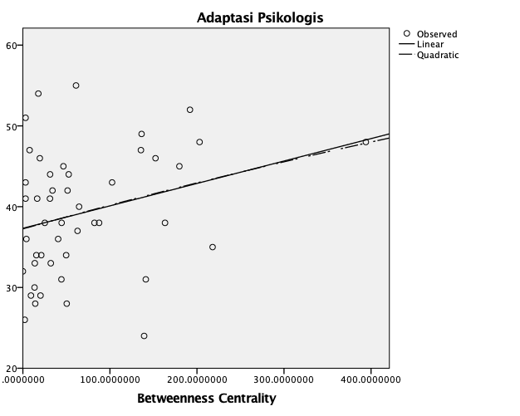

* Curve Estimation.
TSET NEWVAR=NONE.
CURVEFIT
/VARIABLES=Adaptasi_Psikologis WITH EVC
/CONSTANT
/MODEL=LINEAR QUADRATIC
/PRINT ANOVA
/PLOT FIT.

Curve Fit

Notes
Output Created |  | 15-APR-2020 13:41:21
Comments
Input | Data | /Volumes/EAD/The Researces I Did/2020 - Social Network Analysis personalitas adaptasi psikologis dan penerimaan perbedaan budaya/2020 - Social Network Analysis penerimaan kebhinekaan kultural/Uji SPSS v2/SPSS v2.sav
Input | Active Dataset | DataSet2
Input | Filter | <none>
Input | Weight | <none>
Input | Split File | <none>
Input | N of Rows in Working Data File | 47
Missing Value Handling | Definition of Missing | User-defined missing values are treated as missing.
Missing Value Handling | Cases Used | Cases with a missing value in any variable are not used in the analysis.
Syntax |  | CURVEFIT  /VARIABLES=Adaptasi_Psikologis WITH EVC  /CONSTANT  /MODEL=LINEAR QUADRATIC  /PRINT ANOVA  /PLOT FIT.
Resources | Processor Time | 00:00:00.18
Resources | Elapsed Time | 00:00:00.00
Use | From | First observation
Use | To | Last observation
Predict | From | First Observation following the use period
Predict | To | Last observation
Time Series Settings (TSET) | Amount of Output | PRINT = DEFAULT
Time Series Settings (TSET) | Saving New Variables | NEWVAR = NONE
Time Series Settings (TSET) | Maximum Number of Lags in Autocorrelation or Partial Autocorrelation Plots | MXAUTO = 16
Time Series Settings (TSET) | Maximum Number of Lags Per Cross-Correlation Plots | MXCROSS = 7
Time Series Settings (TSET) | Maximum Number of New Variables Generated Per Procedure | MXNEWVAR = 60
Time Series Settings (TSET) | Maximum Number of New Cases Per Procedure | MXPREDICT = 1000
Time Series Settings (TSET) | Treatment of User-Missing Values | MISSING = EXCLUDE
Time Series Settings (TSET) | Confidence Interval Percentage Value | CIN = 95
Time Series Settings (TSET) | Tolerance for Entering Variables in Regression Equations | TOLER = .0001
Time Series Settings (TSET) | Maximum Iterative Parameter Change | CNVERGE = .001
Time Series Settings (TSET) | Method of Calculating Std. Errors for Autocorrelations | ACFSE = IND
Time Series Settings (TSET) | Length of Seasonal Period | Unspecified
Time Series Settings (TSET) | Variable Whose Values Label Observations in Plots | Unspecified
Time Series Settings (TSET) | Equations Include | CONSTANT

Model Description
Model Name |  | MOD_4
Dependent Variable | 1 | Adaptasi Psikologis
Equation | 1 | Linear
Equation | 2 | Quadratic
Independent Variable |  | Eigenvector Centrality
Constant |  | Included
Variable Whose Values Label Observations in Plots |  | Unspecified
Tolerance for Entering Terms in Equations |  | .0001

Case Processing Summary
 | N
Total Cases | 47
Excluded Casesª | 0
Forecasted Cases | 0
Newly Created Cases | 0

a. Cases with a missing value in any variable are excluded from the analysis.

Variable Processing Summary
 |  | Variables
 |  | Dependent | Independent
 |  | Adaptasi Psikologis | Eigenvector Centrality
Number of Positive Values |  | 47 | 47
Number of Zeros |  | 0 | 0
Number of Negative Values |  | 0 | 0
Number of Missing Values | User-Missing | 0 | 0
Number of Missing Values | System-Missing | 0 | 0

Adaptasi Psikologis

Linear

Model Summary
R | R Square | Adjusted R Square | Std. Error of the Estimate
.109 | .012 | -.010 | 7.769

The independent variable is Eigenvector Centrality.

ANOVA
 | Sum of Squares | df | Mean Square | F | Sig.
Regression | 32.548 | 1 | 32.548 | .539 | .467
Residual | 2715.878 | 45 | 60.353
Total | 2748.426 | 46

The independent variable is Eigenvector Centrality.

Coefficients
 | Unstandardized Coefficients |  | Standardized Coefficients | t | Sig.
 | B | Std. Error | Beta | t | Sig.
Eigenvector Centrality | 10.825 | 14.741 | .109 | .734 | .467
(Constant) | 37.892 | 2.150 |  | 17.622 | .000

Quadratic

Model Summary
R | R Square | Adjusted R Square | Std. Error of the Estimate
.181 | .033 | -.011 | 7.773

The independent variable is Eigenvector Centrality.

ANOVA
 | Sum of Squares | df | Mean Square | F | Sig.
Regression | 89.974 | 2 | 44.987 | .745 | .481
Residual | 2658.452 | 44 | 60.419
Total | 2748.426 | 46

The independent variable is Eigenvector Centrality.

Coefficients
 | Unstandardized Coefficients |  | Standardized Coefficients | t | Sig.
 | B | Std. Error | Beta | t | Sig.
Eigenvector Centrality | -59.494 | 73.621 | -.598 | -.808 | .423
Eigenvector Centrality ** 2 | 192.306 | 197.254 | .722 | .975 | .335
(Constant) | 42.518 | 5.210 |  | 8.161 | .000

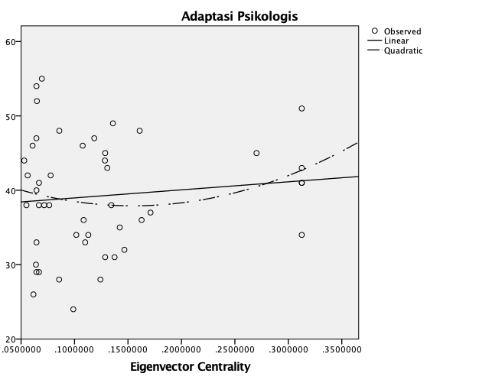

* Curve Estimation.
TSET NEWVAR=NONE.
CURVEFIT
/VARIABLES=Adaptasi_Psikologis WITH IC
/CONSTANT
/MODEL=LINEAR QUADRATIC
/PRINT ANOVA
/PLOT FIT.

Curve Fit

Notes
Output Created |  | 15-APR-2020 13:41:34
Comments
Input | Data | /Volumes/EAD/The Researces I Did/2020 - Social Network Analysis personalitas adaptasi psikologis dan penerimaan perbedaan budaya/2020 - Social Network Analysis penerimaan kebhinekaan kultural/Uji SPSS v2/SPSS v2.sav
Input | Active Dataset | DataSet2
Input | Filter | <none>
Input | Weight | <none>
Input | Split File | <none>
Input | N of Rows in Working Data File | 47
Missing Value Handling | Definition of Missing | User-defined missing values are treated as missing.
Missing Value Handling | Cases Used | Cases with a missing value in any variable are not used in the analysis.
Syntax |  | CURVEFIT  /VARIABLES=Adaptasi_Psikologis WITH IC  /CONSTANT  /MODEL=LINEAR QUADRATIC  /PRINT ANOVA  /PLOT FIT.
Resources | Processor Time | 00:00:00.22
Resources | Elapsed Time | 00:00:00.00
Use | From | First observation
Use | To | Last observation
Predict | From | First Observation following the use period
Predict | To | Last observation
Time Series Settings (TSET) | Amount of Output | PRINT = DEFAULT
Time Series Settings (TSET) | Saving New Variables | NEWVAR = NONE
Time Series Settings (TSET) | Maximum Number of Lags in Autocorrelation or Partial Autocorrelation Plots | MXAUTO = 16
Time Series Settings (TSET) | Maximum Number of Lags Per Cross-Correlation Plots | MXCROSS = 7
Time Series Settings (TSET) | Maximum Number of New Variables Generated Per Procedure | MXNEWVAR = 60
Time Series Settings (TSET) | Maximum Number of New Cases Per Procedure | MXPREDICT = 1000
Time Series Settings (TSET) | Treatment of User-Missing Values | MISSING = EXCLUDE
Time Series Settings (TSET) | Confidence Interval Percentage Value | CIN = 95
Time Series Settings (TSET) | Tolerance for Entering Variables in Regression Equations | TOLER = .0001
Time Series Settings (TSET) | Maximum Iterative Parameter Change | CNVERGE = .001
Time Series Settings (TSET) | Method of Calculating Std. Errors for Autocorrelations | ACFSE = IND
Time Series Settings (TSET) | Length of Seasonal Period | Unspecified
Time Series Settings (TSET) | Variable Whose Values Label Observations in Plots | Unspecified
Time Series Settings (TSET) | Equations Include | CONSTANT

Model Description
Model Name |  | MOD_5
Dependent Variable | 1 | Adaptasi Psikologis
Equation | 1 | Linear
Equation | 2 | Quadratic
Independent Variable |  | Information Centrality
Constant |  | Included
Variable Whose Values Label Observations in Plots |  | Unspecified
Tolerance for Entering Terms in Equations |  | .0001

Case Processing Summary
 | N
Total Cases | 47
Excluded Casesª | 0
Forecasted Cases | 0
Newly Created Cases | 0

a. Cases with a missing value in any variable are excluded from the analysis.

Variable Processing Summary
 |  | Variables
 |  | Dependent | Independent
 |  | Adaptasi Psikologis | Information Centrality
Number of Positive Values |  | 47 | 47
Number of Zeros |  | 0 | 0
Number of Negative Values |  | 0 | 0
Number of Missing Values | User-Missing | 0 | 0
Number of Missing Values | System-Missing | 0 | 0

Adaptasi Psikologis

Linear

Model Summary
R | R Square | Adjusted R Square | Std. Error of the Estimate
.106 | .011 | -.011 | 7.771

The independent variable is Information Centrality.

ANOVA
 | Sum of Squares | df | Mean Square | F | Sig.
Regression | 30.775 | 1 | 30.775 | .510 | .479
Residual | 2717.650 | 45 | 60.392
Total | 2748.426 | 46

The independent variable is Information Centrality.

Coefficients
 | Unstandardized Coefficients |  | Standardized Coefficients | t | Sig.
 | B | Std. Error | Beta | t | Sig.
Information Centrality | 2.346 | 3.287 | .106 | .714 | .479
(Constant) | 34.171 | 7.182 |  | 4.758 | .000

* Curve Estimation.
TSET NEWVAR=NONE.
CURVEFIT
/VARIABLES=Adaptasi_Psikologis WITH IC
/CONSTANT
/MODEL=QUADRATIC
/PRINT ANOVA
/PLOT FIT.

Curve Fit

Notes
Output Created |  | 15-APR-2020 13:46:17
Comments
Input | Data | /Volumes/EAD/The Researces I Did/2020 - Social Network Analysis personalitas adaptasi psikologis dan penerimaan perbedaan budaya/2020 - Social Network Analysis penerimaan kebhinekaan kultural/Uji SPSS v2/SPSS v2.sav
Input | Active Dataset | DataSet2
Input | Filter | <none>
Input | Weight | <none>
Input | Split File | <none>
Input | N of Rows in Working Data File | 47
Missing Value Handling | Definition of Missing | User-defined missing values are treated as missing.
Missing Value Handling | Cases Used | Cases with a missing value in any variable are not used in the analysis.
Syntax |  | CURVEFIT  /VARIABLES=Adaptasi_Psikologis WITH IC  /CONSTANT  /MODEL=QUADRATIC  /PRINT ANOVA  /PLOT FIT.
Resources | Processor Time | 00:00:00.16
Resources | Elapsed Time | 00:00:00.00
Use | From | First observation
Use | To | Last observation
Predict | From | First Observation following the use period
Predict | To | Last observation
Time Series Settings (TSET) | Amount of Output | PRINT = DEFAULT
Time Series Settings (TSET) | Saving New Variables | NEWVAR = NONE
Time Series Settings (TSET) | Maximum Number of Lags in Autocorrelation or Partial Autocorrelation Plots | MXAUTO = 16
Time Series Settings (TSET) | Maximum Number of Lags Per Cross-Correlation Plots | MXCROSS = 7
Time Series Settings (TSET) | Maximum Number of New Variables Generated Per Procedure | MXNEWVAR = 60
Time Series Settings (TSET) | Maximum Number of New Cases Per Procedure | MXPREDICT = 1000
Time Series Settings (TSET) | Treatment of User-Missing Values | MISSING = EXCLUDE
Time Series Settings (TSET) | Confidence Interval Percentage Value | CIN = 95
Time Series Settings (TSET) | Tolerance for Entering Variables in Regression Equations | TOLER = .0001
Time Series Settings (TSET) | Maximum Iterative Parameter Change | CNVERGE = .001
Time Series Settings (TSET) | Method of Calculating Std. Errors for Autocorrelations | ACFSE = IND
Time Series Settings (TSET) | Length of Seasonal Period | Unspecified
Time Series Settings (TSET) | Variable Whose Values Label Observations in Plots | Unspecified
Time Series Settings (TSET) | Equations Include | CONSTANT

Model Description
Model Name |  | MOD_6
Dependent Variable | 1 | Adaptasi Psikologis
Equation | 1 | Quadratic
Independent Variable |  | Information Centrality
Constant |  | Included
Variable Whose Values Label Observations in Plots |  | Unspecified
Tolerance for Entering Terms in Equations |  | .0001

Case Processing Summary
 | N
Total Cases | 47
Excluded Casesª | 0
Forecasted Cases | 0
Newly Created Cases | 0

a. Cases with a missing value in any variable are excluded from the analysis.

Variable Processing Summary
 |  | Variables
 |  | Dependent | Independent
 |  | Adaptasi Psikologis | Information Centrality
Number of Positive Values |  | 47 | 47
Number of Zeros |  | 0 | 0
Number of Negative Values |  | 0 | 0
Number of Missing Values | User-Missing | 0 | 0
Number of Missing Values | System-Missing | 0 | 0

Adaptasi Psikologis

Quadratic

Model Summary
R | R Square | Adjusted R Square | Std. Error of the Estimate
.382 | .146 | .107 | 7.304

The independent variable is Information Centrality.

ANOVA
 | Sum of Squares | df | Mean Square | F | Sig.
Regression | 401.376 | 2 | 200.688 | 3.762 | .031
Residual | 2347.049 | 44 | 53.342
Total | 2748.426 | 46

The independent variable is Information Centrality.

Coefficients
 | Unstandardized Coefficients |  | Standardized Coefficients | t | Sig.
 | B | Std. Error | Beta | t | Sig.
Information Centrality | -71.203 | 28.074 | -3.211 | -2.536 | .015
Information Centrality ** 2 | 17.032 | 6.462 | 3.337 | 2.636 | .012
(Constant) | 111.548 | 30.122 |  | 3.703 | .001

