

LEMBAGA PENGEMBANGAN BAHASA, KERJASAMA & URUSAN INTERNASIONAL

UNIVERSITAS MUHAMMADIYAH MAKASSAR

SURAT KETERANGAN PENERJEMAHAN
NO. 021//LPBKUI/1.A/V/1442/2021

Yang bertanda tangan di bawah ini:
Nama : Maharida S.Pd.,M.Pd.
NBM 1081597
Jabatan : Ketua Lembaga Pengembangan Bahasa, Kerjasama dan Urusan Internasional (LPBKUI) Universitas Muhammadiyah Makassar
Menerangkan bahwa:
Nama : Jalaluddin B.
Institusi : Komunikasi dan Penyiaran Islam (KPI)
Universitas Islam Negeri Alauddin Makassar
Telah melakukan penerjemahan artikel dengan judul “Under Age-Marriage: Asserting ‘Bapak’s Dominantion over Female Adolescent from Traditional Setting to Patriarchy” di Lembaga Pengembangan Bahasa, Kerjasama dan Urusan Internasional (LPBKUI) Universitas Muhammadiyah Makassar pada tanggal 01 Agustus 2021.

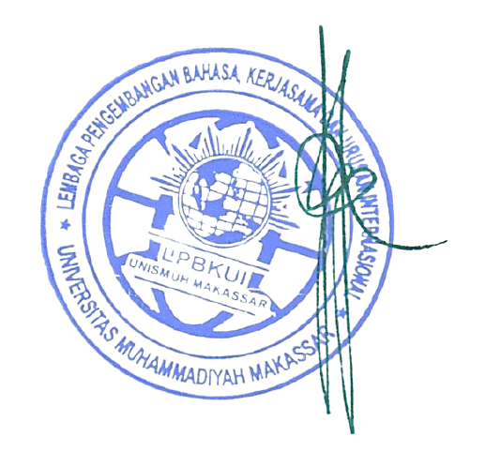
Makassar, 10 Agustus 2021
Ketua LPBKUI Unismuh Makassar

Maharida, S.Pd., M.Pd
NBM. 1081597

UNDER-AGE MARRIAGE: ASSERTING ‘BAPAK’S DOMINATION OVER FEMALE ADOLESCENT FROM TRADITIONAL SETTING TO PATRIARCHY
by Jalaluddin B

Submission date: 11-Aug-2021 03:49PM (UTC+0700)
Submission ID: 1630220199
File name: MANUSCRIPT_OF_PROFETIK_JOURNAL_OCTOBER_2021.docx (55.65K)
Word count: 5476
Character count: 30871

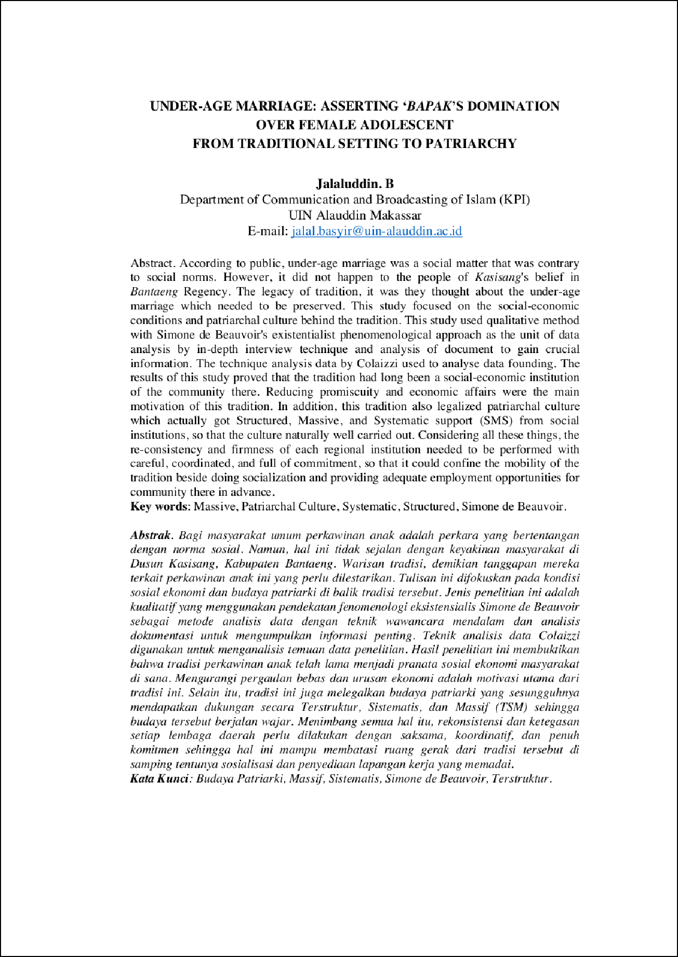

3

2

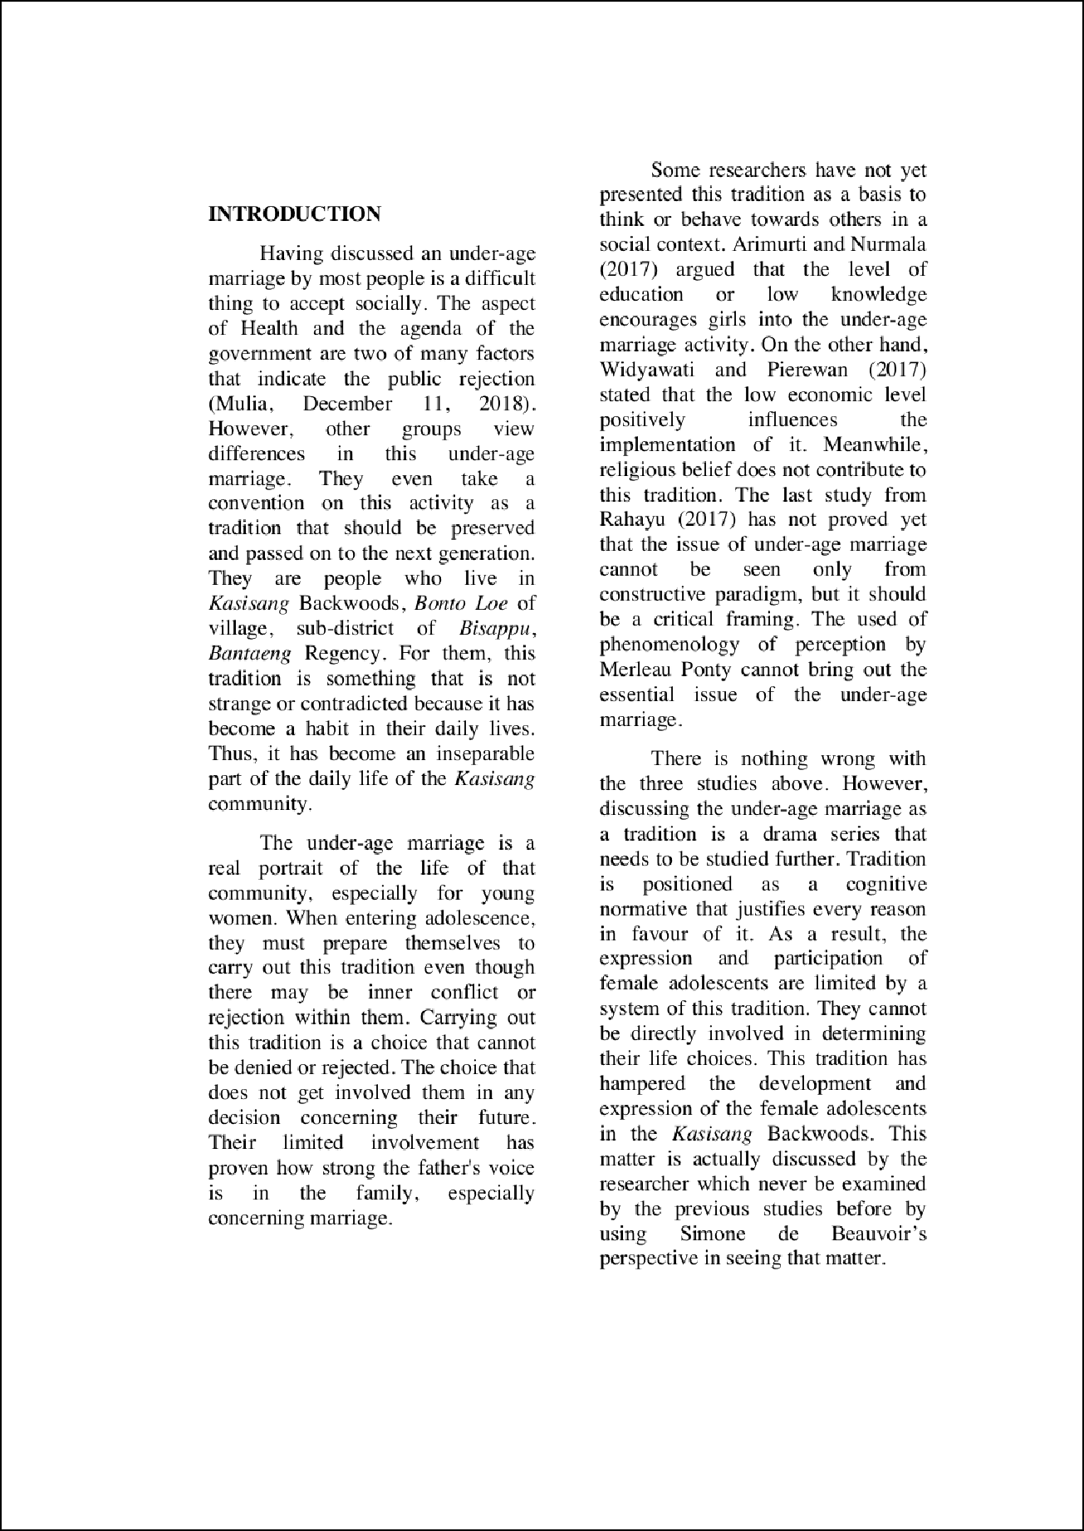

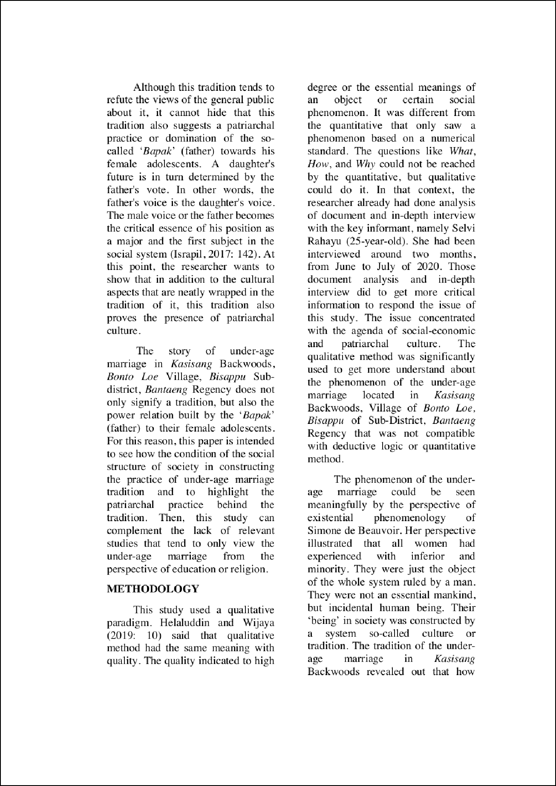

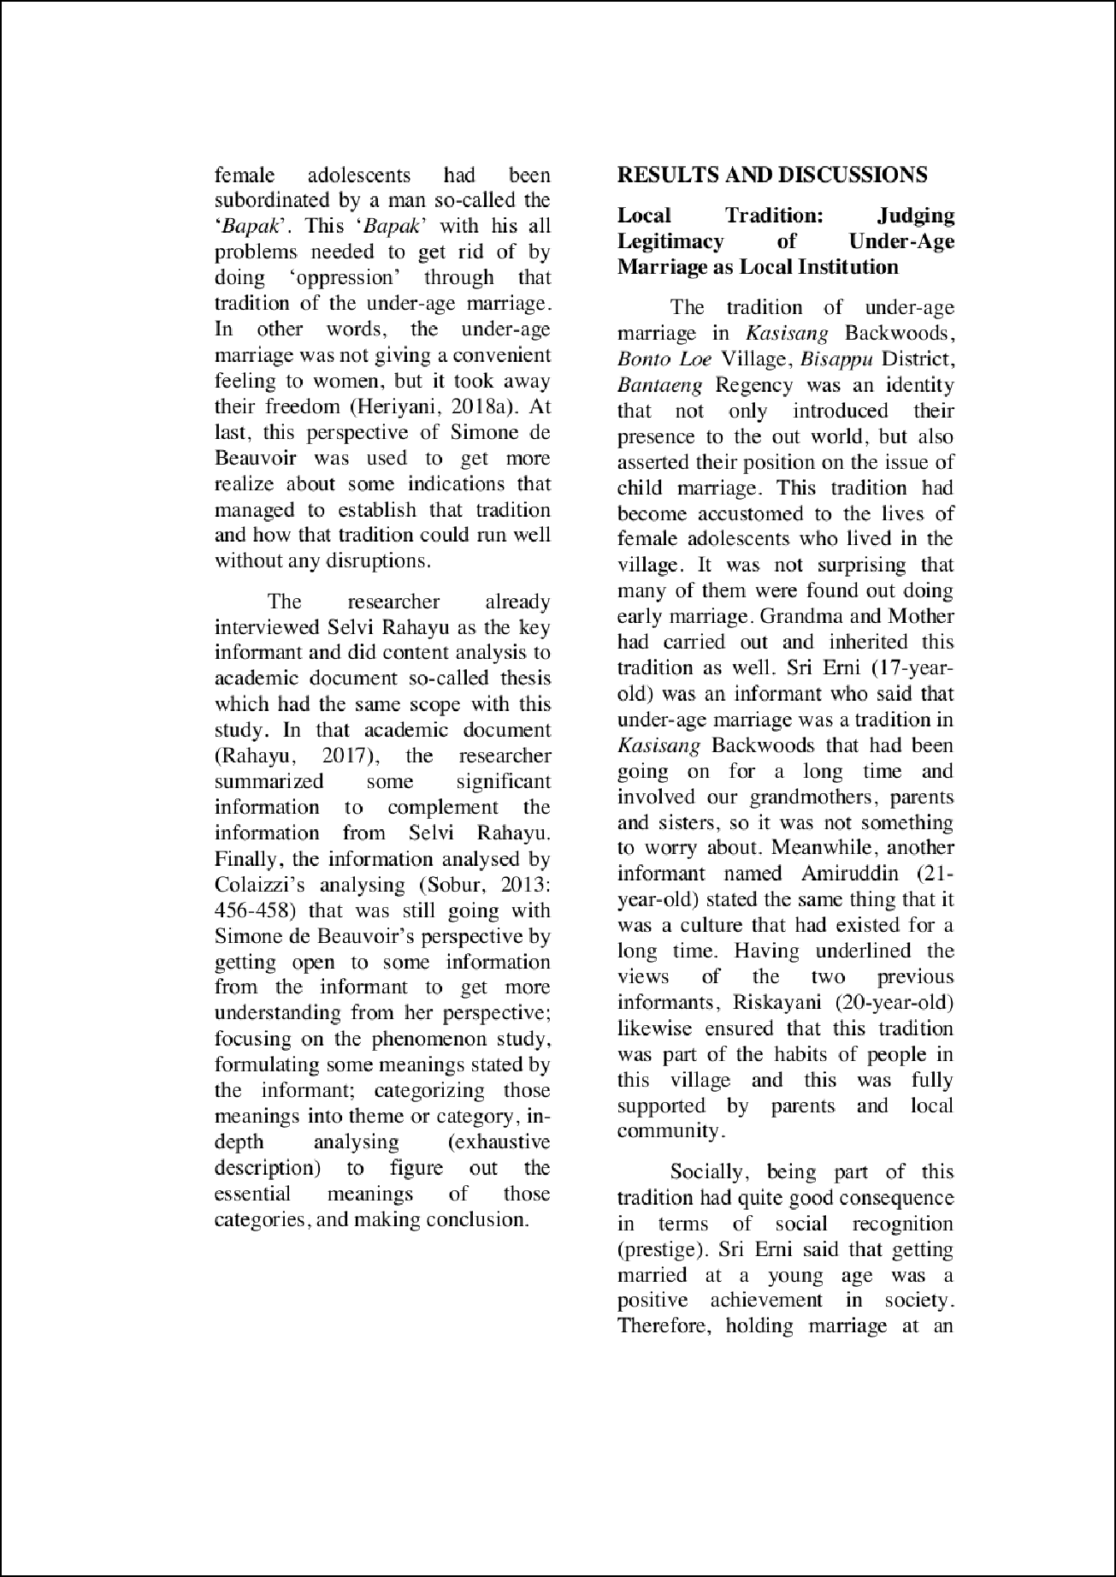

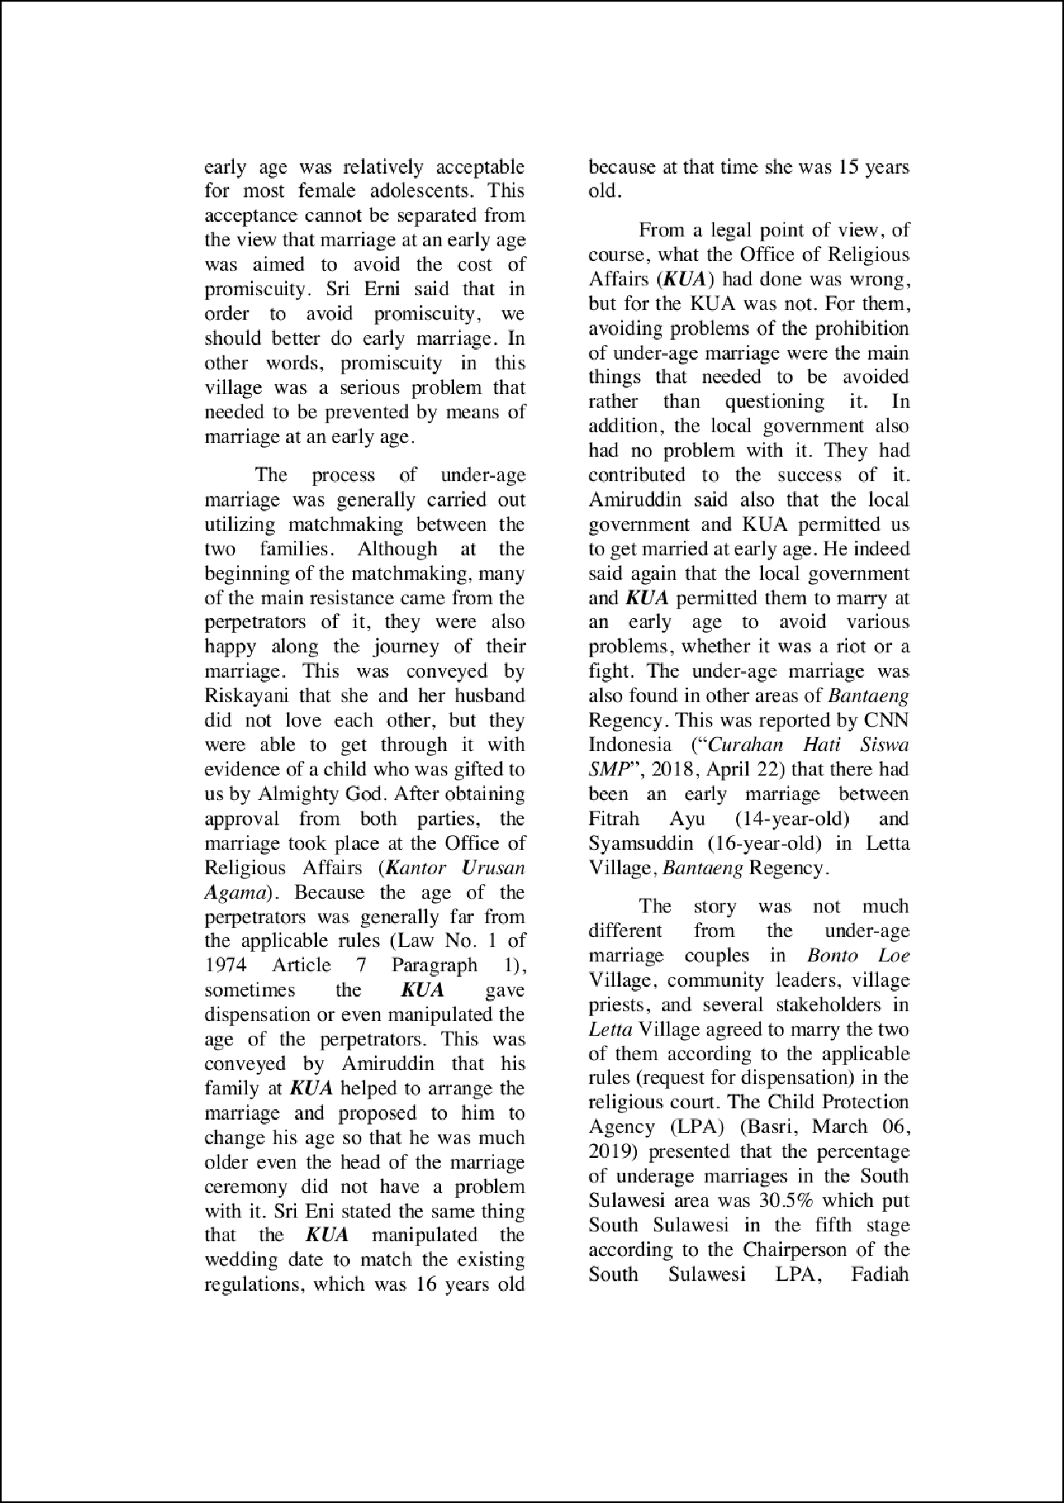

1

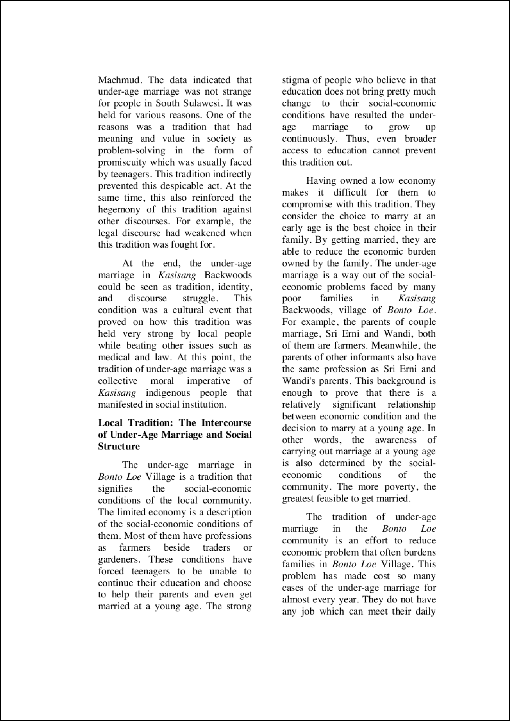

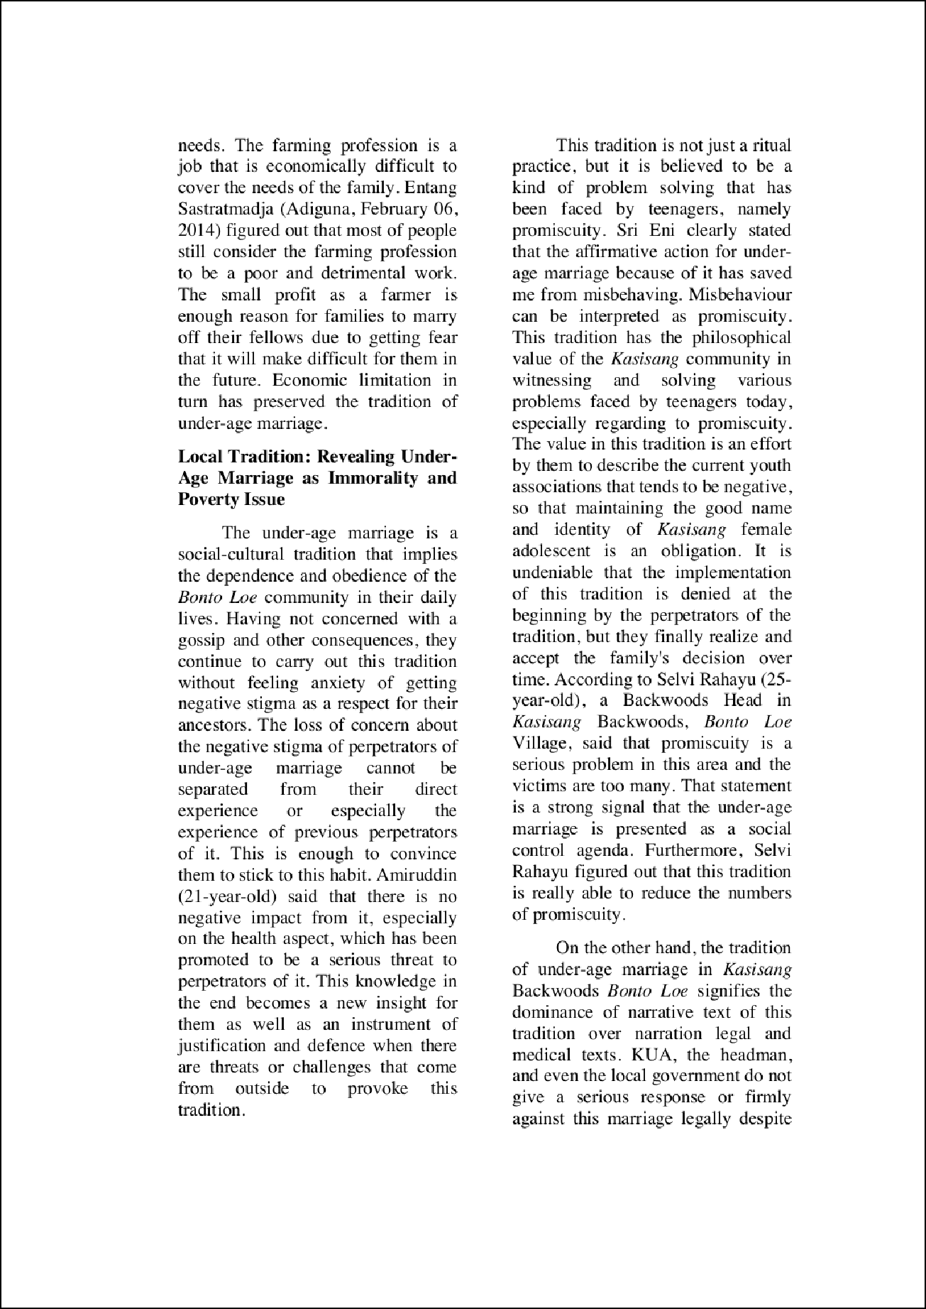

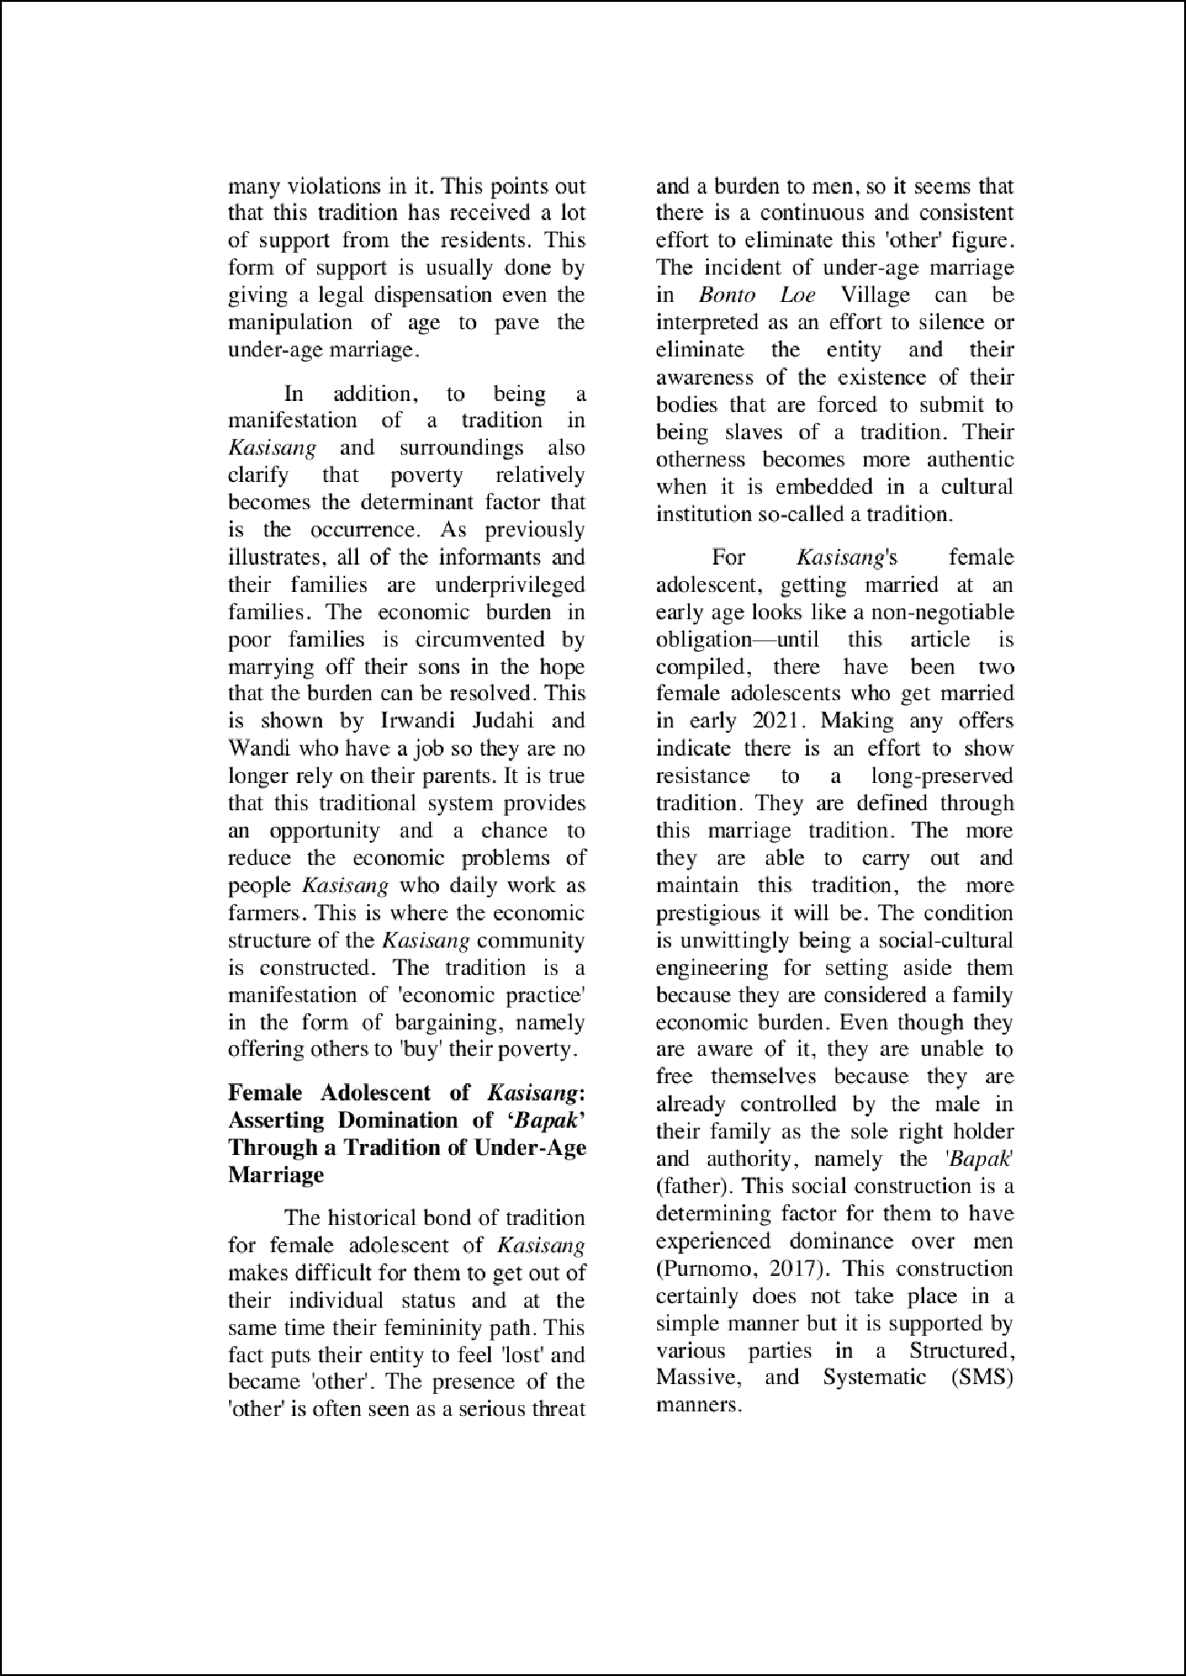

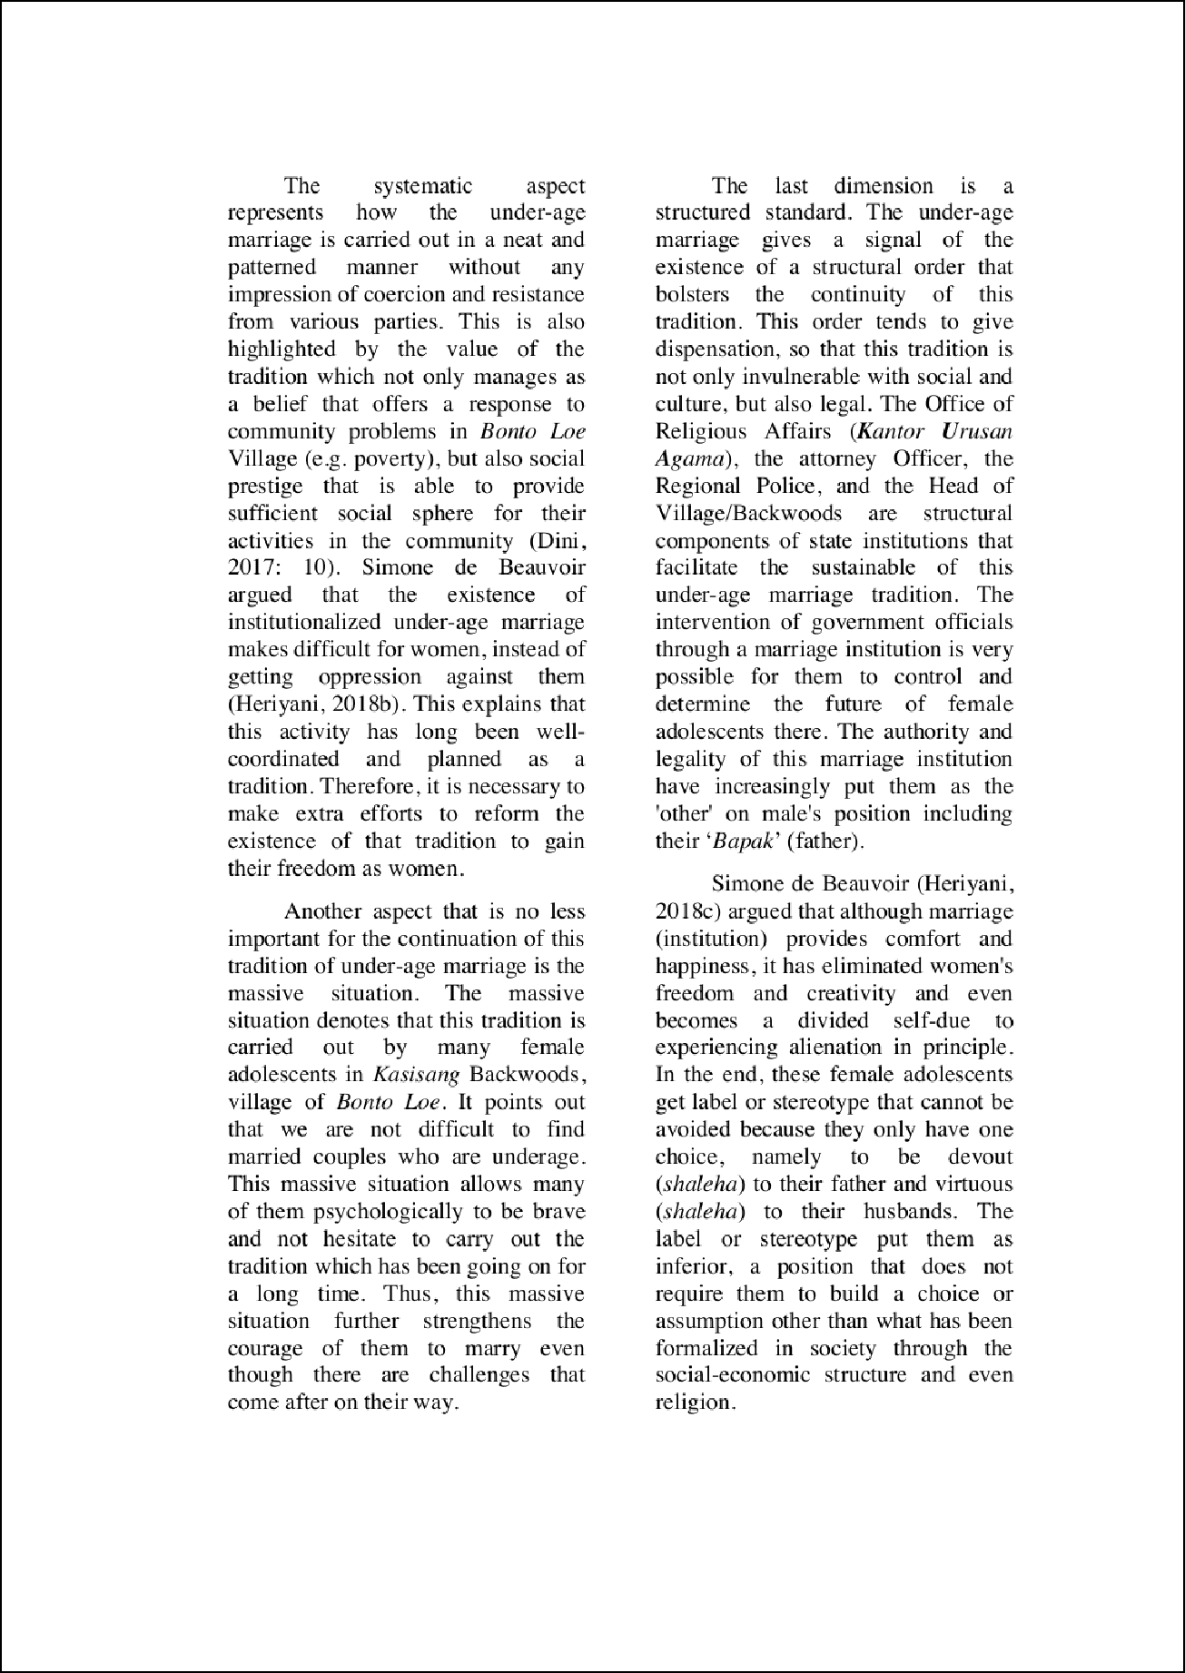

1

5

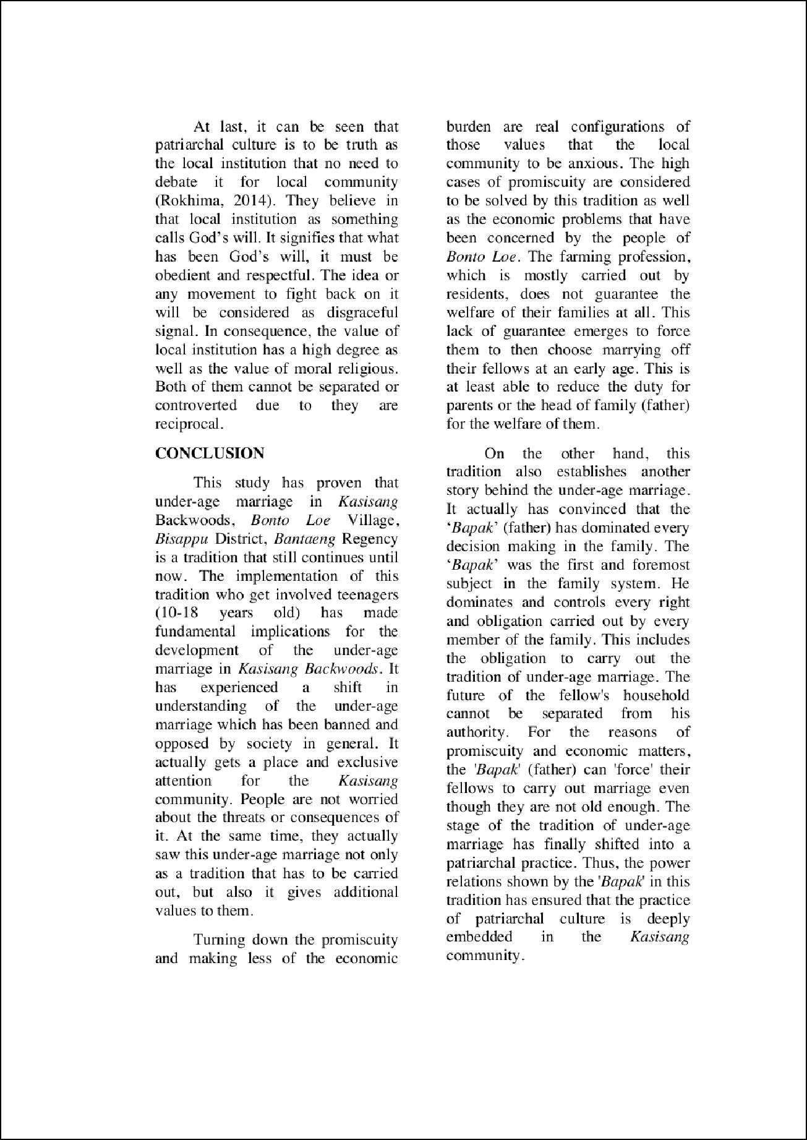

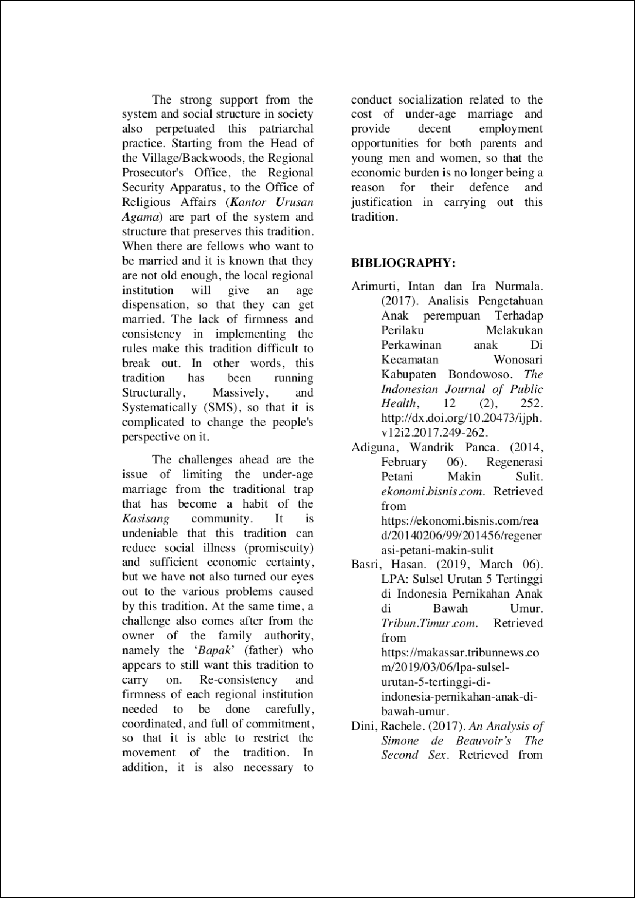

1

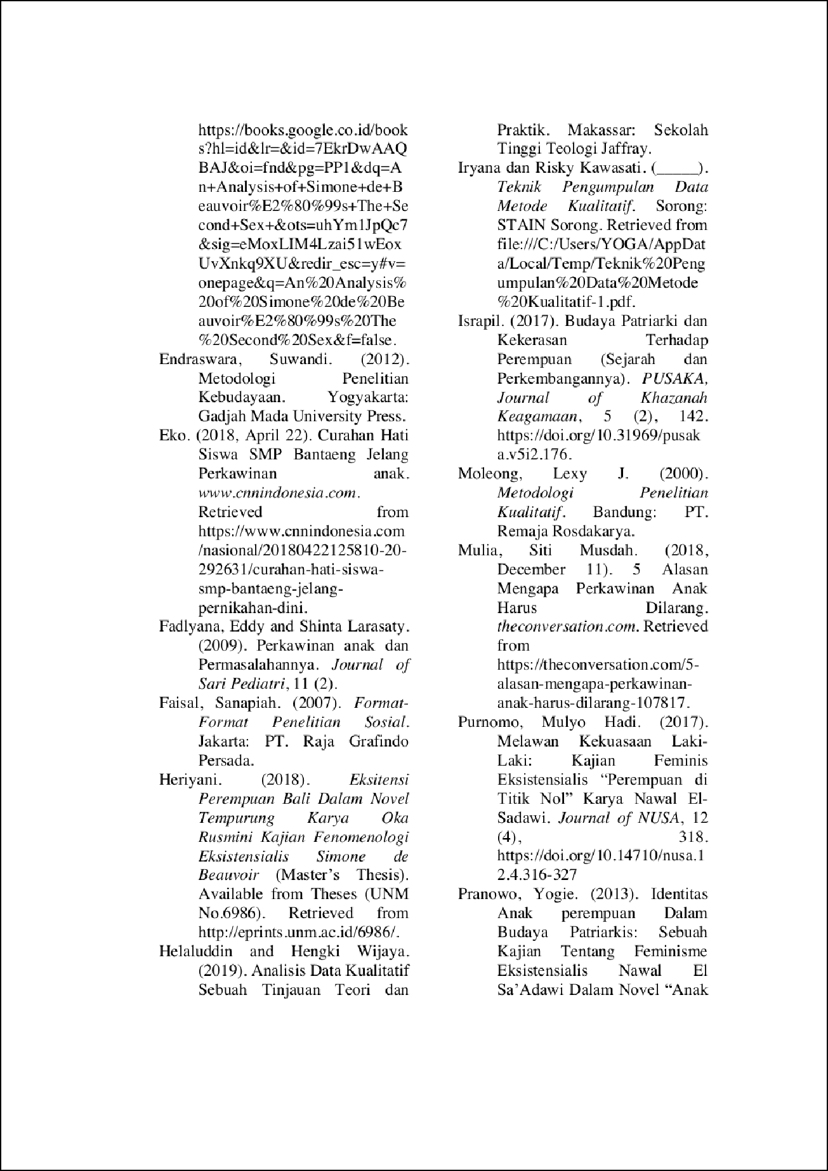

2

4

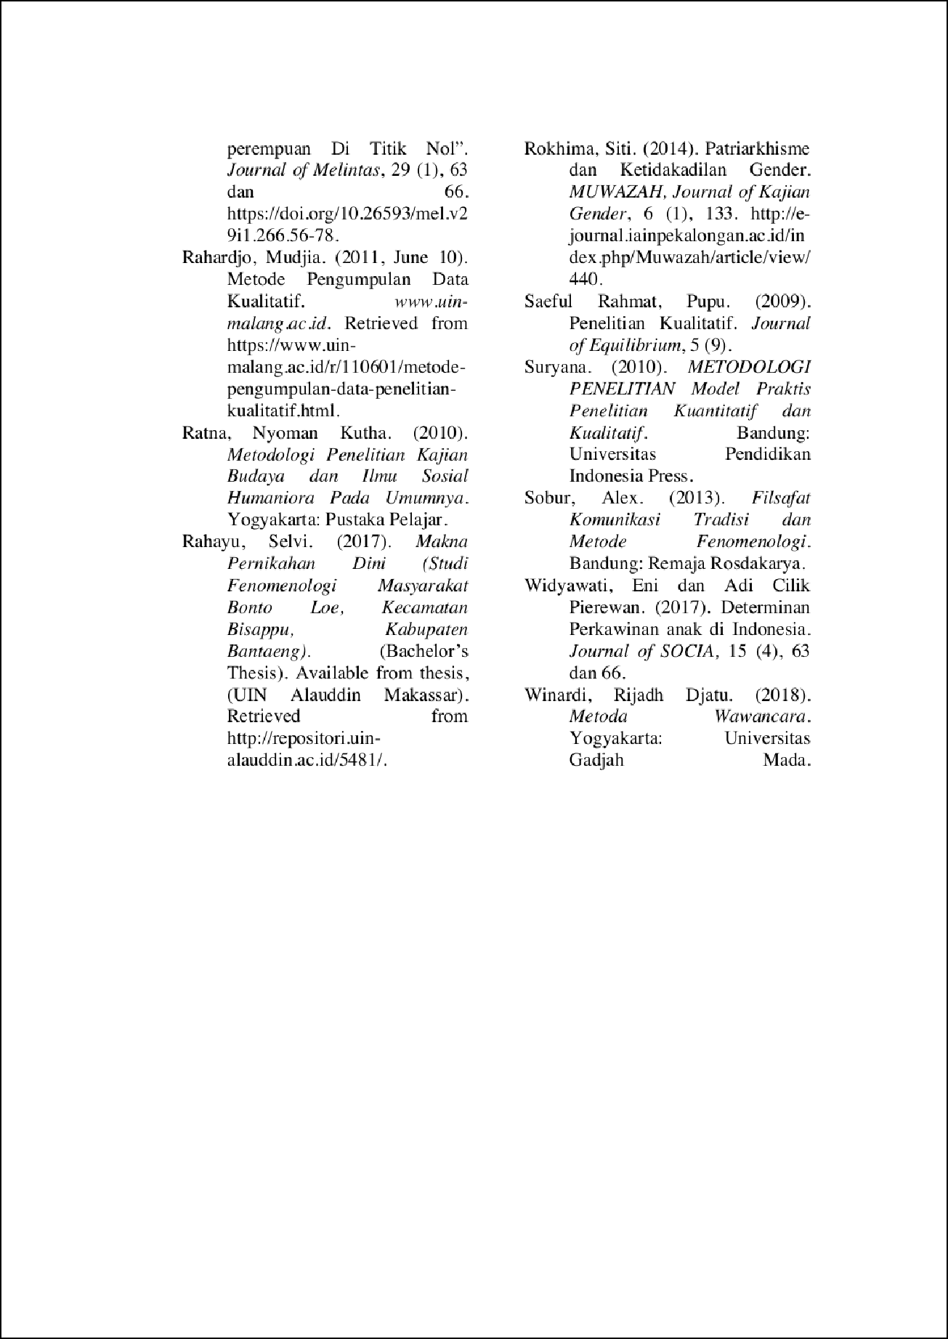

2

3

6

UNDER-AGE MARRIAGE: ASSERTING ‘BAPAK’S DOMINATION OVER FEMALE ADOLESCENT FROM TRADITIONAL SETTING TO PATRIARCHY

ORIGINALITY REPORT
2

%
SIMILARITY INDEX
1%
INTERNET SOURCES
1%
PUBLICATIONS
0%
STUDENT PAPERS

PRIMARY SOURCES

1 Ratno Lukito. "The enigma of legal pluralism in Indonesian Islam: the case of interfaith marriage", Journal of Islamic Law and Culture, 2008
Publication

ejournal.kopertais4.or.id
2
Internet Source

repositori.uin-alauddin.ac.id
3
Internet Source

jurnal.uns.ac.id
4
Internet Source

5 "1st Annual Conference of Midwifery", Walter de Gruyter GmbH, 2020
Publication

www.ejurnal.poltekkes-tjk.ac.id
6
Internet Source
1%

<1%
<1%
<1%
<1%
<1%

