**Women Portrayal in Beauty Product Advertisements of Pakistani Private Channels**

**Abstract**

Since advertising was introduced many centuries ago, women have been objectified and, in some cases, insulted or belittled. The second wave of feminists challenged society's definition of femininity, and challenged society's insistence on equating men with thought and women with "nature" and "body." As early as the 1970s, feminists realized the power of male "glaring" and materialized it by fixing the female body in photographs, paintings, or other art forms." Feminists have been very critical of advertisements and other popular textualized [standardized] specific images of slim, young, and soft female bodies." Feminists believe that TV commercials do not sell products, they just sell bodies. Women are more objects of desire and sex than people with feelings. Therefore, the main purpose of this article is to study how Pakistani television advertisements objectify women and idealize the specific image of a slender, and smooth female body as ‘female capital”. Researcher used a qualitative method (content analysis) to emphasize how sexist media constructs an unattainable or objective image of female beauty. We believe that the image of the ideal woman (as depicted in advertisements and other popular texts) degrades women as objects of pure desire, leisure and sex, rather than people with emotions and feelings (human beings). The conclusion of the study is that, physical beauty of a woman shown in the advertisements not only reinforces the unattainable standards of beauty but also emphasis on the stereotypical images of unnatural, alluring and glamorous women. Their personal achievements and accomplishments are only acceptable if they meet the criteria of unrealistic beauty standards.

**Key Words**: Objectification, Sexualized, Femininity, Materialized, Normalization, Beauty Standards

Depiction of women in broad communications is definitely not another discussion. Since women's activists have been raising voices over the victimization of women. The field of publicizing is amazingly expansive and various. In everyday terms, obviously, an ad is basically a public notification intended to pass on data and welcome support or another reaction. As that proposes, advertisement has two fundamental purposes: to advise and to convince, and keeping in mind that these intentions are discernable both regularly are at the same time present. objectifying isn't equivalent to showcasing or advertising as a rule, however; it is a method or instrument utilized by either of these. Objectification can be exceptionally basic a nearby, even or it very well may be extremely perplexing, including complex examination and media crusades that range the globe. The field of media is extremely tremendous and various; and it turns into a significant wellspring of study. The primary goal of the ad is to pass on their message to general society and to convince them. Its main point is to draw attention of the viewers and convince them to purchase that item and adjust the thought or new style. Advertisements and promotions are an unavoidable an integral part of the present group environments. It is a specialized instrument that explicitly attempts to persuade potential clients to purchase or utilize to a greater degree a particular brand or administration. In the modern age, the most impressive selling media is promoting (Hakin, 2004).

1. **Advertisements**

Television advertisements are significant means for advancement and progression as a racial result of media. Sex jobs are differentiated by those results of media. Sex distinction passes from one culture to another, and Pakistan is a man centric development with latent female and winning guys. The way of life plays suggested those parts in the light of Islamic points of view. Actual appearance and body associate as the objectification of women on TV notice beginnings psychosomatic buildings and apprehension among Pakistani women. Pakistan-Islamic racial outfit for women is shalwar, kameez, and dupatta that is famous from everywhere the world. Men in the commercial are plentifully robed while the female is taken advantage of as the sex object. In Pakistani TV advertisements, women accomplishment only built on her actual appearance and exquisiteness. (Schneider,1979)

Advertisements might be a widespread and unavoidable method of correspondence, yet it is just one of the many variables to socialization of sexual orientation. Messages in promotions are made by depiction of people which are admired and generalized. Belief systems in advertisements are the establishment of generalizations. There is a solid connection between viewers‟ conventional mentalities towards sexual orientation establishments and their openness to sex depictions towards genders.

Publicizing and externalization, is a piece of our mystical media area. It is a beneficial industry and influences all for the duration of our lives. We are each open to such countless ads consistently, addressing maybe the most impressive instructive equipment in the public eye. Consistently, women and especially young girls are barrage with notices which urge them to meet impossible thoughts of actual excellence. The vast majority of individuals invest bunches of energy watching various kinds of products on TV advertisements and in newspaper and magazines too. The ads sell significantly more than items. They sell, esteems, pictures, and ideas of achievement of perfect body. They tell the overall population, what our identity is a lot we ought to be. Promoting changes, the reasonable benefit of utilizing items into the representative benefit of trading items into products. (Philips,2004)

1. **Portrayal of women in advertisements**

Advertisements make an optimal existence where individuals are excellent, thin, rich and beautiful. In this world, individuals talk just about items and promotions sell the items through making a dreamland. To make such world the promoting offices frequently utilize female models in all conceivable ads. Females are depicted diversely in various kinds of commercials and the most models do it with no protests.

women are regularly addressed as an item in commercials. They will in general play the job of assistant or item. Men are as yet addressed as solid characters and their examination is by all accounts the focal worry of the female models. The portrayal of women on screen are regularly generalized as far as adjusting to social assumptions. In media the actual magnificence of women gets more worth than any of her different abilities. The shortage of solid female good examples and the counterfeit idea of such depictions look similar to the truth experienced by women around the world. (Schroder, 1985)

From the day first, women have been depicted as housewives, dependent upon men and sex objects in notices. In any case, for recent decade there have been a few changes in the pictures of women. Portrayal of women in notices has been encountering a shift from the house spouse driven promotions to the vocation women ads. She is for the most part introduced as a superwoman, who figures out how to accomplish practically everything at home and at work with the assistance of an item, obviously, not of her significant other or kids or companions. The pictures of women are consistently appealing, who gives the helpful picture to the notice, independent of her significance to the notice. Countless advertisements have introduced females as respectful, detached, modest, unintelligent, delicate, fantastic, vulnerable, prone to be controlled, portraying accommodation, withdrawal and petition. Men are portrayed as amazing, valuable, self-ruling, accomplishing and signifying control, force and predominance. (Jack & Lisa, 2017).

(Nussbaum & Martha,1995) has affirmed that notwithstanding contrasts in the social, political and monetary frameworks in Asia, depiction of sex jobs by the Asian media is "naturally reliable" in the entire district. They further see that females are depicted as compliant, casualties, supporting, reliant, benevolent, sex items, hetero and whores.

In this paper as researcher, I want to talk about how woman is address in advertisements, what the general public holds as an optimal picture of her. Women are kept on being prevalently depicted as a sexual item, negligent, subordinate, overseers, engrossed with excellence.

1. **Contextualization of study**

The record of television in Pakistan is in certain respects like that of radio. State-asserted Pakistan TV (PTV), remained the only Channel in the country for a long time. It was exclusively after the establishment of PEMRA that elite Stations were permitted to work. A huge separation, regardless, was that not typical for radio stations, numerous private Television channels were allowed to impart their own news and current endeavors programs.

In the prolonged stretch of time since private Channels began working, television has gotten the overall medium and the method of choice for getting to news just as infotainment and entertainment content. Any spot television is available, most Pakistanis seem to support it toradio as a wellspring of information. As a matter of fact, 2017, 89 satellite television licenses had been given by PEMRA. Another 29 new channels had been yielded landing rights.

Somewhere near 30 private Television stations, perceptible among them Geo News, Dawn News, Aaj television, ARY News, Capital television, Samaa, Dunya News, Waqt News, and Express News, exclusively broadcast news and recent concerns programs. Many print media affiliations working going before 2002 reached out to join television news stages. Basically, all television news stations stay aware of their locales, which join news consideration from their essential stages.

Pakistan's transmission business has created over the latest 50 years starting with the beginning of Pakistan TV (PTV) in 1964 as an elite station approved by the public authority of Pakistan. PTV started its transmission from Lahore in 1964, followed by Dhaka, Bangladesh (in the past East Pakistan), then Rawalpindi/Islamabad. In 1966, PTV started its transmission from Karachi (Iftikhar, 2017). In 1971, the public authority of Pakistan nationalized PTV. In the 1970s, one-inch appealing spool was used to record sound and moving pictures as a solidified stream. Regardless, the early records were lost because of nonappearance of cooling in the legitimate rooms and general dismissal achieving the insufficiency of recorded fortune from the public telecom television splendid time (Islam, 2017).

In 1988, Shalimar TV station (STN) outlined as a public-private association, begun sending CNN rebroadcasts under game plan and in 1990 it supported on a transmission arrangement bargains simultaneousness with M/s Organization TV Advertising (NTM). NTM's use of STN's natural advertisers spread across Pakistan, added to its flourishing especially with the dispatch of some hit family performance serials (extending a more useful contemporary lifestyle). People considered NTM's transmissions a genuinely necessary boost in the post-Zia-ul-Haq military extremism period (Waheed, 2014) considering the way that its composing PC programs was socially open and not open to significant altering by Zia-ul-Haq's strategic government.

GEO television, Pakistan's third greatest Channel, was dispatched in August 2002 and orchestrated with general races composed by the Musharraf government. It expected a pressing part in scattering political systems and messages of various philosophical gatherings and their candidates. (Nisar, 2010).

1. **Theoretical Framework**

The current investigation fundamentally breaks down the marvel of women externalization on TV commercials in Pakistan. Woman's rights and the body has been a discussion since second wave of women's liberation. Second wave of women's activists tested meaning of womanliness and its emphasis on comparing men with mind and sense, and women with “nature and body”. As far back as the 1970's women's activists knew about the force of female look to typify the female body by fixing it in photos, compositions or different types of art. In England, for instance, the stone carver “Allen Jones” turned into the objective of women's activists' assault for his series "women as furniture" which portrayed women whose fetishized bodies were utilized as allies for foot stools. Women's activists challenge these portrayals of conventional generalizations of femininity since it is through the media that female buyers disguise sex personality. In 1978, Susie Orbach published "Fat is a women's activist issue", wherein she examined dietary problems like bulimia and anorexia as instruments for declining sexual generalization. Orbach was the specialist of Woman Diana Spencer. During the 1980s, women's activist exercises rotated around endeavors at recovering the female body by deconstructing the generalizations and visual items which characterized it. Women's activists' not really set in stone to recognize and dissect the fundamental philosophy and the social conditions which delivered pictures of women as products. (J, Cathia. 2007).

Notwithstanding, it was not until the 1990,s that the discussion over the portrayal of the female body was developed further and a few speculations about how women are seen by men were introduced. Regardless of whether it is the flimsy and thin or the shapely and enticing, the ideal female body has consistently been an object of interest and fetishism. In 1990, Noami Wolf published the bestseller "the beauty myth" in which she talked about how excellence pictures are utilized against women featured the solid impact of media on women' impression of their bodies. Women encounters, sensations of insufficiency, self-loathing and defects, on being barraged with visual portrayals of the best body. While women have accomplished a lot of public impact, they have lost their private relationship with their bodies. Media as a fundamental offender answerable for the ascent in dietary problems and corrective medical or surgical procedures. (G, Judy.2007)

I additionally considered “objectification theory” as a system for understanding the experiential outcomes of being female in a culture that physically generalizes the female body. Objectification theory (Fredrickson & Roberts, 1997) states that media places women's bodies and physical appearance at exclusively assimilate standard which make women to self-objectify (i.e., to view themselves as outsiders or be more focused on physical attributes), or to feel conscious or embarrassed about their bodies. Main focus of this theory is, that young women are regularly assimilated to disguise a spectator's viewpoint as an essential perspective on their actual selves. This viewpoint on self can prompt constant body checking, which, thusly, can build women' chances for disgrace and nervousness, decrease openings for top persuasive states, and reduce consciousness of interior substantial states. Aggregations of such encounters might help represent a variety of emotional wellness chances that lopsidedly influence women: unipolar melancholy, sexual brokenness, and eating problems. Objectification theory likewise enlightens why changes in these emotional well-being hazards seem to happen in sync with life-course changes in the female body.

1. **Methodology**

This research is qualitative in nature and content analysis method was used to discussed the advertisement language in detail. Latent analysis was used to describe the language and messages of advertisements in themes.

**5.1 Target Population**

Target population for this study was the advertisements of Pakistani private channels during the prime-time transmission from 8 to 10’o clock. These channels were selected on the basis of their popularity.

**5.2 Sampling technique**

Purposive sampling was used to select advertisements. As the title of the research shows how women are portrayed in beauty product advertisements of Pakistani TV. These advertisements were shown for six months on private channel in 2020.

**5.3 Sample**

All advertisements of each beauty product were chosen, including face wash, whitening creams, lotions, hair removal creams soaps and shampoos.

**5.4 Unit of analysis**

Pictures, messages and dialogues of each selected advertisement is the unit of analysis. Themes are driven from the advertisements, messages and ideas of the ads are discussed in detail.

1. **Analysis**

**Whitening creams, soaps and lotions are the source to become valuable in society?**

women have always been beauty conscious & insecure about their appearances. Advertisers have exploited this bombarding them with ways in which to improve their appearance. For example, we all have been seen the ads of fairness creams where the advertisers pass the message to the audience that only using their product a woman can be beautiful and get the desire results. These commercials show that all young women in Pakistani society need the sparkle and excellence. An enormous number of young women are stressed and discontent with their dull coloring and harsh skin. They all need to gleam and excellence along these lines, e.g. one young woman in the advertisement with reasonable sparkling skin said to other dull complexion young woman, you need the shine like mine. Reasonable and dazzling wash gives you the excellence and light complexion which you need. It is a common phenomenon in Pakistani society that fair skinned young women can carry on with better life when contrasted with the dull complexion young women.



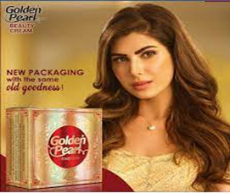





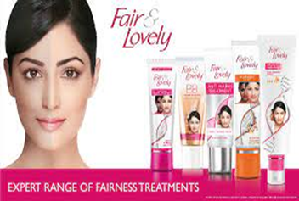



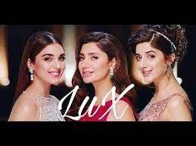

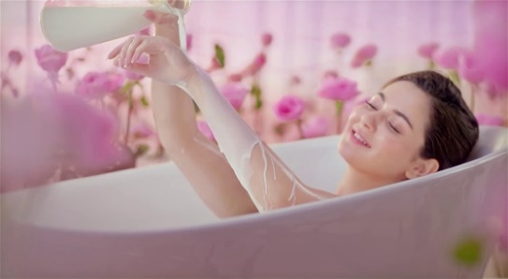

There are number of Asian nations where white or fair skin shading includes as a vital factor in magnificence. In an article Hooligan and Cowardly (2003) expressed that in our way of life brown complexion shading is connected with low pay individuals who function as field work while white skin is related with unrivaled class which hold power. Lal (2004) expressed that longing of white skin has additionally been driven from South Asian films in which the positive characters like legend and champions are in every case fair skinned and gorgeous while the negative characters are generally dim shaded. For skin easing up, there are many creams and blanching specialists are accessible on the lookout. Other than these items various methodology are additionally accessible, for example, corrective treatments by dermatologists and non-sedated medicines in beauty parlors. Del Guidice (2002) referenced that skin lighteners are not just normal in Asian nations yet additionally generally accessible in non-white areas of world for example Africa. Feeling of inadequacy is portrayed by absence of self-regard or fearlessness. It's for the most part found in women.

(Woo, 2004) expressed that in this male consumerist framework, women outside look have become the estimating standard for their characters (Halprin 1996). In an exploration, Greene (1992) stated that analyst contend that women body is the image of her character and she firmly needs to take care her beauty. In request to ward themselves off from complex and tension, women attempt to adjust the shallow strategies or even beauty care products medical procedure to devour a perfect body (Charm, 2004). Adam Smith said "the most essential human requirements are not natural, but rather social." A light complexion or white skin is the indication of magnificence in numerous non-whites social orders. In Chinese customary culture there is a figure of speech "one white conceals three ugliness"(Bray, 2002). In Korean culture, a white individual is considered as better (Yoo,2001). In India dark or non-white skin tone considered as lamentable, grimy and out of line, while white skin is considered as indication of magnificence and joy (Arif, 2004). As per Hong (1999), for the occupation reason women are not just assessed as far as their abilities, schooling and capacity yet their actual appearance matters more in their work.

In another ad, a mother and her daughter are shown on a function & some family relative come to her and said, you are beautiful as always. A young boy from the gathering says, ‘hey beautiful!’ at his remark the girl smiles’. There is a very strong message in the ad that a woman should get praise from men as man’s gaze s important for her. A woman wants attention of others. She smiles at guy’s comment which shows that she wants attraction, attention and appreciation of males specially. When she dances, her motive was to attract males. The others females on that wedding ceremony get embarrassed & feel themselves inferior because the girl using this product taking applause from everyone at wedding. The main theme of this ad ‘aur kisi py nazr ku jaey’ means when I am so elegent, then why someone would look at others.

Another ad shows that a girl using Lux Soap goes on date on a candlelight dinner with her beau. Her beau flaunts at her and blows the candle. On being asked he says “when moon is here then why I need a candle” shows how women get impressed with her praise.

Himalya Neem Face wash advertisement illustrate a stereotypical message. A guy on wedding, smiles at his fiancée and girl starts hiding her face by saying. I can’t achieve my destination (A man for wedding) if I have pimples on skin. Her sister asks her to use face wash regularly and she becomes confident and smiles back at her fiancée on next occasion.

Fair & lovely (a whitening cream) doesn’t give glow it gives HD glow. Means now every woman using this product can have HD glow. Now no woman will be afraid of sun rays as almost every girl start using “Fair & Lovely” which is specially designed to protect skin from harmful rays of sunlight.

Face fresh cream gives a strong stereotypical message by a young group of women saying “we girls should have fresh face” for making our place in society.

**Women seeking power through silky and shiny hair**

**Hair color makes an individual successful in all spheres of life**

Long and shiny hair reinforce the idea of being empowered in typical societies. Hair is a subject that is vital to women and their confidence. The positive or negative perspective on one's hair can significantly influence a woman, particularly in case she is of shading. Hair, its length, surface and shading, all impact how an individual looks and how they will be seen to others. women of shading explicitly are influenced by this on the grounds that alongside their skin tone; their hair isn't really the most well-known and acknowledged by far most.

Black hair is not in fashion and women must change the color of their hair to look trendy and stylish. If she wants appreciation from the society, she must change herself into “blonde” Olivia hair color gives you a new look with trendy shades. All around the world individuals endeavor to accomplish this through skin blanching and hair fixing causing those of shading to feel second rate. This is explicitly significant in regards to hair since women of shading are brought into the world with hair that isn't as simple to oversee and isn't really that straight of Europeans. As per Sims, "Generally, Black women' decisions regarding how to wear their hair has been educated by cultural pressing factors to take on Eurocentric guidelines of straight hair (Lester, 2000). Nonetheless, in the United States during the 1960s, Afrocentric hair started to be emphatically connected with the mission for equivalent rights in the Civil Rights and Black Power developments (Kelley, 1997)." This is the time that the expression "Dark is beautiful" started to be utilized to divert negative generalizations and perspectives on dark magnificence. This was a positive message yet as times persevered "By the 1970s the Afro had become to a great extent masculinized to some degree due to its nearby relationship with the generally male, aggressor administration of the Black Panthers (Kelley, 1997). Consequently, there was a negative response to Black women wearing Afros. Specifically, when worn by Black women, the Afro hinted a prevailing lady who might participate in racial disobedience with bosses and man-slamming to men." (Sims) A large number of women go through the process of shading with hurtful, and harming chemicals to be characterized as lovely and fit the form. Since youth, people of color have gotten their hair loosened up going through horrible strain and agony including serious consumes from the profoundly unforgiving synthetic compounds used to make the hair smooth and straight. "Hair relaxers can cause consumes and sores in the scalp, working with passage of hair relaxer constituents into the body." (Wise, Palmer, Reich, Cozier &Rosenberg) Not just are relaxers hazardous to the scalp yet they are risky to hair too. These synthetic substances might fix the hair follicles; however, they likewise debilitate them and make the hair slenderer also. Numerous women go through this undesirable practice just to feel more acknowledged by society.

In another advertisement a mother gives her daughter a very stereotypical massage but in a strong way. The girl is having problem in adjustment with school environment and her mother asks her to use “lifebuoy shampoo” to make her hair strong. The message of being a strong woman is delivered in a metaphorical way, as our strong hair do not get hurt when twisting or pulling, the same way a strong girl is not influenced by negative environment of society. In another advertisement where a girl is participating in “university politics” her fellow warns her to stay away from politics in order to protect her hair from dust, sweating and hot weather. But that girl replies him back by saying “we will participate in politics and we will shine with pride” (Sunsilk shampoo 24/7 shine)

Another advertisement from the same shampoo brand shows a girl playing “basketball” in college. When her team coach advises her to play devotedly instead of making hair long. But she ignores him by saying “Let’s see” and continues to play. After few months her hair becomes long and thick and with this bouncy and luscious hair, she wins the match of basketball as well. Her coach also admires her by keeping her aim high along with long hair.

Pantene shampoo shows a girl who is going to be interviewed by an Ad Agency. But she is having a problem of hair fall, after using Pantene she gets selected in Ad Agency not because of her qualification but because of her strong hair which makes her personality so confident.

These advertisements are glimpse of what advertisements of hair products depict.

Living with the impediments of being dark alongside the obstructions of being a woman it tends to be difficult for them to arrive at progress on the grounds that there's so many chances against them alongside pre-made decisions. As indicated by Williams, "Notwithstanding the steps that have been made in America to further develop things for women and ethnic minorities, the interlaced cultural guidelines of magnificence do exclude African American women. This norm of excellence influences women in that regardless of how insightful they are, looks have a significant impact in their expert life." Black women are relied upon to look a specific way in an expert setting and that is of regular European styled magnificence guidelines. This incorporates straight hair that is long and one strong shading. "People of color who decide to wear Eurocentric hairdos might be adjusting to this norm of demonstrable skill with an end goal to be acknowledged in the work environment, subsequently satisfying the need to belong."(Sims, Barclay, Kurt) Women have the decision to wear their hair anyway they need, how it is seen notwithstanding, is unique, "when a Black woman decides to wear an Afrocentric haircut, she might be conflicting with the standard uncovering a minor character quality. This decision to conflict with the standard Eurocentric qualities might be considered as a demonstration of organization or predominance. The woman isn't adjusting to greater part standards rather she is showing a piece of herself that is one of a kind, satisfying her need to feel unmistakable." (Sims, Barclay, Kurt) When a woman meets these standards, she is viewed as a danger and somebody who isn't keeping the norm and is frequently condemned and advised to quiet down and adjust.















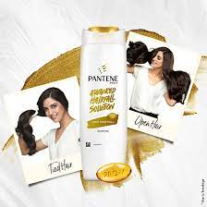

**Women’s worth lies in silky, soft and fairer body**

Hair removing creams gives a strong message to women to be flaunt in their hair free bodies. Mahira khan who is a leading actress of Pakistan shares her experience and gives a message, that every girl should always be ready to go outside with using “veet hair removing cream”. She is wearing pink color which is also symbolically used for girls, she dances with her friends and enjoys event as she is confident for not having hair on her body. Confidence comes with soft silky smooth and supple skin and beautiful body attracts everyone around.





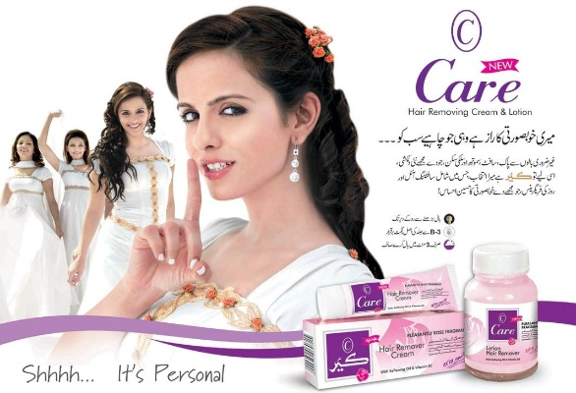

The model in ‘care hair removing cream emphasis on the idea of having hair free body by saying “the secret of my beauty is the one (cream) which everyone wants”

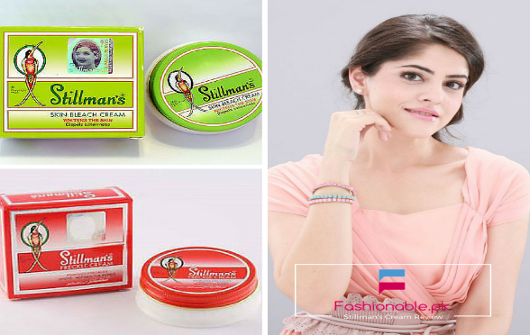

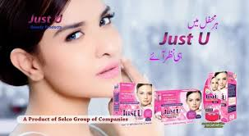

Whitening bleaching creams having a huge amount of toxic chemicals urge women to go for anything which can bleach their skin and make them fairer. In the bleaching advertisement a model saying “you will be seen in every ceremony”

Following themes can be drive from the themes of advertisements

* Women luck belongs to her fair complexion
* Only fair women can get jobs and marriage proposals easily
* Man’s attention is the major goal of woman’s life
* Women must have bright complexion to be accepted in society
* Woman with dark and dull complexion has lower status in society
* Males are always attracted to beautiful and glowing skinned women
* Pimples and acne make women depressed and unattractive and she cannot be a choice of any guy
* Bouncy, black and shiny hair make women best in every field of life
* Strong hair brings strong character and build high self esteem
* A smooth, hair free body makes women outgoing, self-confident and paradigmatic
* Women’s talent and intelligence is nothing to do for job promotions and development growth
* Ideal hair color makes woman right candidate for every competition
* Black hair is dull and boring (culturally varies)
* Women with colored hair are confident
* Hair color should match the skin tone of woman
* Women with black hair must dye hair in blonde
* Long and shiny hair makes women worthy in society
* Fair complexion, thick and long hair are not genetically but beholden by whitening creams and synthetic shampoos.

**Conclusion**

The overall instance of the article is that, television ads increment and legitimize female body as an item. display, for both the female and male look. Television in Pakistan makes a pipedream that permits women subjection and externalization. Media only spotlight on her genuine appearance and charm (for instance white tone, fragile and perfect skin, long and skipping hair, skin tight appealing outfits). These advertisements assurance to accomplish such impossible magnificence norms, especially among young men. These truly epitomizing messages prescribe women to use certain things to get appreciation and applause from men and society. Our key concern is that the overemphasis of television advertisements with appearance/actual charm as genteel greatness injures women/young women to comprehend that their certifiable worth abides not in their actual charm but in superficial personalities. It is proper to make reference to here that women on television are not real and ordinary, their faces are finished through magnificence care items and make up which looks typical on them (see Jacobson and Mazur, 1995). Thusly, the kind of woman, her body and ideal image of eminence showed on television is an unfathomable thing for a wide margin a large portion of woman to achieve. Furthermore, on the off chance that they are veritable, they may address a little piece of women across Pakistan; however, at that point, of that little numbers, none will meet all of the necessities to be contemplated extraordinary and ideal. Taking everything into account, these actually exemplifying attachments deal with and ingrain these nonexistent faces, body shapes, skin organization and hair type as ideal in unrealistic manner and make women commodities. They are no more treated as human but objects. The idea of being “perfect” is reinforced through media but mostly women are suffering with anxiety, depression and the feeling of being insecure in their homes. The fear of being inferior and rejection make them vulnerable and less competitive in society which develops a sense of passiveness and low self-esteem.