Implementation Improvement Analysis of

M-Library Application at XYZ University

Rizqiyatul Khoiriyah1, Devi Handayani2

Department of Information Systems

Universitas Gajayana

Malang, Indonesia

1rizqiyatul@unigamalang.ac.id, devihndyn94@gmail.com2

Tungga Bhimadi3

Department of Mechanical Engineering

Universitas Gajayana

Malang, Indonesia

tunggabhimadi2@gmail.com

**Article History**

Received month dd, yyyy

Revised month dd, yyyy

Accepted month dd, yyyy

Published month, yyyy

*Abstract*— XYZ University library provides offline and online book loan services. The library's online service uses the m-library application. This study aims to see the implementation of the m-library application and see the extent of the evaluation of the application. The m-library application is used for the process of borrowing books, viewing catalogs, and reading book online. The method used in this research is qualitative descriptive through interviewing interviewees and observing applications. The results of this study are that there are several benefits and weaknesses to the m-library application. From these shortcomings, it can be recommended to increase the implementation of the m-library application, namely the need for application development towards menu flexibility and application services, ease of online membership registration process, compatibility of online and offline book catalogs and more effective use of application features according to the University library business process. This application also requires broader socialization to the university academic community so that its use is more optimum.

Keywords—M-Library; Improvement Analysis; Business Process

# INTRODUCTION

Currently, the growth of science and technology very rapidly developing. The development of information and communication technology has penetrated all areas of life and has become a lifestyle. The use of gadgets, wearable technology, and daily activities cannot be separated from the use of technology. The development of information technology in all fields including education also influences learning activities and patterns. The modernity of information media in the era the information has given birth to various innovations in the field of libraries and information, among others produce various library innovations digital. The presence of information technology and communication in the library field produces acceleration and accuracy in building library services.

Technological sophistication these include library automation systems, digital library system, network system digital library, electronic database system and the internet. In that implication in society advances in information technology gave rise to net generation (net generation) and digital native in the information society [1]. Today's modern libraries are more relying on information technology in the form of mobile application for library (m-library) services to borrow and return books without having to come to the library [2]. The mobile application is a term used to describe an internet application that runs on a smartphone or other mobile device. This mobile application is usually used using a Personal Computer (PC) that is connected to the internet but can be opened using mobile [3]. The term Mobile Library comes from the word mobile device abbreviated as M which means cellphone and Library / Libraries which means library. According to the International Federation of Library Associations and Institutions (IFLA): “Any library service that does not stay in one place is classed as a Mobile Library” [4]. In terms of management (management techniques), with the increasing complexity of library collections, membership data, library collection circulation transactions, and so on, there is a need for the use of information technology to automate the business processes of various administrative services in libraries. The system developed with the basic idea of ​​how we automate various service activities in the library which is later known as the library automation system [5][6].

XYZ University has library services for students, lecturers, and other readers. University Libraries provides an application that can be used for library needs. Before the mobile library application, this library has used the SLiMS (Senayan System Management Library). SLiMS is one of the Free Open Source Software (FOSS) web-based which can be used to build systems library automation [7][8]. However, SLiMS has been deprecated since 2018. Then in 2019, the XYZ University library used the mobile library application (m-library). However, the use of m-library is not optimal. Many library users do not understand m-library applications and prefer to come directly to the library to borrow books. Even though if used properly and optimally, this application will facilitate and streamline the XYZ university library service process. This research will discuss the evaluation of the m-library application and the opportunity to increase the implementation of m-library application in XYZ University.

# METHOD

This research is a qualitative research. Qualitative research is research that uses a natural background, to interpret the phenomena that occur and carried out by involving various methods that exist [9]. Meanwhile, Sugiyono (2012) explains the meaning qualitative research as a research method based on a philosophy postpositivism is used to examine the condition of natural objects, where the researcher is as a key instrument, data collection techniques with triangulation, data analysis inductive or qualitative and the results emphasize meaning rather than generation. This type of research is descriptive research. According to Nana Syaodih Sukmadinata (2011), a qualitative descriptive study aimed to describe and describe the existing phenomena, both natural and human engineering, which is more concerned with the characteristics, quality, linkages between activities. So that this study does not provide treatment, manipulation, or changing the variables under study, but describe the conditions just the way you are [10]. Sources of data obtained from the interviews were conducted on the Head of Libraries and Staff. Head of Libraries and Staff know the course of all business processes that are running in the library so that researchers can get the real information and what existence. Data from interviews and observations obtained will be analyzed by:

1. Identifying data obtained from the University library.
2. Identify the input and output requirements for each activity.
3. Identify weaknesses and strengths in library services XYZ University.
4. Observing the implementation of each section library mobile application.
5. Identifying opportunities for improving the implementation of m-library applications.
6. Describe the analysis results with the suitability of the m-library in XYZ University.

# RESULT AND DISCUSSION

XYZ University Library is one of the units technical implementers who provide services to all academicians as well as other parties who need information and are always trying to improve its services both in terms of quality and quantity of materials provided. This library is managed independently by the library section directly by carrying out a business process, namely registering new members, borrowing and returning books.

## Business Processes at XYZ University Libraries

The university library business process that will be discussed in this research is the process of registering new members, borrowing process, and book return process.

### Process of registering new members: Readers / students come and register themselves to make a membership card, then the library staff provides a registration form. If the data filled in is not suitable then fill in the form again, after the form has been filled in completely then proceed to receive new member data in the library by getting a new member card that has been printed by the staff. The process is described as follows:

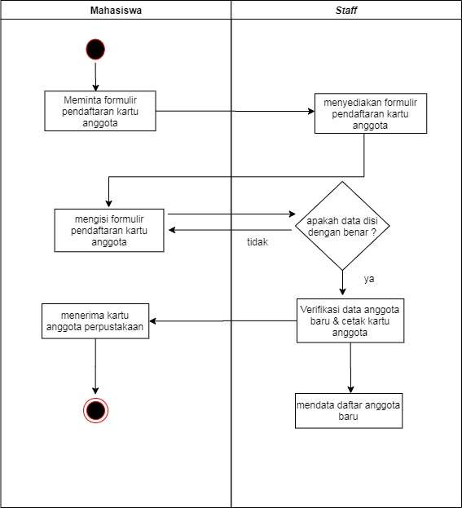

1. Process of registering new members

### Process of borrowing and book return: When visitors (students, lecturers, employees) come to the library to borrow the desired book, then visitors fill out the list attend a visit and then look for a book on the available shelf. If the book can be found, then make a loan to the library staff. If the book is not found, the library staff will help find the desired book then process the book borrowing. Borrowing books is given a week, beyond that time will be fined according to the count of days of delay. While the process of returning books is that the borrower must bring the borrowed book and library staff checks the card borrowing whether there is a delay in returning the book or not.

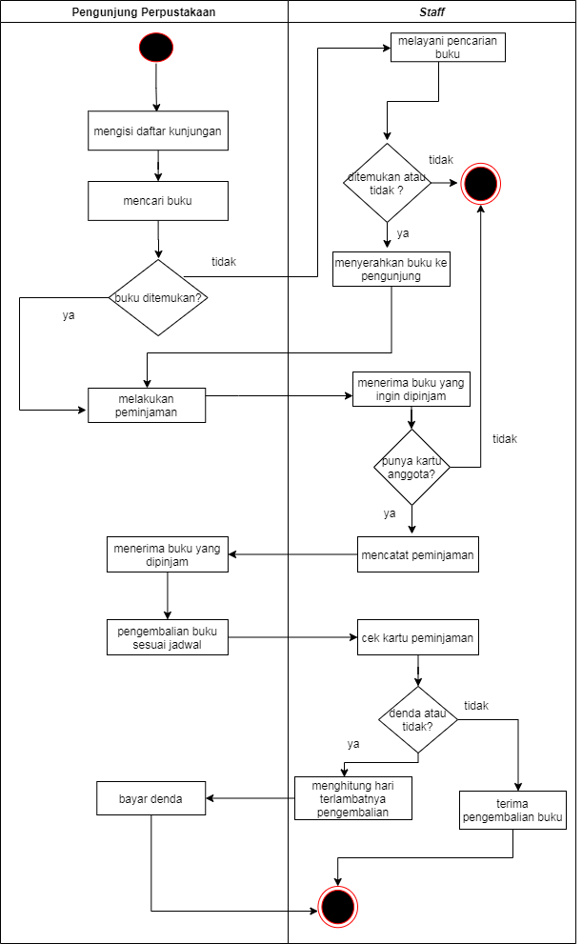

1. Process of borrowing and book return

## Business Processes at M-Library App

The XYZ University m-library application is a system that has a variety of mobile library services that provide access to members to borrow and read books anywhere using a smartphone device. This application was created in May 2019 and put into use in August 2019.

This application comes from the vendor PT. Enam Kubuku Nasional, so the books in this application are online books or e-books provided by the vendor. Users must first download and install the m-library application "UNIGA Library" in the playstore. However, the application cannot be used immediately. Users have to do account registration and other processes first.

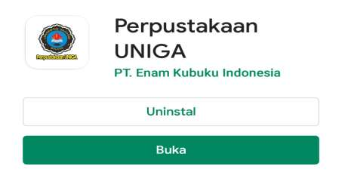

1. M-Library App

The following is a business process in the m-library application "Perpustakaan UNIGA":

### Process of new user registration: The user downloads the m-library app, then create a user account. Online user account registration process by filling incomplete biodata. If the registration is successful, the system will send a registration notification to the user's email. However, users still need account verification by coming directly to the library staff. This verification is done to check whether this user is a student / lecturer / other parties from the university academic community. If the verification process by the library staff is successful and active, users can use the m-library application.

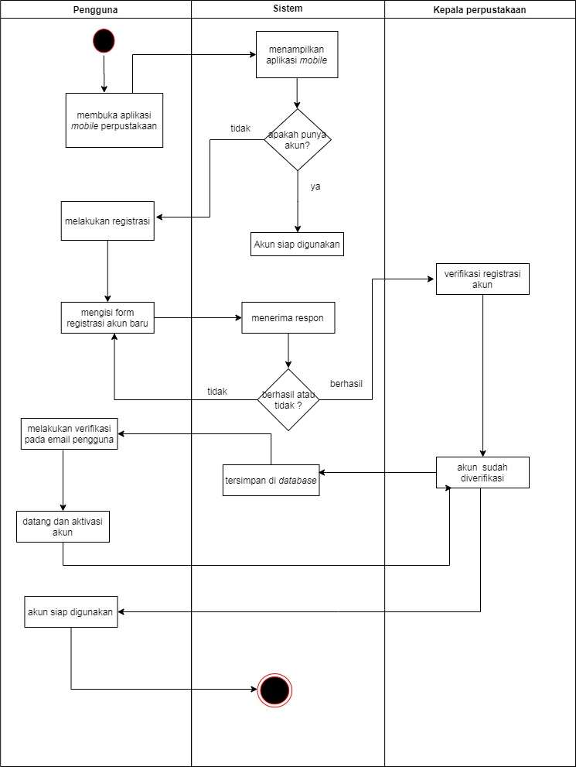

1. Process of new user registration

### Process of borrowing and book return : After successfully logging into m-library, the user goes to the book catalog which contains various types of book categories. If the book is found, the user selects the borrow menu. The online book will then go to "Rak Saya" and be ready to read online anytime. If the user only wants to read books without borrowing, the user selects the reading menu. Next, the book will immediately be readable like an e-book, but only read once. It's different from the borrow menu, which at any time can continue to read books again on "Rak Saya". For the book return process, users will be notified after reading the book. This notification says "Apakah buku ingin dikembalikan?". When the user clicks "Ya", the book is returned from "Rak Saya".

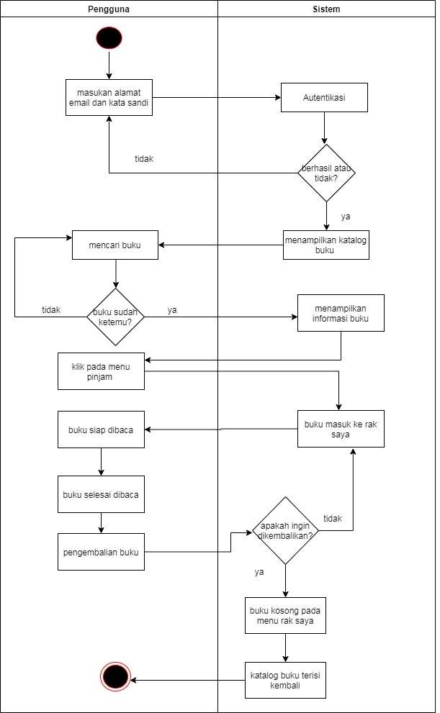

1. Process of borrowing and book return

### Process of book donation: There are two donation menus, namely catalog and donation points. The "Catalog" donation menu is donating books according to the existing catalog list. Meanwhile, the "Donation Points" menu is donating money online (deposit) according to the list of rupiah book prices. The donation payment process can be through money transfer, Gopay, OVO, and so on. After the donation payment process is complete, the user will receive a confirmation from PT. Enam Kubuku Nasional. Books that are successfully donated will immediately become a collection of books in the m-library.

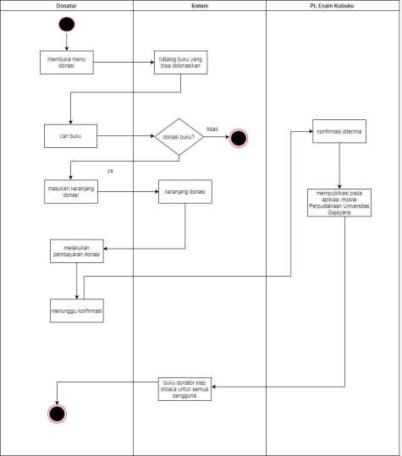

1. Process of books donation

## Evaluation of XYZ University M-library App

M-library apps can be used by users who already have accounts from students, lecturers, employees, and users outside the University. The evaluation of the m-library app is carried out based on the business processes that occur in the m-library apps. As for the strengths and weaknesses m-library app services are as follows:

Table 1 Benefits and Strengths of M-Library

|  |  |  |
| --- | --- | --- |
| **No** | **Strengths** | **Information** |
| 1 | Easy to access application libraries that are not limited to space and time | The library mobile application can be accessed anywhere and anytime with the internet network |
| 2 | Access the m-library apps for free and just download and install via Playstore | Previous users will need to register and activate an account. |
| 3 | The process of borrowing and returning books online, not limited to a week so there are no fines. | Users can borrow books online no time limit, except 30 days no reads will be lost automatically without warning |
| 4 | In terms of collection storage, digital libraries are more economical space, because it can store a very large number of documents. | The collection storage in m-Library will be more efficient and you don't need a shelf or a book holder |
| 5 | As a digital reference that is easily accessible to anyone and anytime | Easy to use, read books digitally, copy text info in writing and so on |

Table 2 Weakness of M-Library

|  |  |  |
| --- | --- | --- |
| **No** | **Weakness** | **Information** |
| 1 | User account registration new is not based on cardmembers of the University library. | Input data in the form of email, password, and identity name (KTP and KTM). |
| 2 | M-library book catalog not the same as a physical book catalog in the XYZ University library. | Books are available in m-library only comes from an e-book vendor, namely PT. Enam Kubuku Nasional |
| 3 | The list of physical book catalogs in the university library cannot be added to the m-library online book catalog | The online books on m-library only come from e-book vendors |
| 3 | M-library features not all of them work with well, for example, there is a feature "Teman Baca" which is not utilized for reading together or join in one application, only display a friend's name read on the main page | Only provide e-books that can read-only not to be shared with fellow users |
| 4 | XYZ University cannot add its book collection to the m-library | The university must contact the vendor and make certain agreements with the vendor |
| 5 | The donation menu does not provide physical book donations, only e-books on the application | Every book donation requires vendor approval before entering the book catalog |
| 6 | M-library of XYZ University cannot be modified accordingly university needs | The university must contact the vendor and make certain agreements with the vendor |

## Analysis of Improved M-Library Application Implementation

XYZ University m-library requires socialization to the university academic community so that its use can be used thoroughly because this m-library can streamline business processes that take place in the library.

To improve the implementation of m-library is the weakness of the m-library, namely:

* + - * The registration of a new account should be input by using a registered membership card from the library of XYZ University, so the validation and activation process is from the user's email only.
* The book catalog in the m-library needs to be adjusted to the physical book catalog in the University library. Collaboration with vendors also includes the addition of a collection of existing books in the university library.
* Features that cannot be used properly, for example, "good friends" should be used by giving the university access rights to manage them.
* The university should be given access rights to make modifications/developments according to the needs of the academic community with the conditions agreed upon with the vendor.
* The use of m-library should also be supported by hardware that is following the minimum specification requirements of the m-library so that this application can run properly and all features can be used.

# CONCLUSION

Based on the results of the analysis of the increase in the implementation of the m-library application, it can be concluded that this application has a simple and practical application display. There are many benefits obtained from using the m-library, especially the efficiency (time and cost) of the library's business processes. Meanwhile, increasing the implementation of the m-library app is by reducing and providing solutions to the weaknesses of the m-library. From these shortcomings, it can be recommended to the need for application development towards menu flexibility and application services, ease of online membership registration process, compatibility of online and offline book catalogs and more effective use of application features according to the University library business process. This application also requires broader socialization to the university academic community so that its use is more optimum.

##### ACKNOWLEDGMENT

This research is fully supported by the Department of Information Systems, University of Gajayana Malang. We are grateful to those who have participated in supporting the completion of this research.

##### REFERENCES

[1] H. Hartono, “STRATEGI PENGEMBANGAN PERPUSTAKAAN DIGITAL DALAM MEMBANGUN AKSESIBILITAS INFORMASI: Sebuah Kajian Teoritis pada Perpustakaan Perguruan Tinggi Islam di Indonesia,” *UNILIB J. Perpust.*, vol. 8, no. 1, pp. 75–91, 2017, doi: 10.20885/unilib.vol8.iss1.art7.

[2] A. O. P. Dewi, “Penggunaan Mobile Library untuk Perpustakaan Digital,” *Anuva J. Kaji. Budaya, Perpustakaan, dan Inf.*, vol. 3, no. 2, pp. 151–155, 2019.

[3] E. Turban, J. K. Lee, D. King, J. McKay, and P. Marshall, “Electronic Commerce: a managerial perspective 2008,” *Commer. A Manag. Perspect. (5th ed.*, no. July 2015, pp. 1–53, 2008, [Online]. Available: http://wps.prenhall.com/bp_turban_ec_2008/79/20298/5196418.cw/index.html%5Cnhttp://scholar.google.com/scholar?hl=en&btnG=Search&q=intitle:Building+e-commerce+applications+and+infrastructure#4%5Cnhttp://www.scientificcommons.org/58999413%5Cnhttp://hdl.hand.

[4] B. Georgios and P. Panagiota, “Mobile Libraries: Defining the phenomenon,” *Int. J. Libr. Inf. Sci.*, vol. 10, no. 3, pp. 35–40, 2018, doi: 10.5897/ijlis2017.0816.

[5] M. A. Muin, “Penerapan Sistem Otomasi di Perpustakaan Fakultas Adab dan Humaniora UIN Alauddin Makassar,” *Al-Kuttab J. Perpust. dan Inf.*, vol. 2, no. 1, 2015, [Online]. Available: http://perpustakaanstainpsp.net/e-journal/index.php/alkuttab/article/view/51.

[6] R. E. Fitriani, “Layanan UNILA Library Mobile: Inovasi Teknologi Digital di Perpustakaan Universitas Lampung,” *Pustabiblia J. Libr. Inf. Sci.*, vol. 2, no. 1, p. 149, 2018, doi: 10.18326/pustabiblia.v2i1.149-162.

[7] D. Rahmadhani and Marlini, “Pemanfaatan Software SLiMS (Senayan Library Management System) Di UPT Perpustakaan Kopertis Wilayah X (Sumatera Barat, Riau, Jambi, Dan Kepulauan Riau),” *J. Ilmu Inf. Perpust. dan Kearsipan*, vol. 4, no. 1, September 2015, pp. 192–203, 2015.

[8] W. Nashihuddin, “MENGULAS SENAYAN LIBRARY MANAGEMENT SYSTEM ( SLIMS ) DARI,” no. July, 2020.

[9] A. Cropley, *Introduction to Qualitative Research Methods*. Hamburg, Germany, 2015.

[10] B. I. Suwandayani, “Analisis Perencanaan Pembelajaran Tematik Pada Kurikulum 2013 di SD Negeri Kauman I Malang,” *ELSE (Elementary Sch. Educ. Journal) J. Pendidik. dan Pembelajaran Sekol. Dasar*, vol. 2, no. 1, pp. 78–88, 2018, doi: 10.30651/else.v2i1.1214.