THE CORRELATION BETWEEN AUDIO VISUAL ON BLOOD CIRCULATION MATERIAL AND LEARNING OUTCOMES OF PRIMARY STUDENTS IN MI MUHAMMADIYAH KALIKAJAR WONOSOBO

Risqi Fani Angraeni¹, Ahwy Oktradiksa², Muis Sad Iman³
^{1,2,3} Program Studi Pendidikan Guru MI Universitas Muhammadiyah Magelang
e-mail: rickyfanny616@gmail.com, ahwy@ummgl.ac.id, muis_sad_iman@yahoo.com

ABSTRACT
The use audio-visual media is on learning outcomes of science on circulatory material at MI Muhammadiyah Kalikajar Wonosobo. This research is a quantitative study with audio-visual media variables and variable learning outcomes of science in the blood circulation material. The population in this study was totaling 212 students. The sample in this study was 20 students. Collecting data are using questionnaire, interviews and documentation to decide data analysis then using product moment correlation analysis. The results that the learning process of natural blood circulation material before using audio-visual media is less effective, the use audio-visual media at this time in the high class is shown from the respondent's answered 55%. Improved learning outcomes of the science of blood circulation material the Minimum completeness criteria (KKM) complete predicate as many as 16 students with a percentage of 80% and there are 4 students who had not completed the KKM with a percentage of 20%. From the product moment correlation analysis obtained r^{xy} count value of 0.489 with a significant level of 5% greater than r table which means Ha was accepted Ho was rejected, namely there was a correlation between the use audio-visual media on studying of blood circulation science materials.
Keywords: audio visual media, blood circular, learning outcomes
INTRODUCTION
Education is one of the necessities and needs that is very important for every person, the core of education is the teaching and learning process and the learning process which involves the teacher as a teacher who transfers knowledge and students as learners who receive knowledge.
Teachers must have complex abilities so that they can allow the learning process in class without ignoring the conditions, diversity of attitudes, characters and abilities of students in accepting learning. One effort to create effective atmosphere in the classroom, namely all students must accept the learning presented. The teacher's ability in question is the insight and skill to organize and manage all elements related to the learning process by the aims of the school curriculum.
Teachers are required to be able to develop skills in making instructional media that will be used if the media is not yet available. For this reason, teachers must have enough knowledge about learning media, which includes:
- Media as a communication tool to make teaching and learning more effective.
- The function of the media to do educational goals.
- The intricacies of the teaching and learning process.
- The relationship between teaching methods and educational media.
- The value or benefits of educational media in teaching.
- The choice and use of educational media.
- Various types of educational media tools and techniques.
- Educational media in each subject.
- Innovation efforts in educational media.
But in reality today there are still many teachers who are found without using learning media. Often teachers only use teacher and student textbooks as a reference for teaching. As the researchers found based on observations at MI Muhammadiyah (MIM), Kalikajar, Wonosobo, there are still many teachers who have not fully used the learning media. Even though learning media are used primarily on 3 compulsory subjects or subjects used for national exams, namely sciences subject, math, bahasa, English, will be able to make students effective in learning and expected with the existence of student learning media will be responsive, understanding and learning outcomes will increase.
Based on student report cards obtained, that 60% of learning achievement in science subjects class V at MIM Kalikajar is still least KKM which is 75 that has been set by MIM Kalikajar. Especially in the learning of science circulating material students still feel confused and learning outcomes are declining. Visible teaching and learning process takes place in one direction. Students only listen and record the lessons given by the teacher. The teacher has not used effective learning media. Apart from that students neglect themselves and are not enthusiastic in learning. Some students are permitted to go to the bathroom because they are bored in class, and when the teacher asks questions many students do not understand the contents of the learning that is just happening. This can be seen in the use of learning media which are still common in the form of blood circulation media and science textbooks.
RESEARCH METHODS
This type of research conducted at this time is quantitative research using the same structured or systemic questions to many people, for then all answers obtained are examined and recorded, processed and analyzed, structured / systematic questions are known as questionnaires. This study involved a population of 212 students, and simplified it into a sample of research into 20 students. Data collection techniques consisted of questionnaires, interviews and documentation followed by tests of the validity and reliability of research instruments. Technical analysis of research was using quantitative with product moment correlation.
RESULT AND DISCUSSION
Media is anything that can be used to channel messages from the sender to the recipient so that it can stimulate students' thoughts, feelings, concerns, and interests and attention in the learning process. The media is a component of learning resources or physical vehicles that contain instructional in the environment of students that can stimulate students to learn. Audio visual media or audio-visual devices are "audible" means that they can be heard and means "visible" means they can be seen. So audio-visual media is a media that can be heard and can also be seen by the five senses such as video recordings, which can be grouped in audio-visual media, among them, television, interactive power point slides, interactive videos, sound films, video cassettes or CDs and computer. The term audio-visual materials is commonly used to refer to those instructional materials that may be used to convey meaning without complete dependence upon verbal symbols or language.
The development of information technology so rapidly turned out to have a broad impact on the area of teaching materials, one of which is audio visual. These teaching materials have a variety of forms of variation; there are forms of games, questions, and those in the form of teaching materials. This is the positive side of information technology for education.
In general the benefits that can be obtained are the learning process more interesting, more interactive, the amount of teaching time can be reduced, the quality of student learning can be improved and the learning process can be done anywhere, anytime and student learning attitudes can be improved.
Learning outcomes are abilities possessed by students after he has received his learning experience. While according to Arikunto argues that learning achievement is the level of achievement that has been achieved by students or students towards the goals set by each field of study after the teaching program in the closest time.
A science is concerned with finding out about nature systematically, so that natural science is not only mastering a collection of knowledge in the form of facts, concepts, or principles, but also is a process of discovery.
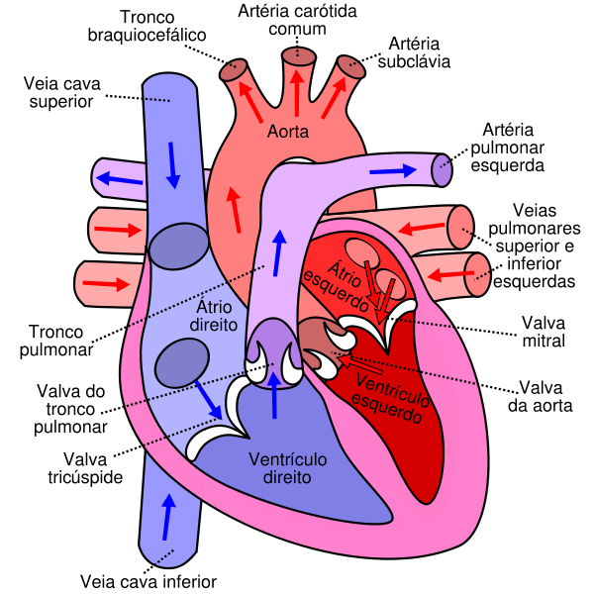
Blood circulation is an organ system that functions to move substances to and from cells. This system also helps stabilize body temperature and pH (part of homeostasis). There are two types of circulatory systems, namely the open circulatory system and the closed circulatory system. The circulatory system is part of the performance of the heart and the network of blood vessels (cardiovascular system) is formed. This system guarantees the survival of the organism is supported by the metabolism of every cell in the body and maintains the chemical and physical properties of the collapsed liquid.

Figure. 1 Anatomy of the Heart and Sources : id.m.wikipedia.org
The results of the classification of respondents' answers can be seen from the following table :

Table 1. Variable categories use of visual audio media
No | Skor | Quatity | Procentage | Criteria
1. | 29-36 | 11 | 55% | high
2. | 20-28 | 7 | 35% | Middle
3. | 12-19 | 2 | 10% | Low
Total |  | 20 | 100%
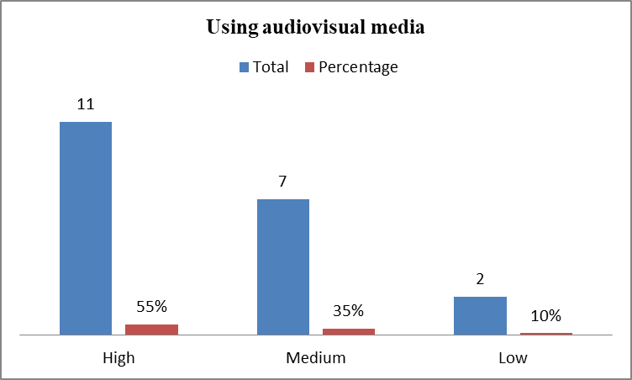
Based on the above frequency distribution of answers from 20 respondents, those who get scores from the number of questionnaires are 12 to 19, there are 2 with a percentage of 10% in the low category, those who score 20 to 28 are 7 with a percentage of 35% in the medium category and who score 29 to 36 as many as 11 with a percentage of 55% in the high category. The distribution of the responses can be described as follows:

Chart. 1 Distribution of respondents' answers using audio visual media
The learning outcomes of the science of circulatory material are taken from the book test scores of the students of circulatory material, based on these values the learning outcomes of the science of blood circulation material are then categorized into three namely high, medium, low. The division of categories uses the formula interval class that is the ideal highest value minus the ideal lowest value plus one then divided by the number of classes. The highest ideal score is obtained from the study results of the science of blood circulation material in the student test scores that is 85 and the lowest value is 66.
The results of the classification of respondents' answers refer to MIM Kalikajar with KKM’s value of 75 and according to the calculation of the interval can be seen from the following table:
Table 2. Variable Learning Outcomes of Science Natural Circulatory Material
No | Skor | Quantity | Percentage | Achievement KKM
1. | 75-85 | 16 | 80% | Reached
2. | 66-74 | 4 | 20% | Not reached
Total |  | 20 | 100%
Based on the frequency distribution of the answers above from 20 respondents, referring to the value of the science learning outcomes of blood circulation material students who scored 75 to 85 as many as 16 students with a percentage of 80% in the complete predicate KKM, and students who scored 66 to 74 as many as 4 students with a percentage 20% in the KKM predicate is not complete. The distribution of the responses can be described as follows:
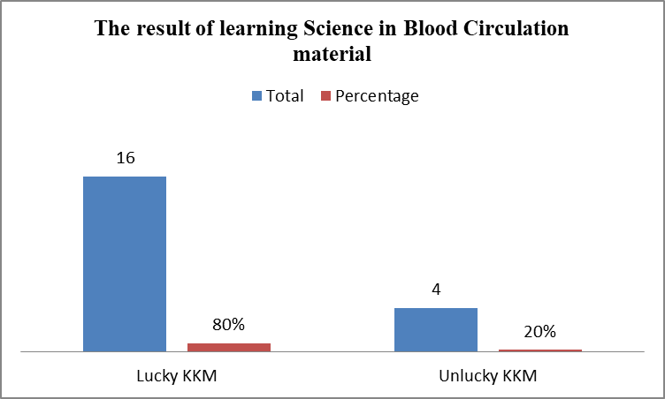

Chart 2. Distribution of respondents' responses to learning outcomes of Sciences in blood circulation material

With research conducted by researchers using the questionnaire method, interviews and documentation are expected to be able to get correct data about the use audio-visual media on the learning outcomes of natural science circulatory material.
Based on the research data obtained, the use audio visual media at MIM Kalikajar in the high class is based on the formulation of the questionnaire results of 20 respondents and 12 question items in which the frequency of answers is 11 students in the high class with a percentage of 55%, 7 students in the medium class with the percentage of 35% and 2 students in the low class with a percentage of 10%.
The learning outcomes of the science of circulatory materials at MIM Kalikajar is based on the results of the student test scores that 16 students in the KKM predicate completed with a percentage of 80%, and 4 students in the KKM predicate not completed with a percentage of 20%.
The value of rxy obtained 0.489 based on the formula df = N-nr = 20-2 = 18 is known r table at 5% significance level that is 0.444 then the rxy of 0.489 is greater when compared to r table 5% significance level. Thus Ha submitted. While Ho was rejected. So it can be concluded that there is a positive correlation between the use audio-visual media on the learning outcomes of the science of circulatory material at MIM Kalikajar.
From the product moment correlation test results above the obtained rxy value of 0.458 lies between 0.40-0.599 based on the guidelines table to give interpretation of the correlation coefficient which is classified as moderate or enough.
Audio-visual media is a media that can be heard and can also be seen by the five senses such as video recordings, which can be grouped in audio-visual media, among them, television, interactive power point slides, interactive videos, sound films, video tapes or CDs and computers. The Audio-Visual Aids defined as the computer delivered combination of a large range of communications elements text, sound, graphics, pictures, photographs, animation and moving video.; The ability of this media is considered better and more interesting, because it has both the first and second elements of media type. Utilization of audio visual media is usually equipped with student activity sheets that guide students to utilize audio visual media in the learning process.
Thus the use audio-visual media in learning science circulatory material will greatly assist teachers in delivering material because with audio-visual media the teacher can display parts of the human body such as the heart and lungs with pictures, the teacher can also explain or show the circulation process in the human body with videos and teachers can summarize or create the core of the material in the book using interactive power point slides. Learning will be more effective and efficient so that the value of student learning outcomes will increase because students more easily understand the material.
Based on research during the field, researchers can give an illustration that the learning process of natural blood circulation material before using audio visual media seems to be less effective, so with the use of audio visual media which has now been applied well in the natural science class 5 blood circulation learning material has a positive influence and has improved student learning outcomes to be better than before, this can be seen from the test scores of students more than some students have reached KKM which is 75 and there are only a few students who have not reached the KKM applied by MIM Kalikajar..
CONCLUSION
Based on the analysis and discussion of research data, there is a correlation between the use of audio-visual material on blood circulation in science subjects, the results of which can increase the effectiveness of teachers and students in understanding the material. This is evidenced by the acquisition of rxy value obtained at 0.489. This is when compared to r tables at 5% significance level with df = N-nr = 20-2 = 18 r refers to tables of 5% significance level that is 0.444 then the rxy of 0.489 is greater when compared to r tables. And from the product moment correlation test above the obtained rxy value of 0.489 lies between 0.40-0.599 from here it can be stated that the strength of the correlation between the variable use of audio visual media and the variable learning outcomes of blood circulation science material is a correlation that is classified as moderate or enough.
REFERENCES
Al-Khayyat, Ali Sabah Jameel, ‘The Impact of Audio-Visual Aids (AVA) and Computerize Materials ( CM ) on University ESP Students ’ Progress in English Language Ali Sabah Jameel Al-Khayyat Department of English Language Faculty of Education University of Anbar , Iraq Email : Alisabah4’, International Journal of Education and Research, 4.1 (2016), 273–82
Arikunto, Suharsimi, Dasar-Dasar Evaluasi Pendidikan, (Jakarta: Bumi Aksara, 2003)
Arsyad, Azhar, Media Pembelajaran (Jakarta: PT Raja Grafindo Persada, 2014)
Doosuur Ashaver, ‘The Use of Audio-Visual Materials in the Teaching and Learning Processes in Colleges of Education in Benue State-Nigeria’, IOSR Journal of Research & Method in Education (IOSRJRME), 1.6 (2013), 44–55 <https://doi.org/10.9790/7388-0164455>
Chairil, Dkk, Buku IPA Saling Temas Kelas (Jakarta: Pusat Perbukuan Departemen Pendididan Nasional, 2008)
Daryanto, Media Pembelajaran Perananya Sangat Penting Dalam Mencapai Tujuan Pembelajaran (Yogyakarta: GAVA Media, 2013)
Desstya, Anatri, ‘Kedudukan Dan Aplikasi Pendidikan Sains Di Sekolah Dasar’, Profesi Pendidikan Dasar, 1.2 (2014), 193–200
Malik, S., and A. Agarwal, ‘Use of Multimedia as a New Educational Technology Tool–A Study’, International Journal of Information and Education Technology, 2.5 (2012), 468–71 <https://doi.org/10.7763/ijiet.2012.v2.181>
Prastowo, Andi, Panduan Kreatif Membuat Bahan Ajar Inovatif (Yogyakarta: DIVA Press, 2014)
Sadiman, Media Pendidikan (Jakarta: Pustekom Dikbud dan PT Raja Grafindo Persada, 2012)
Shabiralyani, Ghulam, Khuram Shahzad Hasan, Naqvi Hamad, and Nadeem Iqbal, ‘Impact of Visual Aids in Enhancing the Learning Process Case Research: District Dera Ghazi Khan.’, Journal of Education and Practice, 6.19 (2015), 226–33
Sudjana, Nana, Penilaian Hasil Proses Belajar Mengajar (Bandung: Remaja Rosdakarya, 2013)
Daniel Kuok Ho Tang, and Rangis Intai, ‘Effectiveness of Audio-Visual Aids in Teaching Lower Secondary Science in A Rural Secondary School’, Asia Pacific Journal of Educators and Education, 32 (2018), 91–106 <https://doi.org/10.21315/apjee2017.32.7>

(Sadiman, 2012, p.6)
(Arsyad, 2014, p.4)
(Daryanto, 2013, p. 5-7)
Doosuur Ashaver, ‘The Use of Audio-Visual Materials in the Teaching and Learning Processes in Colleges of Education in Benue State-Nigeria’, IOSR Journal of Research & Method in Education (IOSRJRME), 1.6 (2013), 44–55 <https://doi.org/10.9790/7388-0164455>.
(Prastowo, 2014, p.327)
(Daryanto, 2013, p.52)
(Sudjana, 2013, p.22)
(Arikunto, 2003, p.269)
(Desstya, 2014, p.194)
(Chairil, 2008, p.58)
Ghulam Shabiralyani and others, ‘Impact of Visual Aids in Enhancing the Learning Process Case Research: District Dera Ghazi Khan.’, Journal of Education and Practice, 6.19 (2015), 226–33.
Ali Sabah Jameel Al-Khayyat, ‘The Impact of Audio-Visual Aids (AVA) and Computerize Materials ( CM ) on University ESP Students ’ Progress in English Language Ali Sabah Jameel Al-Khayyat Department of English Language Faculty of Education University of Anbar , Iraq Email : Alisabah4’, International Journal of Education and Research, 4.1 (2016), 273–82.
S. Malik and A. Agarwal, ‘Use of Multimedia as a New Educational Technology Tool–A Study’, International Journal of Information and Education Technology, 2.5 (2012), 468–71 <https://doi.org/10.7763/ijiet.2012.v2.181>.
and others, ‘Effectiveness of Audio-Visual Aids in Teaching Lower Secondary Science in A Rural Secondary School’, Asia Pacific Journal of Educators and Education, 32 (2018), 91–106 <https://doi.org/10.21315/apjee2017.32.7>.

